***Student Data Improves Pennsylvania’s Future***



Computer Resources announced today that they will offer Pennsylvania Early Warning System and Intervention Catalog implementation services that will enhance educators’ ability to respond to students who are at risk of dropping out of PA schools.

|  |  |  |  |  |  |  |  |  |  |
| --- | --- | --- | --- | --- | --- | --- | --- | --- | --- |
| [cid:part1.08060205.08010300@cri-mms.com](https://twitter.com/MMSforSchools) | [cid:part3.02080106.06090804@cri-mms.com](https://www.facebook.com/ComputerResourcesLlc) | [cid:part5.06030008.01040308@cri-mms.com](https://plus.google.com/u/0/103329904087934704730/posts) | [cid:part7.07050204.01040409@cri-mms.com](http://mmsforschools.tumblr.com/) | [cid:part9.02050901.03060104@cri-mms.com](http://www.linkedin.com/company/computer-resources) | [you-tube-share](https://www.youtube.com/watch?v=QZTp9vUl4dk) |  |  |  |  |

Video Case Study at:

https://youtu.be/QZTp9vUl4dk

Computer Resources LLC

888.665.4046

[www.cri-mms.com](http://www.cri-mms.com)

[info@cri-mms.com](mailto:info@cri-mms.com)

***Computer Resources supports research-based efforts to improve graduation rates in Pennsylvania with free professional services for schools***

*To tweet this news, copy and paste to your Twitter handle with the hashtag #mmsforschools*

[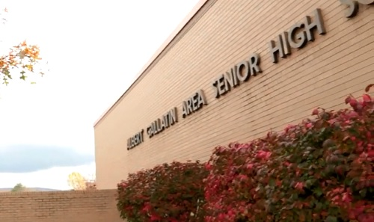](https://www.youtube.com/watch?v=QZTp9vUl4dk&feature=youtu.be)

Pittsburgh, PA— To improve the graduation rates for districts in the Commonwealth, the Pennsylvania Department of Education has made a state-wide Early Warning System and Intervention Catalog (EWS) available to all schools. While all schools are eligible, scheduling time to implement during the middle of the year creates a barrier for schools to adopt the powerful program.

To help ensure the success of this program, Computer Resources is donating free on-boarding services to interested districts.

“The benefits of this program are quite clear,” says Michael Bronder, Computer Resources Group VP, “and the Pennsylvania Department of Education has made this as easy as possible for districts to get on board and take advantage of the dashboard and alerting system they’ve built. However, we know it’s always hard for school districts to take on new projects so we’re donating services to districts to help ease that burden. We know that this research-based early warning system is effective, and we want to do whatever we can to help schools take advantage of this free resource.”

Using web-services, MMS configures and connects schools’ student information systems directly to the EWS. Information Technologist’s involvement is minimal, and once configuration is complete, the EWS runs automatically, making it much easier for guidance counselors and other educators to recognize trends and correlations that indicate a student may be at risk of becoming unengaged with school, through declining grades, a rise in disciplinary infractions, or attendance metrics.

“Now, through the Dashboard, you’re able to see these students that are red-flagged even before they’d be red-flagged during a team meeting,” [(Video Here)](https://youtu.be/QZTp9vUl4dk?t=32s) says Joetta Britvich, a middle school principal from the Albert Gallatin School District. With the Early Warning System, educators can not only more quickly recognize signs that students may be drifting off-track, but with the included catalog of interventions, respond more quickly and effectively to help kids stay successful.

Mandi Figlioli, from the Burgettstown Area School District appreciates the role that Computer Resources is playing “I feel like MMS is ahead of the game. They know what schools want. They know the issues that we are facing and they are working in cooperation with the state to make sure we get the job done right.” [(Video Here)](https://youtu.be/QZTp9vUl4dk?t=250s)

**About Computer Resources:**

Since 1978, Computer Resources has been a leading provider of K-12 technology infrastructures, including the MMS Student Information Platform. They provide a wide range of tools and services to create a healthy and organized school that can stay focused on student and teacher performance. Their modular systems give stakeholders access to the data and resources necessary to create outstanding educational environments.