Ride longer with igus® plastic components for the bicycle industry
The motion plastic specialist will have a range of their lightweight and self-lubricating bearings for bike applications at the 25th annual Sea Otter Classic bicycling and outdoor sports festival, April 16-19th in Monterey, California.
April 7, 2015- East Providence, Rhode Island - In all types of cycles, there is one critical factor – the weight of your bike! To achieve top sporting performance or simply enjoy a relaxed ride with no extra effort, igus’ range of lightweight, self-lubricating, and long lasting iglide® plastic bearings increase service life and performance, without adding extra weight.
A standby of bike manufacturers for years, igus’ range of fiber-strengthened plastic bearings, homogenously blended with solid lubricant, can be found in bike suspensions, dropper seat posts, pedals, brakes, derailleurs, and a number of other bicycle applications.
In addition to their light weight, iglide bearings are resistant against corrosion and have no ability to rust, dampen vibrations, and maintain a constant coefficient of friction, even while riding through dirt and water.
igus, also a sponsor of the Rocky Mountain racing team, will have a number of bicycle application using igus solutions on display at Sea Otter, in booth 376 – next to the main awards stage, and industry specialists will be on hand to give expert advice and technical support. To book an appointment with our technical experts at the festival, please visit http://www.igus.com/Fairs, and to learn more about igus solutions for the bicycle industry, visit our bikes page at http://www.igus.com/bicycle.
About igus®
igus® develops industry-leading Energy Chain® cable carriers, Chainflex® motion cables, DryLin® linear bearings and linear guides, iglide® plastic bushings, and igubal® spherical bearings. These seemingly unrelated products are linked together through a belief in making functionally advanced, yet affordable plastic components and assemblies. With plastic bearing experience since 1964, cable carrier experience since 1971 and Motion Cables since 1989, igus provides the right solution from over 100,000 products available from stock. No minimum order required. For more information, contact igus at 1-800-521-2747 or visit www.igus.com.

Press Photos:
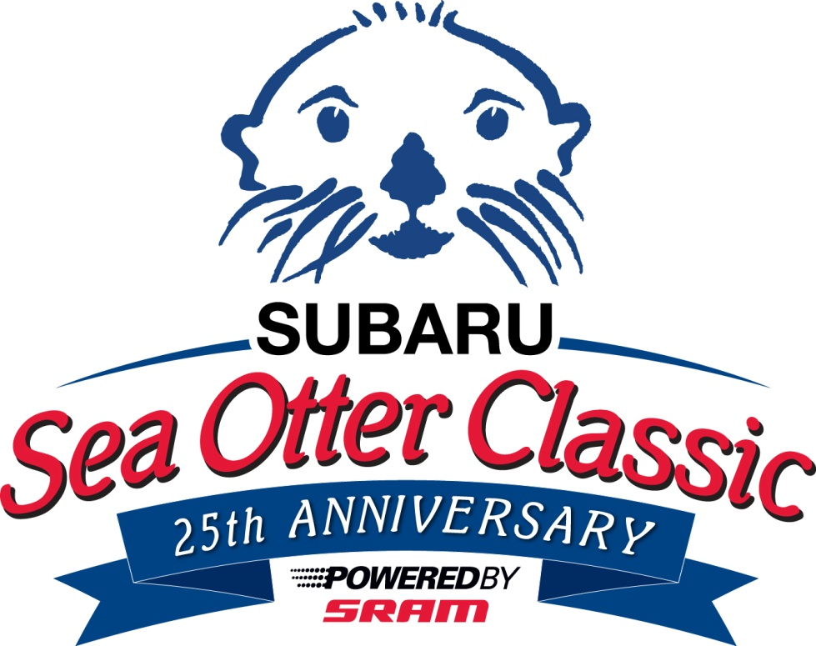
Picture 0615-01
igus will have a range of plastic solutions for the bicycle industry at the Sea Otter Classic in booth 376.
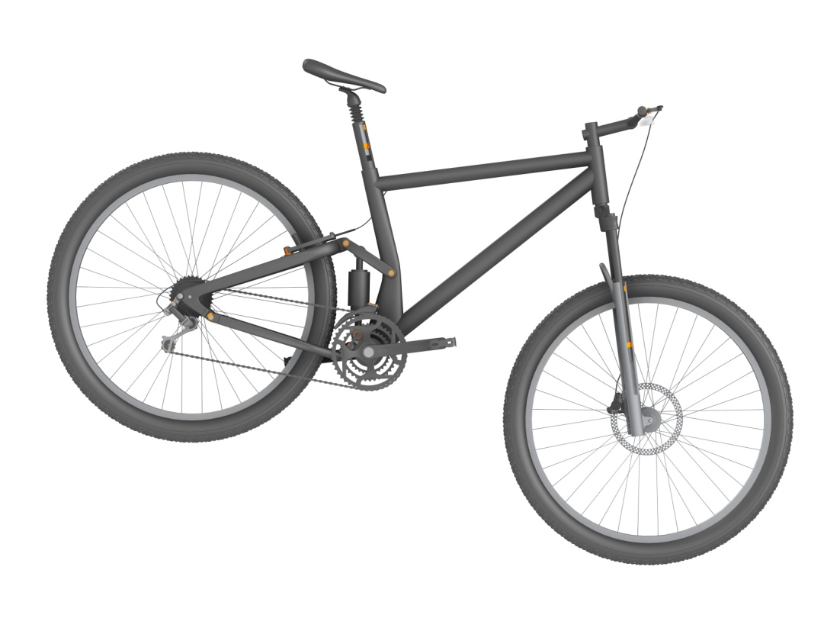
Picture 0615-02, igus Inc.
igus plastic bearings are a perfect solution for a wide range of bicycle applications, including suspensions, dropper seat posts, pedals, brakes, and derailleurs.

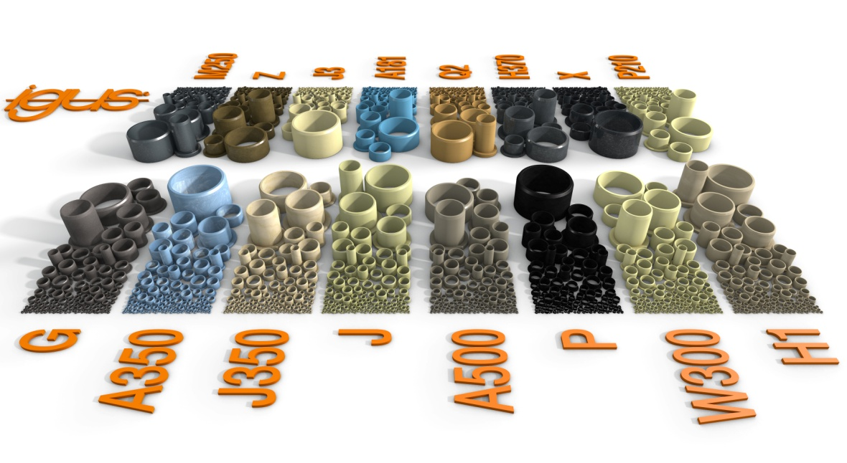
Picture 0615-02, igus Inc.
A variety of igus plastic bearing materials are available for specific application challenges, like dirt, water, and high impact loads.

CONTACT:  igus® Inc.  PO Box 14349  East Providence, RI, 02914  Tel.: 800.521.2747  Fax: 401.438.2200  sales@igus.com  www.igus.com  PRESS CONTACT:  Ellen Rathburn  Public Relations Specialist  PO Box 14349  East Providence, RI, 02914  Tel.: 800.521.2747 x. 288  erathburn@igus.com  www.igus.com | igus, Energy Chain, DryLin, Chainflex, iglide, dry-tech, and igubal are registered trademarks of igus Inc. All other company names and products are trademarks or registered trademarks of their respective companies.

