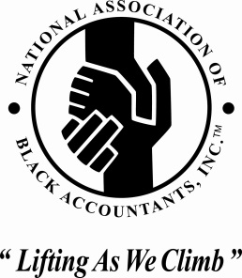

FOR IMMEDIATE RELEASE
April 14, 2015

Contact: Carla Kirkland
empowerseries@aol.com
(214) 284-2194

Comerica Bank, National Association of Black Accountants (DFW Chapter), and Dallas Public Library to join forces to promote financial literacy; improve South Dallas community.

National speaker and best-selling author, Dr. George C. Frasier, to deliver inspirational message.

DALLAS, TX/ April 13, 2015 - As thousands of residents in South Dallas struggle to rise out of poverty, making positive life choices to improve their financial future becomes increasingly important. Currently, the income per capita in South Dallas is a startling $14,705, 45.6% less than the Dallas average and 43% less than the Texas average.

National speaker, author, and CEO of FraserNet, Dr. George C. Frasier, will speak on the importance of adopting interpersonal discipline to achieve economic advancement and financial stability in the 21st Century.

WHAT: The EMPOWER Series “Rise or Die” Free Community Program

WHEN: Saturday, April 18, 2015

TIME: 10:15am

MEDIA Interviews: 10:00am

WHERE: Highland Hills Public Library (So. Dallas)
6200 Bonnie View Road, Dallas, Texas 75241

Dr. George C. Fraser is Chairman and CEO of FraserNet, Inc., a company he founded 25 years ago with the vision to lead a movement that brings together diverse human resources to increase opportunities for people of African descent. He is considered by many to be a new voice for African Americans and one of the foremost authorities on economic development, networking and building effective relationships.

Comerica Bank serves as presenting sponsor of the 2015 EMPOWER Series. “There is nothing more essential to financial well-being than knowledge that results in better money habits and financial stability for families,” says Irv Ashford, Senior Vice President of Comerica Bank. “By connecting communities to this much-needed information, we can help create a better economic future for us all.”

The event is open to the public, and there is no admission charge. Register, visit www.empowerseries.com.

About the EMPOWER Series
The EMPOWER Series approach to community engagement has paid off since kicking off 4 years ago. More than 3,500 people have attended the lectures since its inception. It attracts the intellectually curious; those who want to grow their career and make more impactful contributions, as well as individuals who are already at the top of their class and desire to go even further. All EMPOWER Series events are free of charge and open to the public. For more information and to register, visit www.empowerseries.com.

