Press Release For Immediate Release

Contacts:
Vinitaly International
International Media Dept.
+39 045 8101447
media@vinitalytour.com
www.vinitalytour.com
Twitter: @VinitalyTour
Join Vinitaly International Network on LinkedIn

Vinitaly International Academy unveils the identities of its first 26 Italian Wine Ambassadors

Who are the 26 candidates from 11 different countries who passed the final exam of the Vinitaly International Academy Certification Course and became VIA’S first Italian Wine Ambassadors? Two weeks later, when all candidates have finally flown back to their country of origin, Vinitaly International looks back on the course that has become its leading edge in the promotion of Italian around the world.

On Friday the 20th of March, after four days of intensive classroom lectures and wine tastings, 55 candidates sat for two long hours focused on the 100 multiple-choice question exam that would allow them to achieve one of the two certification levels offered by the VIA Course: Italian Wine Ambassador (IWA) and Italian Wine Expert (IWE).
“After a sleepless night, just before the exam, I lost focus when going through the exam questions and felt really out of sync with reality at that point in time” said Jennie Mack, one of the eight candidates from Hong Kong.
In the end, 26 out of the 55 candidates passed level one managing to become VIA’s first ever Italian Wine Ambassadors (IWA) whilst, because of the very high standards of the course, no one succeeded in becoming Italian Wine Expert. The 5 most deserving students were officially announced the day after during the press conference of OperaWine, the exclusive premier event to Vinitaly: Michaela Morris (Canada), Lingzi He (China), Sarah Heller (Hong Kong), Luiz Alberto (USA) and Tony Polzer (USA) were the first to make a toast to their successful exam results. “It was a challenging exam but the exceptionally high standards speaks to the credibility of the certification. I am absolutely thrilled with my results and look forward to working towards becoming a Certified Expert” said Ms Morris.

Out of the 17 different countries represented during the Certification Course, 11 can now boast one or more Italian Wine Ambassadors. In alphabetical order, with the number of respective IWAs in brackets, we have: Brazil (1), Canada (3), China (5), Germany (2), Greece (1), Hong Kong (3), Korea (3), Russia (2), Singapore (1), United Kingdom (1), United States (4).

From a geographical point of view, the two combos USA - Canada and China - Hong Kong counted the largest number of successful candidates, a fact that seems to reflect the growing interest in Italian wine shown by these two very different markets: Gurvinder Bhatia, Richard Sagala, Geralyn Brostrom and Giuseppe Rosati will be supporting VIA in the wine-savvy Canadian and US markets.
On the other side of the globe Hong Kong based winemaker and wine writer Tersina Shieh speaks about here own experience during the Course:
“It was certainly challenging. I'm lucky and happy that I passed although I'm not pleased with the result. I need to work harder to completely understand and master the subject”.
“The exam covered more areas than I could have ever imagined and the program was very insightful and well taught” added Oliver Zhou, editor for Vinehoo, one of the leading wine media sites in China. ”It has shown me that the wine study truly has no bounds and every wine region in Italy deserves careful observation.”. Mr Zhou and Mrs Shieh are one the 11 candidates to have become Italian Wine Ambassadors in the Far East where education on Italian wine today is greatly needed in order to increase Italy’s market share. Many local operators and consumers know little about wine, let alone understand the great complexity of Italy’s 330 DOCs, 73 DOCGs and over 541 native grape varietals.
A number of the new Asian IWAs are already either wine educators in their home country like Martin Hao and JC Viens, or top notch sommeliers like Yang Lu, corporate wine director for “Shangri-La Hotels and Resorts” and Ying Guo, Chief Sommelier for “Four Season Hotel Pudong”.
Claire Nam, Dongmyung Hong and Insoon Lee from Korea and the Singaporean Wai Xin Chan will also be facilitating the promotion of Italian wine riding the wave of the great interest shown by these countries towards all that is related to the Italian lifestyle.

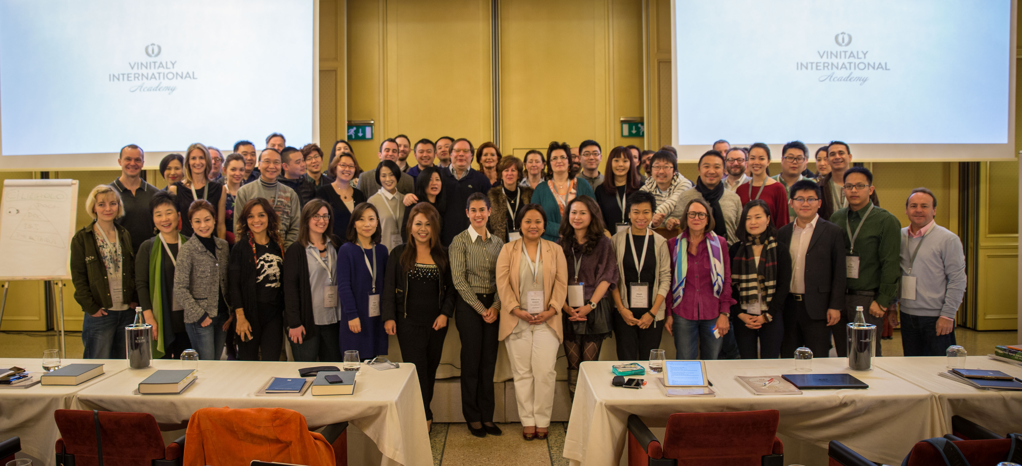

Between the American and Asian continents, which alone count for three-quarters of the total number of candidates, the rest of the Italian Wine Ambassadors mainly come from Europe:
“There were a lot of questions whose answers could not be given only with this course but you had to rely on other information you should have learnt earlier” observes Sara Da Val Franco, Manager of UK wine store Vinothek Vinario e.Kfm. ”Italian wine is so complex, you cannot expect to learn everything in a four-day course, even if the teacher is Ian D'Agata and even the event is organized by Stevie Kim”. Stefan Metzner, a Master of Wine student and wine professional from Germany also expressed his approval for the high standard of the course: “The exam needs to be at this high level and must not be lowered for the title to mean something in the industry”;
In this difficult moment for Russia the certification of two top Russian wine educators, Nikolay Chashchinov and Veronika Denisova is most definitely good news and gives reason for hope in a country where wine communication has been made very difficult in the past few years by local regulations.
Last but not the least, England, Greece and Brazil with one Ambassador each, respectively, wine professional Maria Gerari Emily O’Hare Head Sommelier of “The River Café, London and Alexandra Corvo, Director of Ciclo das Vinhas, only reperesentative for South America.

What about those who did not pass? “It's no big deal” says Ian D’Agata, Scientific Director of Vinitaly International Academy. “Should they still be interested they can resit the exam, just like they would if they retried the WSET or MW exams. The fact they were selected this time round means they are more than qualified to be a part of VIA and we would be happy to have them with us in the future!”

About:

Veronafiere is the leading organizer of trade shows in Italy including Vinitaly (www.vinitaly.com), the largest wine and spirits fair in the world. During its 49th edition Vinitaly counted some 4.000 exhibitors on a 100.000 square meter area and 150.000 visitors including 2.600 journalists from 46 different countries. The next edition of the fair will take place on 10 - 13 April 2016. The premier event to Vinitaly, OperaWine (www.vinitalyinternational.com) “Finest Italian Wines: 100 Great Producers,” will unite international wine professionals on April 9th in the heart of Verona, offering them the unique opportunity to discover and taste the wines of the 100 Best Italian Producers, as selected by Wine Spectator. Since 1998 Vinitaly International travels to several countries such as Russia, China, USA and Hong Kong thanks to its strategic arm abroad, Vinitaly International. In February 2014 Vinitaly International launched an educational project, the Vinitaly International Academy (VIA) with the aim of divulging and broadcasting the excellence and diversity of Italian wine around the globe. VIA has now also organized its very first Certification Course with the aim of creating new Ambassadors of Italian Wine in the World.

###

