**Press Release For Immediate Release**

**Contacts:**

Vinitaly International

International Media Dept.

+39 045 8101447

[media@vinitalytour.com](mailto:media@vinitalytour.com)

[www.vinitalytour.com](http://www.vinitalytour.com)

Twitter: @VinitalyTour

Join Vinitaly International Network on LinkedIn

**Sisterly bond unites Italy and USA in fight against cancer**

On the 30th of April 2015 the American Cancer Society and Vinitaly International will join forces once again on the occasion of the tenth edition of Taste of Hope thus renewing an alliance, consolidated back in 2010, between two sisters, Kris Kim, Chief Operating Officer of the American Cancer Society, the largest health organization in the US dedicated to the fight against cancer, and Stevie Kim, Managing Director of Vinitaly International, the Ambassador of Italian wine in the world.

The collaboration first began on the 25th of October 2010 on the occasion of the Vinitaly Day organized during Eataly, the Italian culinary complex in Manhattan. The American Cancer Society was selected as the charity of choice for the tasting organized by Vinitaly the same evening. Only a few months later, in January 2011, Vinitaly returned to New York taking part in the bell-ringing closing session of the NASDAQ Stock Market with executives from the American Cancer Society and two of the leading Italian women in wine: Marilisa Allegrin i from Allegrini Wines and Cristina Mariani-May, CEO of Banfi Vintners. The event, that served to bring Italian wine to the attention of the American public, was followed by a fundraising wine tasting and the proceeds were donated to the American Cancer Society.

Since then, Italian wine producers, led by Vinitaly International, have been offering their yearly support to Taste of Hope, one of New York’s top fundraising events organized by the American Cancer Society with the precious contribution of the city’s most famous restaurants. During the event, eager donors and philanthropists are able to savour culinary specialties of top-end chefs and taste delectable fine Italian wines provided by some of Italy’s top wine producers under the unifying umbrella of Vinitaly International.

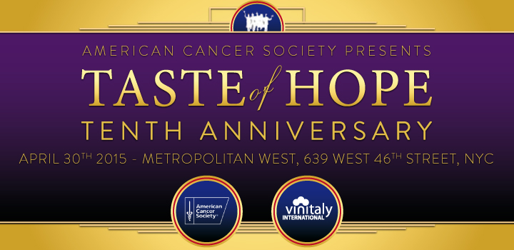

This year’s edition will also see the renewed support of the Consortium Italia del Vino (Banfi, Santa Margherita, Cantina Lunae, Cantine Ferrari, Casa Vinicola Sartori, Casa Vinicola Zonin, Gruppo Italiano Vini, Librandi, Marchesi di Barolo, Medici Ermete & Figli and Terredora), a union of twelve of the most important wine producing companies in Italy that has recently seen the election of its new president: the new lead will be Andrea Sartori, president of Casa Vinicola Sartori, a historic family of wine producers in the Valpolicella area near the city of Verona.

The Consorzio was founded back in 2009 with the aim to reinforce the identity of Italian wine in international markets by transforming competition into an alliance and overcoming the strong individualism that traditionally characterizes Italian wineries.

“Taste of Hope, which each year involves over 800 guests from New York, is an important showcase for the wineries of Italia del Vino – Consorzio and, more importantly, represents an excellent opportunity to be involved in a charity event helping such an important cause” said President Sartori. The group covers all wine producing areas of the peninsula and accounts for nearly 8,5% of the total of Italian wine export.

During the course of the evening, Vinitaly International will also be showcasing the labels of other four fine Italian wineries from the country’s top wine producing regions, Tedeschi, Allegrini, Zenato and Mezzacorona, thus contributing to the evening with a total of 700 + bottles.

This year the event, hosted in the new location of the Metropolitan West in New York, will include important guests such as the famous *Top Chef* alum and leading NYC restaurateur Dale Talde.

Ticket prices:

VIP tickets with early entry at 6:30pm are $250 and tickets for general admission at 7:30 pm are $175. For more information about the event and to purchase tickets, visit: [http://www.tasteofhopenyc.org and](http://www.tasteofhopenyc.org/) vinitalyinternational.com, follow Vinitaly International on Twitter (@VinitalyTour) or Facebook (Vinitaly International) and Taste of Hope for the American Cancer Society on Twitter (@ACSTasteofHope).

**About:**

Veronafiere is the leading organizer of trade shows in Italy including Vinitaly (www.vinitaly.com), the largest wine and spirits fair in the world. During its 49th edition Vinitaly counted some 4.000 exhibitors on a 100.000 square meter area and 150.000 visitors including 2.600 journalists from 46 different countries. The next edition of the fair will take place on 10 - 13 April 2016. The premier event to Vinitaly, OperaWine (www.vinitalyinternational.com) “Finest Italian Wines: 100 Great Producers,” will unite international wine professionals on April 9th in the heart of Verona, offering them the unique opportunity to discover and taste the wines of the 100 Best Italian Producers, as selected by Wine Spectator. Since 1998 Vinitaly International travels to several countries such as Russia, China, USA and Hong Kong thanks to its strategic arm abroad, Vinitaly International. In February 2014 Vinitaly International launched an educational project, the Vinitaly International Academy (VIA) with the aim of divulging and broadcasting the excellence and diversity of Italian wine around the globe. VIA has now also organized its very first Certification Course with the aim of creating new Ambassadors of Italian Wine in the World.

**Taste of Hope** was founded in 2005 by the American Cancer Society. They created this fundraiser as a way to celebrate New York dining while raising funds to help underwrite the Society’s mission to fight for every birthday threatened by every cancer in every community. Between the early 1990’s and 2013 the Society has seen a 20 percent decrease in the overall cancer death rate, which means they have helped to avoid about 1.2million cancer deaths and created the potential for more birthday celebrations.

###