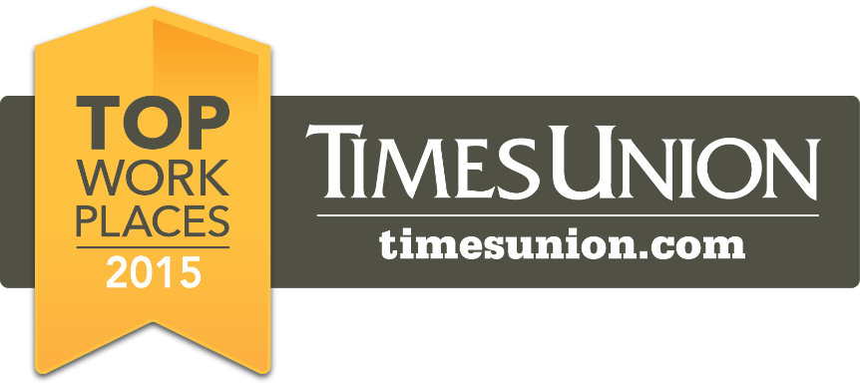
Martin, Harding & Mazzotti, LLP® selected as one of the Top Workplaces in the Capital District for 2015
Contact: Clark K. Supley at clark.supley@1800LAW1010.com
Albany, Schenectady, Troy, Saratoga Springs, Amsterdam, Utica and Plattsburgh, NY, Springfield, MA and Burlington, VT.
April 21, 2015 – Martin, Harding & Mazzotti, LLP® is pleased to announce that the law firm has been selected as one of the Top Workplaces in the Capital District for 2015.
The Top Workplaces are determined based solely on employee feedback. The employee survey is conducted by WorkplaceDynamics, LLP, a leading research firm on organizational health and employee engagement. WorkplaceDynamics conducts regional Top Workplaces programs with 40 major publishing partners across the United States. Over the past year, more than 5,000 organizations and 1 in every 88 employers in the U.S. have turned to WorkplaceDynamics to better understand what’s on the minds of their employees. Through its workplace improvement offerings, WorkplaceDynamics provides solutions, training and tools to help clients improve their workplace. In the Capital District some 700 organizations were invited to participate with over 15,000 employees.
What makes a great place to work? According to the staff at Martin, Harding & Mazzotti, LLP, it's the overall day-to-day atmosphere, a great culture, and a top-down, bottom-up commitment to the company’s mission. Paul Harding, Managing Partner at Martin, Harding & Mazzotti, LLP, credits the people who work there and the clients they serve for the firm’s positive workplace. "Receiving this award means a great deal to all of us at Martin, Harding & Mazzotti, LLP because it emanates from the very people who define our culture and satisfy the mission of the firm,” says Harding.
The commitment to being a great place to work shows in all aspects of the firm’s culture. Martin, Harding & Mazzotti, LLP offers a state of the art digital workplace, with all systems networked to enable a paper-free environment. No paper files has made everyone’s job at the firm easier, and they feel much more efficient and productive.

[More]
-2-

“We value employees who want to come to work and have time and energy to help those in need,” according to Harding. Examples of this cohesive family-like atmosphere are evident in the law firm where partners and staff work - and play - together. For example, staff members play on the firm’s softball team, they come together for the annual Firefighter’s Run 4 Your Life 5K, and help out to fit free bicycle helmets, provided by the firm, to various law enforcement groups.
The atmosphere of giving back to the community extends to various non-profit organizations the firm supports, some of which have personal ties to its employees; including The Legal Project and JDRF. There is a firm-wide commitment to helping the community including the Free 5 Hour Class for students who want to get their driver’s license and the decade old plus program that has been providing Free Cab Rides Home on major celebratory holidays, ranging from Memorial Day to New Year's Eve.
Numerous employee perks help, too! From Staff Appreciation day which includes a catered luncheon and complimentary massages, a day at the Saratoga Race Course, or a Broadway show at Proctor’s Theater; these are the things that make Martin, Harding and Mazzotti, LLP a great place to work.
The Albany Times Union published the complete list of Top Workplaces on Sunday, April 26, 2015. For more information about the Top Workplaces lists and WorkplaceDynamics, please visit www.topworkplaces.com and www.workplacedynamics.com.

About Martin, Harding & Mazzotti, LLP®
Martin, Harding & Mazzotti, LLP® is a law firm whose practice is limited to protecting the rights of those wrongfully injured as a result of negligence. If you or someone you know has been injured, call us toll free at 1.800.LAW.1010 (1-800-529-1010). Based in Albany, NY, the law firm has a storied history of actively engaging their community, including The Legal Project, an organization in which Paul Harding has taken an active role. The Legal Project is a private, non-profit organization, which provides a variety of free and low cost legal services to the working poor, victims of domestic violence and other underserved individuals in the Capital Region.
Martin, Harding & Mazzotti, LLP® Mission Statement
Our mission is to make every client feel a part of our law firm family. We are honored to be their lawyers and we want to understand their needs and work hard to exceed their expectations. For our employees, we strive for a working environment based on respect and communication, encouraging teamwork and loyalty. For the community in which we live, we will continue our tradition of supporting those organizations that matter most to us.
###

