**AVT and Global Vision Collaborate to Offer**

**Cutting-edge Offline Inspection Solutions**

**for Printing Industry**

*Hod-Hasharon, Israel, Montreal, Canada –* [**AVT**](http://www.avt-inc.com/), the world leader in print inspection, print process control, and quality assurance, is joining forces with leading proofing solutions provider [**Global Vision**](http://globalvisioninc.com/) to offer advanced offline inspection solutions to the worldwide printing market.

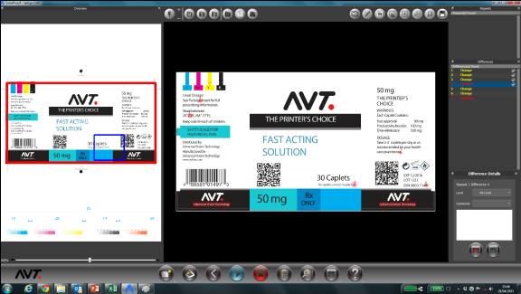Under the agreement, Global Vision will provide AVT with a new software engine for its offline inspection solutions, which are customized to suit the specific needs of the printing industry and its varying production workflow setups and printing applications. The partnership also enables AVT to serve as Global Vision’s print market sales arm, and paves the way for these two key players to jointly develop unique inspection solutions for specific sectors, including the labeling and packaging marketplaces. The companies also will co-develop print quality assurance solutions that connect inline and offline inspection systems while providing timely, comprehensive reporting.

Among AVT’s latest offline solutions is [**SolidProof**](http://www.avt-inc.com/?catid=%7BB3DBD0EA-34FA-4686-AA1C-EA91E23CF420%7D)**,** which provides 100% assurance for wide web, narrow web and sheet-fed applications, ensuring that no critical errors have been overlooked during print production. SolidProof automatically eliminates conversion errors and undetected defects during the pre-press stage, drastically reducing the need for manual inspection and bringing waste levels to near-zero.

Other features include intelligent cropping and automatic alignment utilities, comprehensive reporting and multi-lingual inspection capabilities, as well as options for barcode and Braille verification and a 21 CFR Part 11compliance module for the pharmaceutical sector.

The partnership is seen as a win-win: it benefits both companies and their respective customers by allowing AVT and Global Vision to expand their customer bases and realize the benefit of their combined strengths.

“Our partners at Global Vision offer unsurpassed offline verification and inspection solutions for the markets they serve,” said Jaron Lotan, CEO, AVT. “As a result of our newfound synergy, AVT can now provide its customers all-inclusive tools regardless of printing technology and application.”

“In AVT, Global Vision now has an influential, reputable arm in the print market, while we help bolster AVT’s presence in other capacities,” said Reuben Malz, CEO, Global Vision. “The collaboration is an ideal match that will, most importantly, improve the overall print inspection solutions space through increased access and innovation.”

# # #

**About AVT**

AVT is the global leader in print process control, quality assurance, and press control for the packaging, labels, and commercial print industries. Backed by state-of-the-art technology and field-proven solutions, more than 7,000 AVT systems are installed at customer sites worldwide.

AVT is headquartered in Hod-Hasharon, Israel with sales, marketing, and support offices in the United States, Europe and China. For more information, visit [www.avt-inc.com](http://www.avt-inc.com).

**About Global Vision**

Global Vision is the world leader in the design and delivery of innovative proofreading technologies. The company’s solutions are widely interoperable and have been integrated into the packaging workflows of leading consumer packaged goods companies, printing firms and over 72% of the major pharmaceutical industry worldwide.

Global Vision’s complete suite of advanced solutions, featuring text-based, pixel-based and Braille inspection technologies, are designed to eliminate printed artwork and copy related errors, providing end-to-end security at every stage of the packaging workflow. All of the company’s proofreading solutions meet FDA 21 CFR Part 11 / EMA Annex 11 requirements. For more information, visit [www.globalvisioninc.com](http://www.globalvisioninc.com).

Media Contacts,

Christopher Dale

Turchette Agency

(973) 227-8080 ext. 16

[cdale@turchette.com](mailto:cdale@turchette.com)

Mike Spooner

Marketing Communications Manager

Global Vision

T: + 1 514.624.4422 Ext. 63

mspooner@globalvisioninc.com