Press Release For Immediate Release

Contacts:
Vinitaly International
International Media Dept.
+39 045 8101447
media@vinitalytour.com
www.vinitalytour.com
Twitter: @VinitalyTour
Join Vinitaly International Network on LinkedIn

#HireMeVinitaly, a new speed dating tool for Italian wine producers and potential employees

On the morning of Wednesday the 25th of March during the last day of Vinitaly, the largest international wine and spirits fair in the world, 74 young professionals met 26 Italian wine producers during 10 minute speed dating sessions as part of the new innovative project launched for the occasion by Vinitaly International in collaboration with Wine Meridian, an Italian online magazine specialized in the development of wine companies in the international markets.
Italy remains today one of the top wine producing countries in the world regularly contending the position each year with France, followed at a safe distance, by Spain. A change in Italian’s attitude towards wine together with the increasing popularity of other more casual alcoholic drinks and the recent economic crises have produced a strong downfall in local wine consumption that has left producers seeking for new opportunities abroad. According to a research led by Agrifrance, a subsidiary of Bpn Paribas, exports worldwide have doubled over the past 20 years with Europe maintaining its position as the global leader, exporting 58% of its annual production (Source: Bpn Paribas, 20 April 2015, http://tinyurl.com/phqlo8l). Amongst the top exporting countries, Italy has been the only one to see its trade with foreign market grow in 2014 over 2013 both in volume (+0,8%) and in value (+1,4%).
In the face of this new upturn, the Italian wine sector is now calling for an increase in the number of professional roles, such as export managers, brand ambassadors and experts in international marketing, capable of supporting Italian wine producing companies who wish to join the outbound wave or reinforce their position in upcoming international markets.

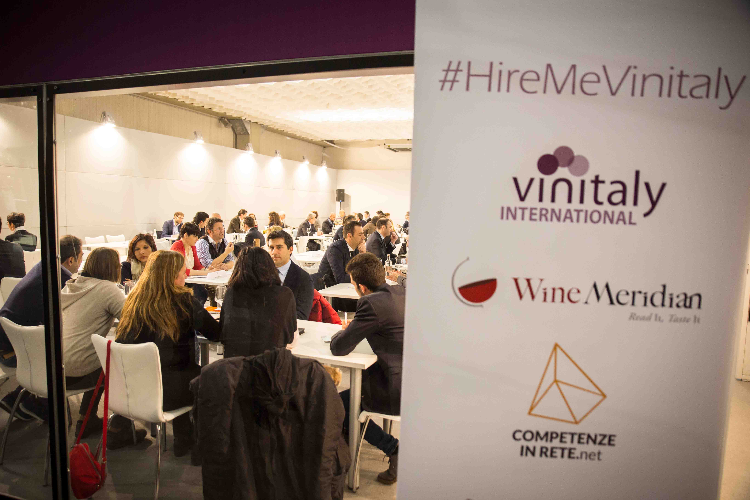

“I receive calls every day from young professionals seeking for a job, but also from wineries asking if I know anyone who could represent a valid support in their internationalization process.” said Stevie Kim, managing director of Vinitaly International, when asked about the new project, #HireMeVinitaly. “I felt the need to create this sort of dating service in order to help both parties. In reality it is no different from a real marriage: you need to get to know each other first and spend some time together”.
The young professionals and wine producers who took part in the beta testing of this new innovative project were given 10 minutes, 5 minutes for the candidate to introduce himself and 5 for the winery to explain its needs and expectations.
The outcome was more than satisfactory: many of the 26 wine producers who took part in the initiative expressed surprise at the great enthusiasm and good will shown by all the candidates and offered a positive feedback with regards to the speed date formula that was adopted:
“It allows you to understand the level of empathy that can arise between the two speakers. In my case it worked very well” said Giuseppe Di Gioia, the export sales director of Zonin 1821 winery.
“I met five or six candidates with very different profiles”, added Francesco Giostra Reitano of the Sicilian winery Azienda Vinicola Giostra Reitano. “Some were high profiled professionals, others students seeking for their first job. But what they had mostly in common was the enthusiasm and the passion they showed. I think that 5 minutes are more than enough in order to understand if the person in front of you has a real project in mind”.
Some of the candidates admitted they had been a little weary about the length of time at their disposal: “I had my doubts but in the end I found the formula to be very effective” said one of the first candidates to be interviewed after her “speed date” with two major Italian wineries.
“We are very satisfied of the format of the speed dating despite some concerns about the logistical aspects of the event” said Lavinia Furlani Editorial Director at Wine Meridian and in charge of the project. ”#HireMeVinitaly was certainly a success: we received at least one thousand curricula just after a month from the launch of the project and one hundred wineries wrote to us for further information. Our idea is to continue this collaboration with Vinitaly International and organize other similar initiatives with the aim of supporting Italian wine makers in their quest for collaborators that can help them in their activity abroad”.

About:

Veronafiere is the leading organizer of trade shows in Italy including Vinitaly (www.vinitaly.com), the largest wine and spirits fair in the world. During its 49th edition Vinitaly counted some 4.000 exhibitors on a 100.000 square meter area and 150.000 visitors including 2.600 journalists from 46 different countries. The next edition of the fair will take place on 10 - 13 April 2016. The premier event to Vinitaly, OperaWine (www.vinitalyinternational.com) “Finest Italian Wines: 100 Great Producers,” will unite international wine professionals on April 9th in the heart of Verona, offering them the unique opportunity to discover and taste the wines of the 100 Best Italian Producers, as selected by Wine Spectator. Since 1998 Vinitaly International travels to several countries such as Russia, China, USA and Hong Kong thanks to its strategic arm abroad, Vinitaly International. In February 2014 Vinitaly International launched an educational project, the Vinitaly International Academy (VIA) with the aim of divulging and broadcasting the excellence and diversity of Italian wine around the globe. VIA has now also organized its very first Certification Course with the aim of creating new Ambassadors of Italian Wine in the World.

Wine Meridian is an online magazine, whose aim is to give a voice to the Italian wine industry and make it spread worldwide.
Editorial staff and contributors from around the world narrate everyday the diverse and unique stories of Italy’s wine industry to all influencers, world-renowned players, and to the increasing number of wine enthusiasts from around the world.
For this reason Wine Meridian is divided into two main sections: the first one, in Italian, designed for all wineries and professionals of the wine industry who aim to gain expertise and export skills to grow global; the second one, in English which provides news and tells stories about Italian winemakers, wine growing regions and anything related to Made in Italy products and lifestyle, aimed at promoting our excellence abroad.
Wine Meridian staff has selected the wine industry’s top experts, the key players in the promotion of Italian wines abroad, and the most experienced journalists, to tell you about wine consumer culture around the world.
Wine Meridan also collaborates with top influencers and world exhibitions such as Wine Monitor (Italian Nomisma’s wine market intelligence tool), Vinitaly International, IWSC, Hong Kong IWSC, Vancouver International Wine Festival…
In March 2015 Wine Meridian launched “Italian Wines in the World”, the first guide signed by WM, an Italian wines story-telling for the international audience.

###

