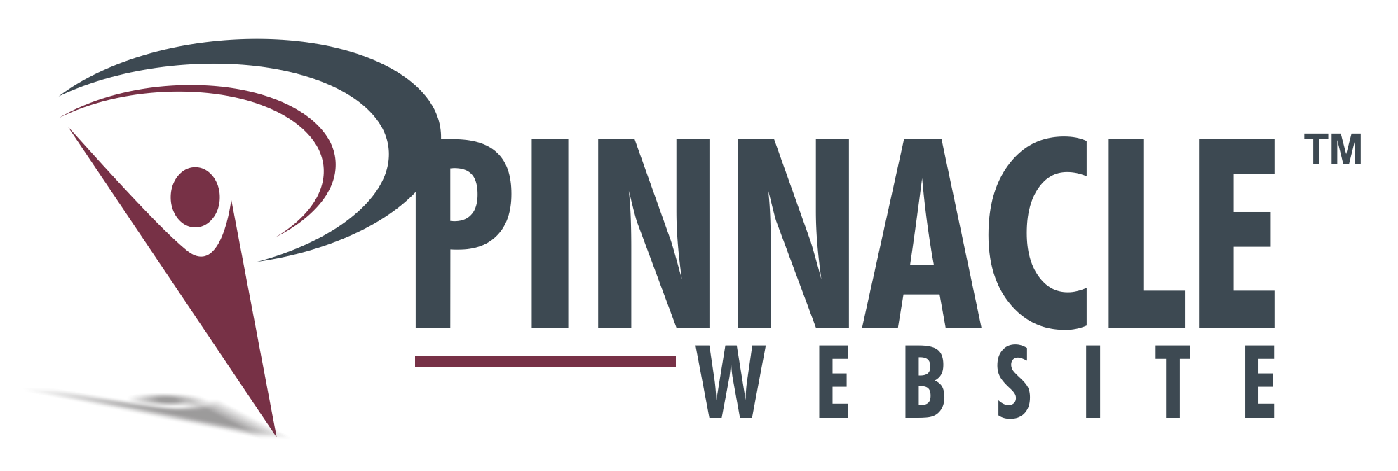

PinnacleWebsite.com
Press Release

Launching PinnacleWebsite.com: Personal Domains for Professional Growth

How do professionals maximize their careers? PinnacleWebsite.com CEO Paul Schlanger says claim a domain—and manage it like a business.

BOCA RATON, FLORIDA (May 2015)—Imagine a platform that displays multiple versions of a professional’s resume and highlights from their life’s work—each version shareable with recruiters, employers, and other professional contacts. Imagine if this platform were easy and robust—and pointed to a domain bearing just that person’s name. PinnacleWebsite.com, launching May 2015, is the job-seeking tool of the 21st century, designed for jobseekers and professionals with jobs, but with an eye toward the next career-expanding step.

In our times, the average professional holds 15-20 jobs in his or her lifetime, changing occupations every 4.4 years. A Pinnacle Website plays into this reality more dynamically than a resume, and more powerfully than a Linkedin profile. Users customize their skills and experiences for different industries or career tracks, adding multimedia clips (images, videos, documents, etc.) that showcase their accomplishments, rather than simply describing them.

An enabler of the personal online brand, users can link a Pinnacle Website to their social media accounts, Linkedin profiles, email signatures, and more.

SEO safeguards ensure a Pinnacle Website always shows up on the first page of a Google search result, protecting the jobseeker’s online reputation.

“A Pinnacle Website is for the jobseeker and successful professional that has a job, does well, but is in the growth phase of his or her career,” says CEO and founder Paul Schlanger. “Either this person’s current success is impeding a promotion, or he or she feels ready to tackle a new challenge,” he adds. A vivid interface to showcase strengths and experience, a Pinnacle Website connects this audience with their next vocation. It’s an easy tool that jobseekers can continue to develop and maintain with commitment—like they would a business.

Acknowledging personal branding as a fact of today’s career marketplace, PinnacleWebsite.com creates online personalities on individualized sites. Careerists claim “theirname.com” to market their careers like brands and manage them like businesses. Selective viewing, effective presentation, and social media engagement all make a Pinnacle Website a personalized engine of professional optimization.

###

A Pinnacle Website is a personal domain designed for professionals looking to move forward in their careers. It allows professionals to brand their online personas and manage them like businesses.

