FOR IMMEDIATE RELEASE For more information, contact:
May 5, 2015 John Maginnis, (225) 295-2405
Corporate.Communications@bcbsla.com
Robin Mayhall, APR, (225) 298-1992
Natalie Straight, (225) 298-7413

Blue Cross and Blue Shield of Louisiana Releases
Enhanced ‘BCBSLA’ iPhone and iPad App
Updated health plan app allows Blue Cross customers to find doctors, contact customer service
and view costs and balances on their Apple devices

As of today, Blue Cross and Blue Shield of Louisiana customers have streamlined access to their healthcare coverage information thanks to the latest release of the free “BCBSLA” app. The updated app is part of a digital strategy that makes it simpler for customers to interact with their health plan and helps them better understand plan benefits and terminology.

The app has a modern design with visual cues that alert users to helpful tips and definitions of terms in context at relevant moments. The app also builds a better experience using the concept of “micro-moments.”

“This app is an exciting step in our digital transformation because it’s our first time experimenting with micro-moments,” said Natalie Straight, manager of Blue Cross’ Digital Experience team. “The app goes beyond traditional experiences with simple, yet thoughtful touches, like taking a steamboat ride down the Mississippi while information loads. Or a friendly nurse avatar appears at key moments to provide definitions of healthcare terminology, making it easier to understand.”

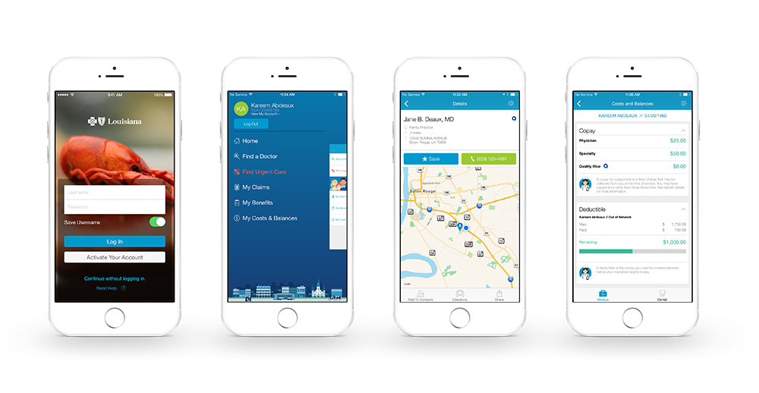
“The app is authentically Louisiana, delightfully human and groundbreaking in simplicity,” said David Le, senior user experience designer. “This is a flagship example of Blue Cross’ new approach to digital tools.”

Core features of the app include:
- Find a Doctor or Urgent Care: Customers can use the app to get a map and directions to a nearby doctor’s office or facility that is in their network, easing their access to care.
- View Benefits and Claims: Customers can see important information about their healthcare coverage benefits, including the status of their claims, deductibles, copayment amounts, coinsurance and balances.
- Save Doctors and Claims: Customers can save doctor or claims details to a favorites list for easy access upon return visits. Customers can also save doctor information, including name, phone number and address, to their contacts list.
- Contact Us: Customers can click to call Blue Cross customer service or submit questions securely with claims data attached, allowing for a streamlined response. Customers can also find phone numbers, maps and directions to any of our eight local offices.

To download the BCBSLA app, users should search for “BCBSLA” in the Apple App Store or visit bcbsla.com/mobile from an Apple device. The company also offers an Android app, available for download in the Google Play store.

About Blue Cross and Blue Shield of Louisiana
Founded in New Orleans in 1934, Blue Cross and Blue Shield of Louisiana is a private, fully taxed nonprofit company, mutually owned by policyholders—not shareholders. It is an independent licensee of the Blue Cross and Blue Shield Association and is governed by a Louisiana Board of Directors.

The company and its subsidiaries provide group and individual health insurance plans, life and disability insurance, group voluntary products and administrative services to Louisiana residents. With headquarters in Baton Rouge and eight district offices around the state, Blue Cross and Blue Shield of Louisiana is committed to improving the lives of its customers by providing them with health guidance and affordable access to quality care.

Learn more on the company’s website at www.bcbsla.com or visit its social media hub to connect via Facebook, Twitter and more.

# # #

