
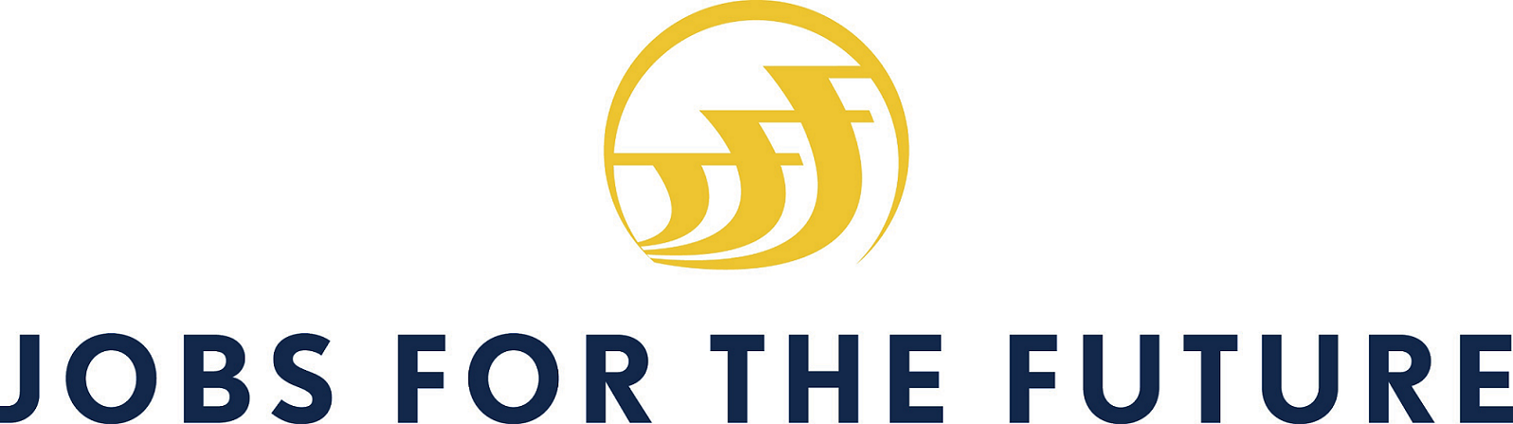
1201 New York Ave, NW,
Washington, DC 20525
www.nationalservice.gov/SIF

One Dupont Circle, NW Suite 700, Washington, DC 20036
Tel. 202-736-5800 • Fax 202-467-0790
www.aspeninstitute.org

88 Broad Street, 8th Floor, Boston, MA 02110
Tel. 617-728-4446 • Fax 617-728-4857
www.jff.org

For Immediate Release
Aspen Contact: Monique Miles Aspen Forum for Community Solutions, Deputy Director 202-736-2296 monique.miles@aspeninstitute.org
JFF Contact: Binoli Dua Anthology Communications,
Senior Account Executive
202-630-4043 bdua@anthologycomms.com
SIF Contact: Sam Warfield Corporation for National
and Community Service,
Press Secretary
(202) 606-6775
sjwarfield@cns.gov

Jobs for the Future and Aspen Institute Award $6 Million in Grants to Successful Youth Programs
Seven Innovative Programs Making an Impact with Opportunity Youth to Receive Federal Funding through the Social Innovation Fund
New Orleans, Louisiana, May 8, 2015 – Today, in response to President Obama’s call to action in launching My Brother’s Keeper (MBK) to promote successful outcomes for boys and men of color, Jobs for the Future (JFF), a grantee of the Social Innovation Fund, and the Aspen Institute Forum for Community Solutions (AFCS) awarded $6 million to innovative organizations that dramatically improve education and employment outcomes for opportunity youth in communities across the country. Opportunity Youth is a term used to describe the 6.7 million young people – between the ages of 16 to 24 in the United States - who are neither enrolled in school nor participating in the labor market.
Seven community grantees will receive three-year grants of $240,000 - $270,000 per year to further develop ladders to success for opportunity youth. Grant award recipients were selected after a rigorous and collaborative evaluation by JFF and AFCS. The grantees, representing a diverse portfolio of communities, are taking a cross-system, cross-sector approach towards improving outcomes for young people, with a particular focus on boys and men of color.

“We have millions of unprepared or underprepared young people in our country, and we’re at a critical point,” said JFF CEO Gina Burkhardt. “We need more young men and women who are college-ready, who can advance into successful, lasting careers. The grantee partners we have selected today are now even better equipped to develop pathways for opportunity youth—especially for boys and young men of color.”
In 2014, JFF in partnership with AFCS received a federal grant from the Social Innovation Fund (SIF), a program of the Corporation for National and Community Service (CNCS), to grow the impact of innovative, community-based solutions that have compelling evidence of improving the lives of people in low-income communities throughout the United States.

“By embracing innovation and expanding what works, Jobs for the Future and its partner, the Aspen Institute, are seeding new ideas to address education and employment outcomes for opportunity youth,” said Lois Nembhard, Acting Director of the Social Innovation Fund. “Together, the seven organizations awarded today bring a diverse geographic scope and set of experiences needed to address those specific challenges in order to increase their impact and advance what works.
Today’s announcement was made by Melody C. Barnes, chair of the Aspen Forum for Community Solutions and former director of the White House Domestic Policy Council, Adria Steinberg, vice-president of Jobs for the Future, and Stephen Patrick, executive director of the Aspen Forum for Community Solutions. They were joined at the announcement by a wide array of committed partners and stakeholders, including New Orleans Mayor Mitch Landrieu; Walter Isaacson, President and CEO of the Aspen Institute; Michael Smith, Special Assistant to the President and Senior Director of Cabinet Affairs for My Brother's Keeper; as well as funders, community leaders, and strategic partners.

“We’re not just awarding dollars today; we’re contributing hard-earned wisdom and knowledge resources to organizations that are making a difference in the lives of young people,” said Melody Barnes. “These local organizations understand that system-wide solutions are needed: they employ a collaborative approach that cuts across traditional barriers between private and public sectors.”

“The President has made investing in evidence-based interventions or “what works” a key priority of his Administration and the My Brother’s Keeper initiative. We applaud Jobs for the Future and the Aspen Institute on its selection of Social Innovation Fund sub-grantees that have a track record of measurable impact, and a plan to get results and create clear pathways to college and career for young people in greatest need,” said Michael Smith, Special Assistant to the President and Senior Director of Cabinet Affairs for My Brother's Keeper.

It is estimated that the 6.7 million opportunity youth cost our country $250 billion annually in lost revenue, earnings, and increased social services. JFF and AFCS have selected seven communities to partner with in an effort to build education and career pathways for these unemployed or underemployed young people. The grantees include:

Boston, MA | Boston Private Industry Council & Boston Opportunity Agenda | Boston Opportunity Youth Collaborative

Hartford, CT | Capital Workforce Partners | Hartford Opportunity Youth Collaborative

New Orleans, LA | Cowen Institute for Public Education Initiatives, Tulane University | Employment and Mobility Pathways Linked for Opportunity Youth (EMPLOY)

Philadelphia, PA | Philadelphia Youth Network | Project U-Turn

San Francisco, CA | Bay Area Community Resources (BACR) | Roadmap to Peace

Santa Clara County, CA | Kids in Common, Planned Parenthood Mar Monte | Santa Clara County Opportunity Youth Partnership

South King County, WA | United Way of King County & Community Center for Education Results | The Road Map Project

###

Jobs for the Future is a national nonprofit organization that works to ensure economic opportunity for all. We develop innovative career pathways and public policies, resulting in increased college readiness and success for students and a more skilled workforce for employers. For over 30 years, JFF has been a leader in building connections between education and work that expand opportunity and strengthen our economy. For more information, visit: www.jff.org

The Aspen Institute is an educational and policy studies organization based in Washington, DC. Its mission is to foster leadership based on enduring values and to provide a nonpartisan venue for dealing with critical issues. The Institute is based in Washington, DC; Aspen, Colorado; and on the Wye River on Maryland's Eastern Shore. It also has offices in New York City and an international network of partners. For more information, visit www.aspeninstitute.org.

The Corporation for National and Community Service is a federal agency that engages more than five million Americans in service and champions community solutions through its AmeriCorps, Senior Corps, Social Innovation Fund, and Volunteer Generation Fund programs, and leads the President's national call to service initiative, United We Serve. For more information, visit www.NationalService.gov.

