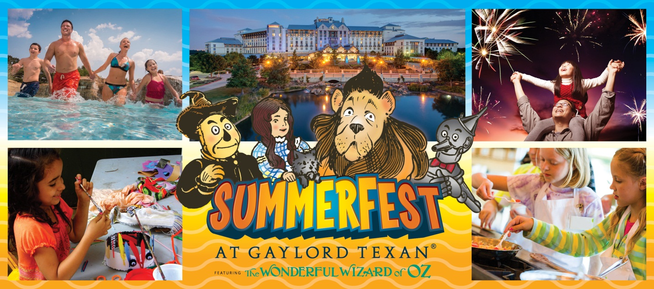
Gaylord Texan Resort Presents the Summer of Oz

~ Experience the magical Land of Oz at this year’s 12th annual SummerFest event at the Grapevine, TX hotel ~

GRAPEVINE, Texas (May 5, 2015)– For the 12th annual SummerFest, Gaylord Texan Resort & Convention Center invites visitors to enjoy a memorable summer vacation taking place May 22 to Sept. 7, 2015. In addition to the Grapevine hotel’s remarkable amenities, the resort will lead you down the yellow brick road to the Land of Oz while encountering the characters second scenes from L. Frank Baum’s original story “The Wonderful Wizard of Oz.”

SummerFest will offer a variety of Oz-inspired activities for children and adults! Events include “The Lost Treasure of Oz Scavenger Hunt,” an interactive scavenger hunt throughout the resort; “Oohs & Ahhz Art Tour” showcasing Oz-themed artwork created by a group of talented local Texas artists; “Create Your Own Ahhz Kids Craft Corner” where kids create a masterpiece with a Wizard of Oz cookie making kit or a custom canvas; and “Friday Night Fireworks” displaying a magnificent fireworks show at the top of the Grapevine resort’s parking garage.

Culinary events include a VIP BBQ Tasting and Glass Cactus Sunset Patio Hour on the decks of Glass Cactus Nightclub, Margarita Madness happy hour specials at Riverwalk Cantina, Wine & Cheese Pairings at Old Hickory Wine Bar, and “Junior Chef Camps” conducted by the hotel’s award-winning executive chefs. Every Friday and Saturday night, adults 21 and up can enjoy live stage music at the Glass Cactus Summer Music Series.

During SummerFest 2015, the DFW area hotel’s local and overnight visitors can also enjoy dining at four award-winning restaurants including Old Hickory Steakhouse & Wine Bar, Zeppole Coastal Italian, Riverwalk Cantina Tex-Mex, and Texan Station Sports Bar & Grill. The resort’s 25,000-square-foot European-inspired Relâche Spa & Salon will offer summer spa specials while its six unique retail shops provide a variety of shopping opportunities. The resort’s 39,000-square-foot Glass Cactus Nightclub on the shores of Lake Grapevine provides a great escape with live stage music, dancing, four signature bars, multi-tiered outdoor decks, and gorgeous sunset views.

Additionally, guests staying overnight at the Grapevine, TX resort will have access to Paradise Springs, the 10-acre outdoor pool and lazy river complex. At Paradise Springs, families can enjoy the Pool-A-Palooza party with live DJ music, games, drink specials, and more. Paradise Springs boasts a 600-foot-long lazy river, a 6,000-square-foot family lagoon with a 27-foot-tall winding waterslide, a 25-foot-long zip-line, two horseshoe-shaped hot pools, water basketball and a dedicated toddler pool. Seating for 1,200 includes chaise lounges, beach chairs and family-style rounds. For VIP treatment, the pool at the Texas resort offers a selection of private cabanas for rent that include flat-screen televisions, refrigerators and fire pits.

In addition to Gaylord Texan’s Oz-themed activities, the City of Grapevine’s Tower Gallery will be featuring an interactive art exhibit after W.W. Denslow illustrations from “The Wonderful Wizard of Oz.” Visitors will feel as if they are stepping into the pages as they walk through the storybook and learn about the science, art and history behind the first American fairy tale. The exhibit is perfect for children ages 2 to 12.

*As always, local day visitors who spend $25 or more in the resort’s restaurants, retail shops, or Grapevine spa receive complimentary validation for short-term self-parking. For information on Gaylord Texan’s 12th annual SummerFest activities as well as summer room rates and packages, please visit www.gaylordtexan.com or call 1-817-778-1000.

2015 Summerfest Events

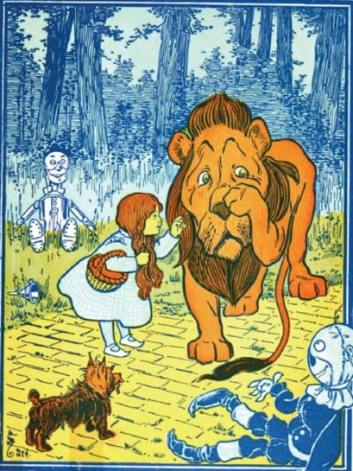
The Lost Treasures of OZ Scavenger Hunt Description: The Munchkins of Oz were on their way to see Dorothy and Toto, but a terrible storm caused their hot air balloon to be trapped in the atrium and their cargo was blown all over the resort! Will you help find the missing treasures? A prize awaits you at the end!
Location: The scavenger hunt takes place throughout the property. The scavenger map can be picked up at the Concierge desk or will be provided upon check-in if included in your hotel package. Once successfully completed, prizes can be collected back at the Concierge desk.
Dates: May 22nd – September 7th
Times: Anytime
Price: $12 per Scavenger Map+ tax
*Maps can be purchased on property

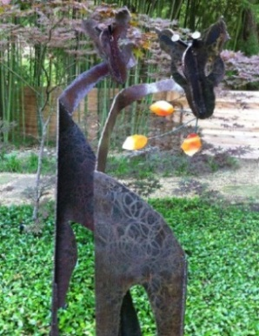
Oohs & Oz Art Tour
Description: Self-guided art walk featuring Oz-themed art by local Texas artists. Journey through Gaylord Texan’s four-and-a-half acres of lush indoor gardens and winding waterways while enjoying the original artwork displays.
Location: Throughout the property
Dates: May 22nd – September 7th
Times: Anytime
Price: FREE

Game Station
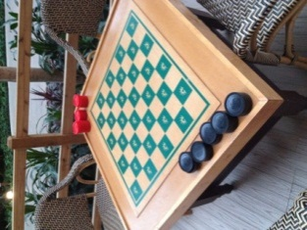
Description: Enjoy a fun game of Checkers, Jumbo Jenga and Corn Hole by the Oil Derrick.
Location: Oil Derrick Deck
Dates: May 22nd– September 7th
Times: Anytime
Price: FREE

Create Your Own Ahhhz Kids Craft Corner
Description: Kids select a Wizard of Oz cookie decorating kit (sugar cookies) or paint their own Oz-themed canvas to create their own masterpiece!
Location: Retail Corridor next to Cocoa Bean
Dates: May 22nd – September 7th
Times:
Friday: 4:00PM – 8:00PM
Saturday: 12:00PM – 6:00PM
Sunday: 10:00AM – 2:00PM
Price: $19.99 +tax (Cookie Decorating Kit or OZ Themed canvas)
$35.99 +tax (any two items)
*Tickets can be purchased on property

Family Movie Night
Description: Movies with the kids.
Location: Lower Level Texan Station
Dates: May 22nd – September 7th
Times:
Friday & Saturday: 6:45PM
* See the weekly entertainment guide for detailed schedule
Price: FREE

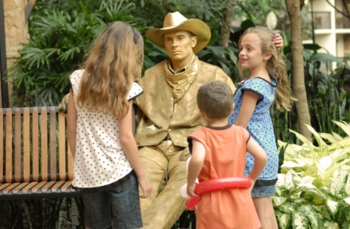
Strolling Entertainment
Description: Meet Dorothy, the Tin Woodsman, a Stilt Walking Scarecrow and the Cowardly Lion as well as a Wicked Witch balloon artist throughout our 4 ½ acres of lush indoor gardens.
Location: Hotel Atriums
Dates: May 22nd – September 7th
Times: Varies
*See the weekly entertainment guide for detailed schedule
Price: FREE

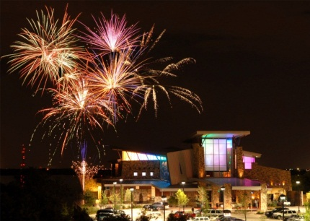
Friday Night Fireworks
Location: Watch Party with DJ on 5th level of resort garage or Glass Cactus Decks for 21 and up
Dates: Every Friday night between May 22nd – September 7th and 4th of July
Times: 9:30PM (Weather permitting)
Price: FREE
*For resort garage, parking rates apply.
Resort guests have free entrance to the Glass Cactus. $10 cover at the Glass Cactus after 8pm for non-resort guests.

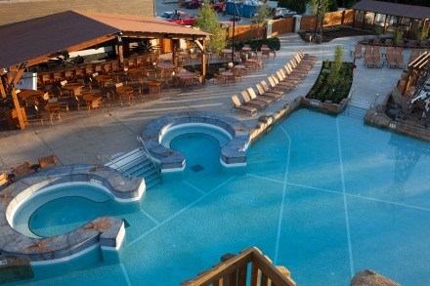
Pool-A-Palooza
Description: Splash into summer at our 10-acre outdoor pool and lazy river playground, Paradise Springs! Featuring DJ music, a pool bar, activities, and games! Kids will enjoy glitter and airbrush tattoos, hair braiding, fireside ghost stories, and more
Location: Paradise Springs
*Must be a hotel guest to enter Paradise Springs
Dates: May 22nd – September 7th
Times: Friday – Sunday
Price: Varies

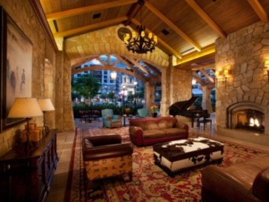
Live Piano Music
Description: Enjoy live piano music every night at Silver Bar!
Location: Front Lobby/Silver Bar
Dates: May 22nd – September 7th
Times: 6PM - 9PM
Price: FREE

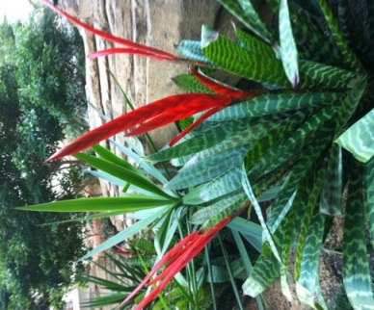
Horticulture Tour
Description: With our self-guided Horticulture Tour, we invite you to discover the lush plant life found within our four-and-a-half acres of lush indoor gardens!
Location: Resort Atriums
Dates: May 22nd – September 7th
Times: Anytime
Price: FREE

Food and Beverage Events
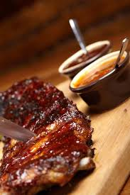
VIP BBQ Tasting
Description: Executive Chef’s Zeb Hartline and Brian “Butta” Stalters prepare a BBQ dinner complete with brisket, ribs, beer-can chicken, man n’ cheese, cole slaw, roasted potato salad, local craft beer and wine. At the end of the demonstration, guests will receive a grab bag with a rub, BBQ sauce and a T-shirt.
Location: Glass Cactus Deck
Dates: June 12, July 17, August 28
Times: 4PM – 6PM
Price: $125 per person. Inclusive of dinner, limit of 3 drinks per person, grab bag (rub, BBQ sauce, t-shirt), tax and gratuity (45-50 people max).*Tickets can be purchased over the phone, on property, or online at GaylordTexanTickets.com

Glass Cactus Sunset Patio Hour
Description: Enjoy drink and appetizer specials while lounging on our two-story patio deck overlooking beautiful Lake Grapevine.
Location: Glass Cactus
Dates: Friday and Saturday
Times: 6PM - 8PM
Price: $4 Wells and Draft Beer, ½ off select appetizers
*Free entrance for resort guests. $10 cover after 8pm for non-resort guests.

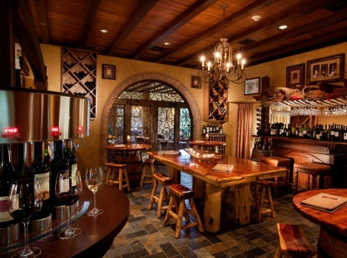
Wine & Cheese Pairing
Description: Please your palate with three expertly paired wines complemented by an Artisanal cheese selection.
Location: Old Hickory Wine Bar
Dates: Friday and Saturday
Times: 4PM – 6PM
*Extended hours on holidays
Price: $35 per person

Junior Chef Camp
Description: A great way to inspire chefs of the future! This interactive day camp for kids is led by Gaylord Texan’s award-winning Executive Chefs as Junior Chefs will learn to cook delicious plates they can create at home!
Location: Zeppole Coastal Italian
Dates: June 13, July 11, August 1
Times: 10AM – 2PM
Menu:
- PIZZA (June 13): Make your own pizza with handmade dough, delicious sauce, and salad with balsamic dressing with Executive Chef Marchesi!
- BBQ (July 11): Create pulled pork quesadillas, tacos, and corn and become a BBQ Champion with Executive Chef Hartline!
- Chicken Wings (August 1): Make BBQ, buffalo, and mango jerk chicken wings, complete with bleu cheese and lime cilantro ranch with Executive Chef Stalters!
Price: $90 per kid (Class includes instruction for one junior chef, personal chef hat and lunch prepared by junior chefs for their two parents/family members). Additional guests can be added for $25 per person. Dining time noon-1pm. 12 kids per class maximum.

*Tickets can be purchased over the phone, on property, or online at
GaylordTexanTickets.com

Riverwalk Margarita Madness
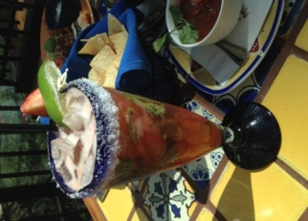
Description: Take your taste buds on a festive journey with our seasonal margaritas specials.
Location: Riverwalk Cantina
Dates: Friday - Sunday
Times: Drink Specials: 4PM - 6PM; Taco Cart: 6PM - 9PM
*Extended hours on holidays
Price: $5 House Margaritas (mango, guava, blood orange, prickly pear, peach, sangria, strawberry, pomegranate, passion fruit)

Pizza Italiano
Description: Indulge in pizza, wine and ice cream all summer long!
Location: Hill Country Shack
Dates: Friday and Saturday
Times: 4PM – 9PM *Extended hours on holidays
Price: Pizza by the Slice - $5, Biscotti - $3.50, Parmigiano Truffle
Fries - $3.50, Soft Drinks - $3.50, Wine - $7, Beer - $6, Frozen Bellinis - $7

Texan Station Happy Hour
Description: (Ages 21 & up)
- Double Cross Vodka Cocktail on Tap: $5
- Daily Bar Tender Cocktail Creation: $5
- Domestic Draft Beer: $4
- House Wine: $5
- Chips Duo Platter: $7
Location: Texan Station
Dates: Daily
Time: 3PM – 5PM

Zeppole Happy Hour
Description: (Ages 21 & up)
- Wine by the glass: $5
- Beer: $3
- Appetizers: $5
- Pizza: $5
Location: Zeppole
Dates: Daily
Time: 4:30pm – 6:30pm

###

About Gaylord Hotels®
Gaylord Hotels® is a collection of hotels and upscale resorts that afford endless opportunities for leisure travelers and conventioneers. The brand’s hallmark — “everything in one place” — provides guests with diverse dining options, quality spa and fitness center services, top-notch entertainment, on-site shopping and endless activities. Gaylord Hotels is a pioneer in the hotel and convention industry with properties in the nation’s most desirable destinations. Gaylord Hotels include Gaylord Opryland® in Nashville, Tenn.; Gaylord Palms® in Kissimmee, Fla. near Orlando; Gaylord Texan® on Lake Grapevine, Texas; Gaylord National® on the Potomac in National Harbor, Md.; and The Inn at Opryland® in Nashville, Tenn. For information, visit www.GaylordHotels.com.

Marriott International, Inc. (NYSE: MAR) is a leading lodging company based in Bethesda, Maryland, USA, with more than 3,800 properties in 74 countries and territories and reported revenues of nearly $12 billion in fiscal year 2012. The company operates and franchises hotels and licenses vacation ownership resorts under 18 brands. For more information or reservations, please visit our web site at www.marriott.com, and for the latest company news, visit www.marriottnewscenter.com.

