Press Release For Immediate Release

Contacts:
Vinitaly International
International Media Dept.
+39 045 8101447
media@vinitalytour.com
www.vinitalytour.com
Twitter: @VinitalyTour
Join Vinitaly International Network on LinkedIn

Vino – A Taste of Italy unveils in China

Vinitaly International returned to China this week to present “Vino, A Taste of Italy”, the Italian wine pavilion at Expo Milan, to key players of the Chinese wine sector; on the 13th of May it took part in a press conference in Shanghai, organized in collaboration with Slow Food and the Consulate General of Italy, whilst on the 14th of May there was a second presentation in the auditorium of the Italian Embassy in Beijing.
The Chinese have already bought more than one million tickets for the Expo and will represent the greatest number of international visitors at the Universal Exhibition. As stressed by Augusto Massari, Head of the Economic and Commercial Office at the Embassy of Italy in Beijing, the project “Vino – A Taste of Italy” has an enormous historical importance since it is the first pavilion at a Universal Exhibition to have been entirely dedicated to wine.
Stevie Kim, Managing Director of Vinitaly International, spoke in front of trade, journalists and sommeliers, describing the work behind the creation of the pavilion and the importance of the Chinese market for Italian wine.
"It is incredibly stimulating to be part of Expo and represent the cultural biodiversity of Italian wines,” stressed Stevie Kim. “Inside the pavilion we used English and Chinese, which proves how important we think the Chinese market is for the future of Italian wine”. Vinitaly International’s return to Beijing represents the continuation of a tour that begun last year with the first stop of the China Expo Road show. During the following eight months the Ambassador of Italian Wine visited 7 other cities in the name of Italian wine together with top importers and distributors.

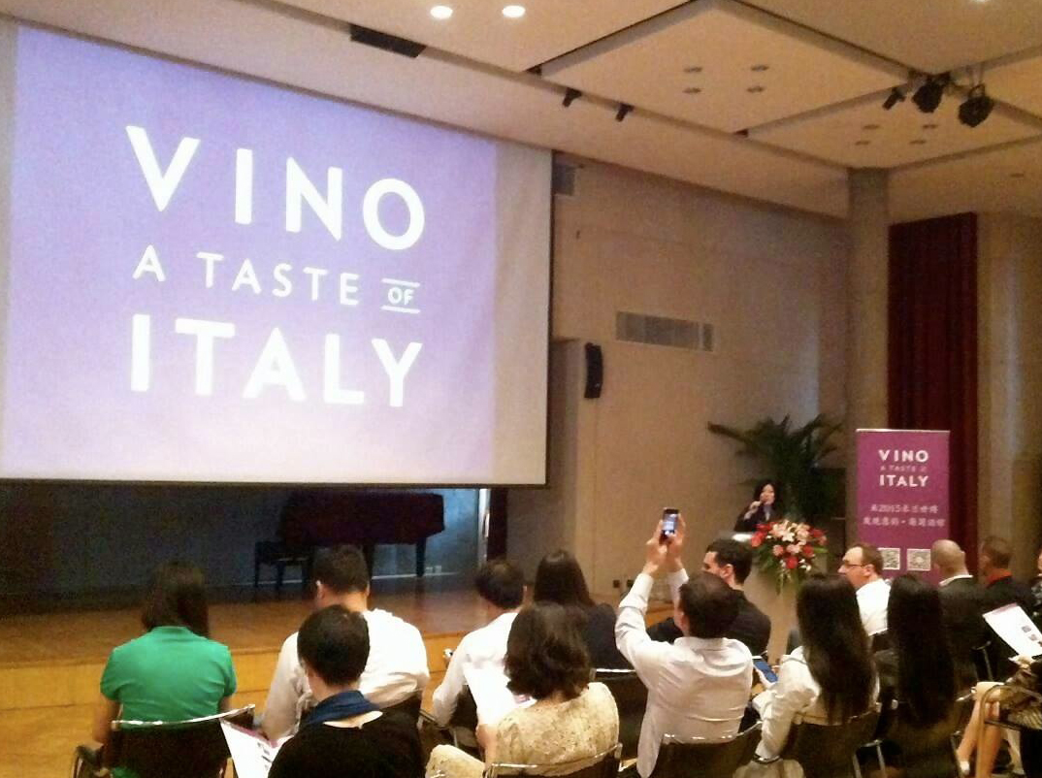

The press conference in Beijing received surprising attention from all attendees. Amongst them were also important members of the media such as Vinehoo, Pinor and Wines-Info as well as giants like Cofco, JD.com and representatives from Mofcom. They all wanted to understand what “VINO – A Taste of Italy” is, what can be found inside the pavilion, the story behind its construction and which activities will be carried out inside during the next six months. Most members of the public were incredulous about the fact that Chinese is the second language to be used inside the pavilion together with English. “Milan is a unique and incredible opportunity for Italian wine,” said Stevie Kim. “I was the first to have some doubts at the beginning. After many days passed inside the pavilion, though, both before and during Expo, I started to feel its international breadth. This is something very gratifying in the face of the many sacrifices made by all those who worked to make this project possible. The conferences in Shanghai and Beijing represented the perfect opportunity to share with Chinese members of the wine sector all that has been going on in the past months”. China Daily will be visiting Expo in Milan on the 8th of June whilst two important delegations from Shanghai have already confirmed their attendance by the middle of next month. Their first visit will be to the Italian wine pavilion itself. Milan, though, will only be their first stop: they will then proceed to visit the territory and wineries following a unique food and wine tour. An incoming activity that Veronafiere - Vinitaly International will be strongly supporting in the next few months.

About:

Veronafiere is the leading organizer of trade shows in Italy including Vinitaly (www.vinitaly.com), the largest wine and spirits fair in the world. During its 49th edition Vinitaly counted some 4.000 exhibitors on a 100.000 square meter area and 150.000 visitors including 2.600 journalists from 46 different countries. The next edition of the fair will take place on 10 - 13 April 2016. The premier event to Vinitaly, OperaWine (www.vinitalyinternational.com) “Finest Italian Wines: 100 Great Producers,” will unite international wine professionals on April 9th in the heart of Verona, offering them the unique opportunity to discover and taste the wines of the 100 Best Italian Producers, as selected by Wine Spectator. Since 1998 Vinitaly International travels to several countries such as Russia, China, USA and Hong Kong thanks to its strategic arm abroad, Vinitaly International. In February 2014 Vinitaly International launched an educational project, the Vinitaly International Academy (VIA) with the aim of divulging and broadcasting the excellence and diversity of Italian wine around the globe. VIA has now also organized its very first Certification Course with the aim of creating new Ambassadors of Italian Wine in the World.

###

