Media Contact:
Ruth Hawk
Public Relations Director
Higher Images, Inc.
412-203-1996
ruth@higherimages.com

Pittsburgh Author Launches Pre-Sale of THINK MORE - REACT LESS
Cracking the code on what makes you do what you do!

“I can tell you this with absolute certainty - the only problem you will ever have is believing your opinions to be true.” - Samuel J. Lucci III

Pittsburgh, PA – Why do some people own the future and others get so stuck in the past? In his new book Think More – React Less™, Pittsburgh Author Samuel J. Lucci III unveils the secret and cracks the code on why we do what we do. The book débuts June 20, and is available now for a limited time offer of $10.95 plus shipping and handling - pre-order here.

“This is brand new information the world hasn’t tapped into yet. Until Now! Life is a gift beyond your wildest imagination. Yet, most of us live our life as a burden, using diversions to run away from how we really feel. How many times have you reacted and what has it cost you?” Lucci said.
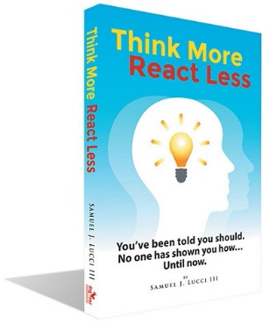
Think More - React Less unveils groundbreaking details through a formula Lucci developed called the B-Code™. It is the result of four decades of research unravelling what makes us tick and creating the pathway for getting what we want out of life. The book provides in-depth new knowledge that culminates into an owner’s manual for the human mind and emotional system. “Our understanding of human behavior today is as primitive as was the practice of medicine before we knew there were germs,” Lucci said. “Until now!” he adds.

The book offers a series of breakout sessions, used to push buried limitations to the surface and eliminate them forever. “The breakouts allow people to make fast and lasting progress by removing what’s blocking them from achieving their goals,” Lucci said. The book doesn’t just tell you to think more and react less. It describes human behavior in a way never done before and gives you the tools to change your life.

Lucci is known for his uncanny ability to read people and effectively respond to them. His words share his life’s work in a journey to transform the way people view themselves and to bring happiness and prosperity into their everyday lives. “If you knew the truth about yourself, your world would be very different,” he said.

Think More – React Less Continued on 2

Think More – React Less Page 2

Lucci details how our minds create what becomes true in our lives. And how unconscious opinions supersede our conscious intent and stop us dead in our tracks. It shows you how to change your opinions and get what you want out of life.

All his life, Lucci sought to identify why intelligent people do stupid things? “My motivation has always been to help people live a better life, bringing out their best,” he said. In the book, the writing offers the ability to see improvement in your life as you read. You won’t have to wait until you’re finished to begin reaping the benefits of thinking more and reacting less.

“I may be the first person to say publicly as a fact, the ego is not your friend. It’s the only enemy that you have,” Lucci said. “What you believe, you make true,” he added. Think More - React Less is an inspiring read - not only for those looking to get a better mindset in life, but also for anyone looking to find positivity in their everyday life.
Lucci began his career as a professional educator and continues his lifelong passion for sharing knowledge. He is also the founder of eight successful businesses. He gained financial independence and turned his attention to follow his growing passion for helping others reach their potential and get the best out of life. For nearly 40 years, while experiencing the frustration of trying to develop sales professionals to staff his own companies, he discovered a missing piece on the pathway to higher levels of success. He developed a comprehensive program to solve the problem and shares this in the book Think More - React Less. Lucci is a founder of a company also called Think More - React Less, where he shares his wealth of knowledge through a process known as ‘Breakout’ that has helped individuals and businesses succeed beyond their expectations.

Unlock your personal power now. Pre-order a copy today to be among the first to reap the lifelong benefits unveiled through the 144-page Think More - React Less.

-30-

