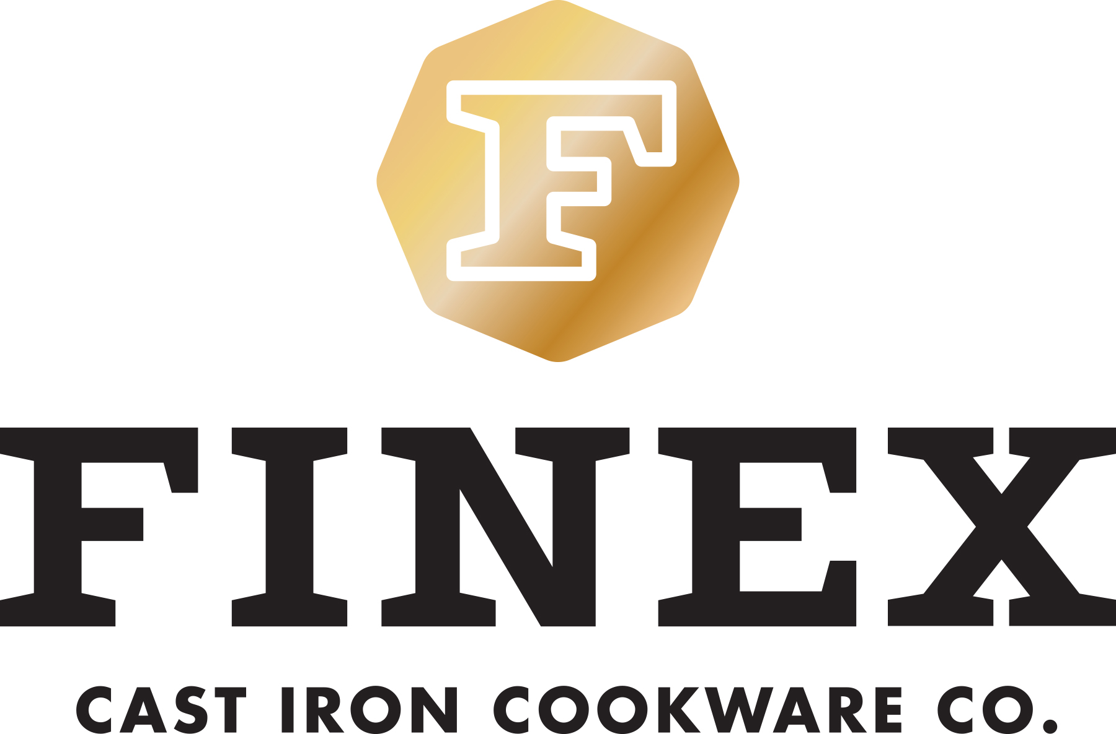
NEWS RELEASE
For immediate release

Williams-Sonoma introduces exclusive FINEX® heirloom-quality cast iron cookware designs

Portland, Ore. (May 21, 2015) — Portland, Ore. innovative cookware company, FINEX Cast Iron Cookware Co. and Williams-Sonoma announce the launch of a collection of heirloom-quality cast iron cookware sold only at Williams-Sonoma stores and online. This family of USA-made products includes FINEX’s 12” Cast Iron Skillet as well as their new 10” Cast Iron Skillet and 10” Cast Iron Ribbed Grill Pans.

For generations Americans have turned to cast iron for perfectly tender yet crispy results on everything from cornbread to home fries to blueberry pancakes to roast chicken. FINEX simplifies cast iron cooking with long overdue redesigns of beloved classics that include handcrafted quick-cooling ergonomic spring handles, true BBQ-width grill ribs and polished easy-release cooking surfaces. FINEX is on track to bring back all the taste and benefits of cast iron cooking along with distinctive design to cooks worldwide.

“We are thrilled to get these modern cast iron cookware heirlooms into even more kitchens through this collaboration with a premium company like Williams-Sonoma,” explained FINEX founder Mike Whitehead.
________
Founded in 2012, FINEX Cast Iron Cookware Co. is a small team of Portland-based perfectionists dedicated to bringing machine polished heirloom-quality cast iron cookware back to America for the first time in over half a century. Inspired by vintage cookware but with modern designs and improved performance FINEX puts as much thought into what you cook in as you do in selecting what you cook in it. They believe your history is slowly baked into every piece of cast iron cookware you use and are honored to be a part of your family meals. FINEX is currently handcrafting 8” skillets, 10” ribbed grill pans and both 10” and 12” skillets and lids in the United States.
For information, visit www.FINEXUSA.com.
---------
Since its founding by Chuck Williams in 1956, the Williams-Sonoma brand has been bringing people together around food. A member of Williams-Sonoma, Inc. (NYSE: WSM) portfolio of brands, Williams-Sonoma is a leading specialty retailer of high-quality products for the kitchen and home, providing world-class service and an engaging customer experience. Products include cookware, cooks’ tools, cutlery, electrics, bakeware, food, tabletop and bar, outdoor, cookbooks, as well as furniture, lighting and decorative accessories. Each store has a professional demonstration kitchen for cooking classes and tastings conducted by expert culinary staff. A comprehensive gift registry program for weddings and other special events is available in stores and online. On williams-sonoma.com and the Williams-Sonoma blog, Taste, customers can find recipes, tips and techniques that help them create delicious meals and wonderful memories.
# # # #
For more information on FINEX Cast Iron Cookware Co., please contact Shauna Bilicic, FINEX Cast Iron Cookware Co.; email: cookwithus@FINEXUSA.com.
For hi-res sample and product images please visit http://finexusa.com/press-resources/

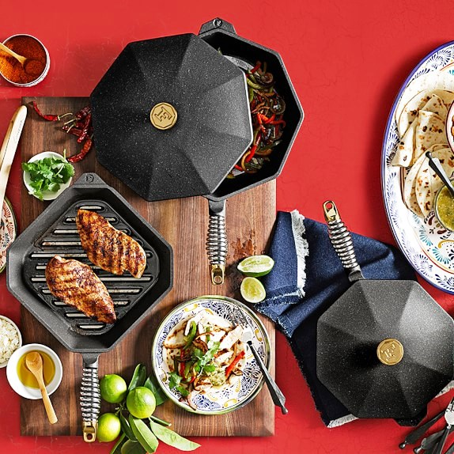
FINEX 10” Cast Iron Ribbed Grill Pan (photograph by Williams-Sonoma)

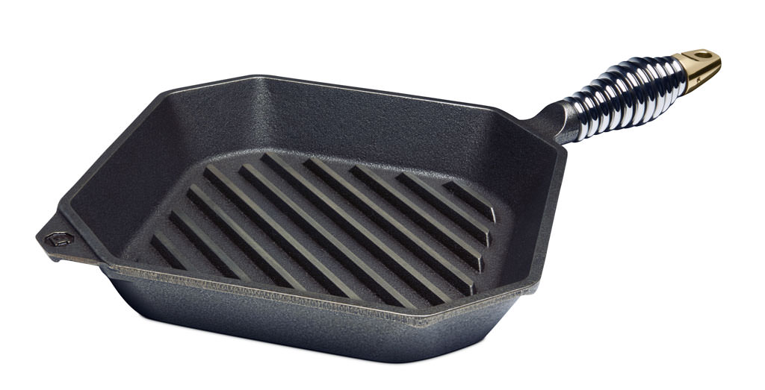
FINEX 10” Cast Iron Ribbed Grill Pan

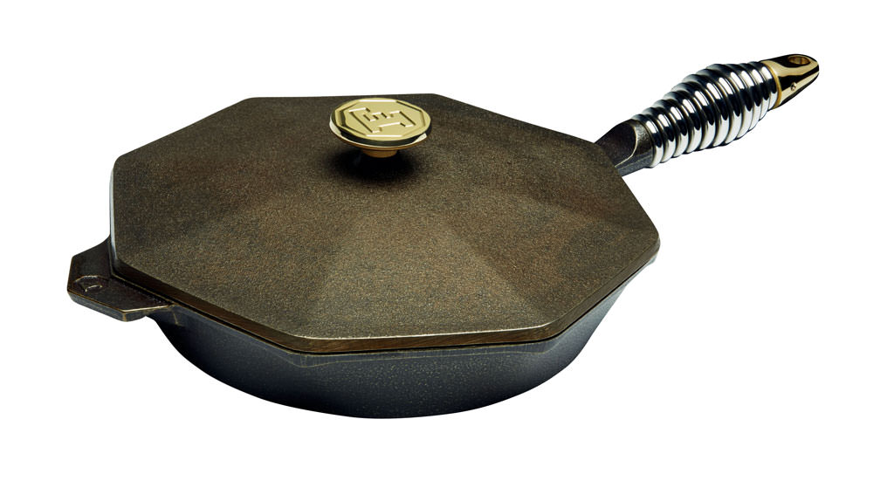
FINEX 10” Cast Iron Skillet

