Kevin Vaughan, Sales Manager, of TAVCO who also teaches in the program, talks about creating molds for small production runs a 3D supplier to Central Texas comments, "..after a client meeting earlier in the week, I was inspired to put the following information together regarding 3D printed injection molds."

TAVCO Wide-Format and 3D Printer Blog

Application Considerations of 3D Printed Injection Molds (Part 2 of 3)
Posted by Kevin Vaughan on Wed, Apr 29, 2015 @ 10:37 AM
Find me on:
LinkedIn Google+

- inShare4

One of the buzzworthy topics in 3D printing is the ability to print injection molds. No doubt this could be a “game changer” for some companies as it provides a way to drastically cut production cycle time. But, there are a few factors to consider regarding 3D plastic injection molds. First of all, what is the material that you are planning to inject and how many final parts are you wanting to make? While metal tooling enables you to produce thousands, if not millions, of parts, plastic 3D printed molds generally accommodate only 50-200 parts before they wear out. However, in the case of prototyping or short-order runs, this can be greatly beneficial because plastic molds can be made quickly at only a fraction of the cost of a metal tool. Here are some key things to keep in mind to ensure the best applications of 3D printed injection molds.
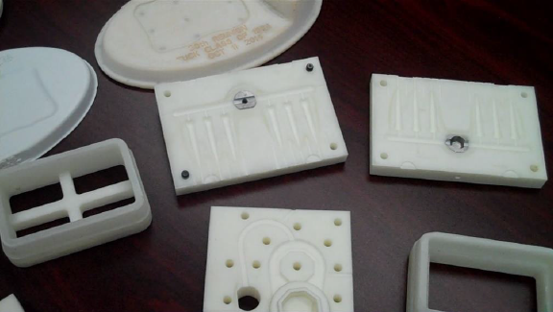

Part Design Adjustment
When comparing metal and 3D printed (plastic) tooling equipment, there are two fundamental differences, thermal conductivity, and mechanical strength. Both are crucial characteristics to take account in the part and tooling design process.
Thermal conductivity – metal is a great thermal conductor. This means that it transfers heat quickly while plastic is an insulator, it transfers heat slowly. The end result is that plastic molds do not cool as quickly so more rest time is needed in between different shots of plastic.
Mechanical strength – metal is obviously much stronger than plastic, therefore, higher clamping pressures and injection pressures can be exerted on metal tooling.

Plastic Mold Trouble Spots
There are a few features that are challenging to mold with plastic tooling. Be aware of these when designing the part to be produced through injection molding.
Thin walls – the injected part’s walls should be greater than 0.080” (2mm) in order to survive the injection process.
Tall/long parts – Parts should be less than 4” (100mm) long. Creating parts that are longer than this is possible, but not recommended due to inconsistent part quality.
Large parts – parts made from a 3D printed mold should be smaller than 3 cubic inches (49 cubic cm). Parts larger than this are possible be can also suffer from some inconsistencies.
Deep draws – are not recommended. Draws should be less than one inch (25.4 mm). Again, anything larger than this is prone to inconsistencies.

Mold Design Considerations
Gates – a tab or fan gate is recommended because these are gates for lower pressure shots. This will help keep a consistent injection pressure to prevent damage to the mold. Do not use direct hot gates with plastic printed tooling. Direct contact with the injector will cause the tooling to distort.
Consistent walls – just like with metal tooling, it is important to keep part walls a consistent thickness. This is done to control shrinkage and preserve the accuracy of the printed parts.
Large draft angle – Typical draft angles for metal tooling are 2-3 degrees, for plastic tooling a 5-degree angle is recommended. This will allow easy part ejection.
No cooling channels – Because plastic is a thermal insulator, cooling channels in the mold are inefficient at removing heat. Additionally, they will weaken the mold because of the voids they create.
Remove sharp corners – if your part has sharp corners, it is more difficult to eject from the tooling mold. It is recommended to put a radius on all corners of the tooling (both interior and exterior) to help in the ejection process.
Vent holes – these are needed so that trapped air may escape. If air is trapped, it will lead to undesired results and possible damage to the tooling. Parting line vents measured at 0.005” (0.127mm) deep are recommended.

Recommended Printing Process on ProJet 3500 Series MultiJet Printer
Recommended print material: Visijet M3-X is recommended due to it high Heat Deflection Temperature (HDT).
Print mold in high-resolution mode: the higher resolution print modes have much smoother side walls, which are required for the ejection process.
Orientation: the molds should be positioned so that parting line and mold cavity face upwards. This will provide the best surface quality on these critical faces.
Alignment: it is possible for tooling to distort a little depending on the geometry. VisiJet M3-X material is a very strong, heat-resistant material. The properties of this material may result in some internal stresses that may lead to slight distortion during post processing. When placed under clamping pressure during the injection process, the molds flatten and align properly. As an extra measure, threads and bolts can be added to assist with clamping the molds.

Get the 3D Printer Buyer's Guide

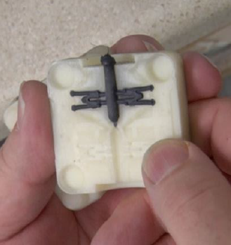

Compatible Thermoplastics
Just about every injectable thermoplastic has the potential to be injected with molds printed on the ProJet 3500. There are no theoretical limitations. Molds printed on the Projet 3500 have withstood injection temperatures of 675 degrees Fahrenheit (350C). Higher temperatures are possible but largely untested.

List of Successfully Shot Thermoplastics into 3D Printed Injection Mold
- Elastomers
- Polypropylene
- Polyethylene
- Styrene
- High Impact Styrene
- Polycarbonates
- Liquid Crystal Polymer (LCP)

Note: The materials are listed in the order from the easiest to the most difficult. Elastomers are the easiest to successfully use with plastic tooling, with LCPs requiring the most care to successfully inject.
Be sure to see the other articles in this three part series:
- Part 1 – Print Injection Molds with a 3D Printer – Key Benefits
- Part 3 - Running Injection Mold Equipment with Printed Molds
This article addresses the aspect of printing 3D molds using a 3D Systems ProJet 3500MAX using the VisiJet M3-X material. Other 3D printers have and are capable of printing 3D molds as well. This includes other larger MJP (Multi-jet Printers) and SLA (Stereo Lithography) units. The reason for focusing on the 3500 series is because offers the lowest cost of entry into the market of 3D mold printing.
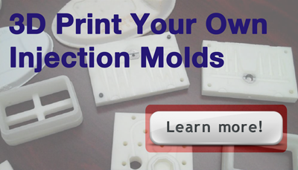
Information source: 3D Systems, Inc.
Tags: 3D printer

First Name *
Last Name
Email *
Website
Comment *
- Subscribe to follow-up comments for this post
Privacy & Terms

Latest Posts
- Producing Parts with 3D Print Injection Molds (Part 3 of 3)
- Application Considerations of 3D Printed Injection Molds (Part 2 of 3)
- Print injection molds with a 3D printer – Key Benefits (Part 1 of 3)
- See New and Innovative Uses for the Océ ColorWave 700
- Large Format Plotter Reviews – Canon iPF780 vs HP T920 ePrinter
- Cad Plotters Help Reduce Construction Costs
- Océ ColorWave 500 Printing System - Watch the Demonstration Video
- Large Format Plotter Reviews - Canon iPF785MFP vs HP T2500eMFP
- Print 3D Models of Architecture - Best Practices
- Canon Announces the New Océ ColorWave 500 Wide Format Plotter

Get updates via email

Email *

http://www.tavco.net/wide-format-plotter-scanner-blog/application-considerations-of-3d-printed-injection-molds-part-2-of-3

