**Press Release Contacts:**

**For Immediate Release** Vinitaly International

International Media Dept.

+39 045 8101447

[media@vinitalytour.com](mailto:media@vinitalytour.com)

[www.vinitalytour.com](http://www.vinitalytour.com)

Twitter: @VinitalyTour

Join Vinitaly International Network on LinkedIn

**Vinitaly International lands in Chicago for the first Italian participation in FMI Connect**

From the 9th to the 11th of June, Vinitaly International will be taking part for the first time in FMI Connect as the co-protagonist of a project supported by the Italian Ministry of Economic Development (MISE) and organized by the Italian Trade Agency (ICE) with the aim of developing the Italian agro-industrial sector through the involvement of three major Italian trade fairs: Fiere di Parma, Fiera di Milano and Veronafiere. As always, Vinitaly International will participate in its capacity as global ambassador of Italian wine, with the goal of leading members of the mature US market through in-depth explorations of some great Italian vintages.

On Tuesday, June 9th, the Vinitaly International Academy (VIA) takes center stage with three Executive Wine Seminars, each focused on the characteristics and nuances of one of Italy’s finest varietals. On hand to present the Academy to Chicago for the first time will be Vinitaly International Managing Director Stevie Kim, as well as VIA Scientific Director and renowned expert on Italian wine grapes, Dr. Ian D’Agata.

From 12:30pm-1:30pm, Dr. D’Agata will inaugurate the series with a Focus level seminar entitled *The somewhereness of Barolo: differences and similarities in these great wines*, in which he will lead participants through a tasting of wines from each of the eleven townships qualified to use the Barolo name. “Each township makes its own uniquely typical wine,” explains Dr. D’Agata. “They are all similar, all being made from Nebbiolo grapes, but each is born from different geology and different exposure based on the terroir. Having trade representatives taste some of the country’s best also furthers the goal of bringing more interest in drinking and buying Italian wine abroad.”

From 2pm-3pm, the second, Advanced level seminar, *Italy’s answer to Champagne: Franciacorta* will explore Italy’s highest quality but undervalued sparkling wine. “People identify Italy with Prosecco,” Dr. D’Agata laments. “Every sparkling wine is viewed as Prosecco abroad. So we’re highlighting Franciacorta to explain how it is different from Prosecco, starting with the fact that it is made in the method of Champagne, with a secondary fermentation in the bottle, and should be thought of more like Champagne. The next step is to highlight that, like Champange, Franciacorta has many different categories, blanc di blanc, blanc di noir, etc., as well as variations based on the production area. Consumers need to understand why Franciacorta has a higher price point than Prosecco, so they will be willing to pay a premium for a premium product.”

Dr. D’Agata concludes the seminar series with an Advanced level course from 3:30pm to 4:30pm, *Montepulciano d’Abruzzo: new, improved and exciting, one of Italy’s greatest red wines*. This is the first time an in-depth tasting of Montepulciano d’Abruzzo of this kind has been done, and Dr. D’Agata is excited to share with Chicago that the wine can be much more than simply cheap and hearty. “Part of the problem is that expensive Montepulciano has been over-oaked, and is not very interesting,” Dr. D’Agata explains. “Now we’re excited to share that there is a new wave of Abruzzo producers, mostly younger family members taking over from their parents, with a new perspective. They’re eschewing the use of oak in favour of stainless steel and cement, and using innovation, research, and talent to catapult Montepulciano into a new realm, producing wines that are far fruitier and lighter, almost pinot noir-like, than ever thought possible.” The tasting will focus on smaller family wineries that produce low volume, a rarity in the Abruzzo wine landscape.

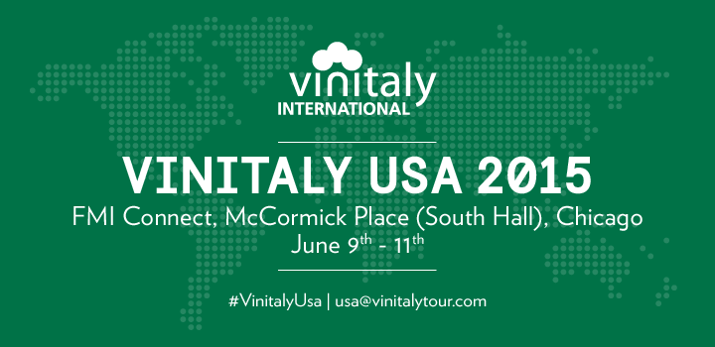

In addition to the three educational VIA seminars, Vinitaly International will also host a Winebar for three days of the event, from June 8th -11th. The first two days will focus on individual grapes, Barbara, Barolo and Dolcetto, while the third day will celebrate the rich diversity of Italian varietals, with sommeliers pouring a wider offering of the best of labels supplied by Consorzio Il Franciacorta, Associazione èAbruzzo and Enoteca Regionale del Barolo. “The US is one of the world’s most mature wine markets, but still consumers tend to drink what they know,” Stevie Kim explains. “We conceived the Vinitaly International Winebar to bring specific focus to one grape and one wine at a time, encouraging guests to really get to know them, as well as to celebrate the variety of Italian wines. Italy has far and away the most native grapes of any wine-producing region in the world, but the outstanding quality of Italian wine can get lost in all that complexity. This is why we started the Vinitaly International Academy, to broadcast, divulge and explore the nuances that make Italian wine a treasure trove for the curious consumer.”

The event comes only one week away from a private Executive Wine Seminar to be held on the first of June by Vinitaly International Academy in collaboration with New York Vintners: the once-in-a-generation tasting is aimed at analysing Sangiovese from different terroirs and vintages ranging form 1974-2001 and will future some rare gems such as the 1974 Monteso di Chianti Rufina by Frescobaldi, Chianti Classico Riserva Rancia by Felsina and Badia a Coltibuono Chianti Classico.

**About:**

Veronafiere is the leading organizer of trade shows in Italy including Vinitaly (www.vinitaly.com), the largest wine and spirits fair in the world. During its 49th edition Vinitaly counted some 4.000 exhibitors on a 100.000 square meter area and 150.000 visitors including 2.600 journalists from 46 different countries. The next edition of the fair will take place on 10 - 13 April 2016. The premier event to Vinitaly, OperaWine (www.vinitalyinternational.com) “Finest Italian Wines: 100 Great Producers,” will unite international wine professionals on April 9th in the heart of Verona, offering them the unique opportunity to discover and taste the wines of the 100 Best Italian Producers, as selected by Wine Spectator. Since 1998 Vinitaly International travels to several countries such as Russia, China, USA and Hong Kong thanks to its strategic arm abroad, Vinitaly International. In February 2014 Vinitaly International launched an educational project, the Vinitaly International Academy (VIA) with the aim of divulging and broadcasting the excellence and diversity of Italian wine around the globe. VIA has now also organized its very first Certification Course with the aim of creating new Ambassadors of Italian Wine in the World.

###