29 May, 2015

GEA: Live and Continuous at ACHEMA 2015

At this year’s ACHEMA trade show in Frankfurt, Germany (15–19 June), GEA will be running live demonstrations of its market-leading continuous pharmaceutical manufacturing solutions, highlighting the company’s expertise and technological breakthroughs.

Process intensification in the pharmaceutical industry has led to the development of smaller and more compact equipment. With the goal of achieving more consistent process control and, ultimately, higher quality end products, manufacturers are increasingly moving away from batch-based systems and switching to continuous production. Providing increased yields, lower utility consumption and reduced waste, continuous manufacturing (CM) presents a paradigm shift in drug production and meets the industry’s demands for faster product development, reduced costs, improved production economics and increased manufacturing flexibility.

GEA has been developing CM solutions for several years and helping customers to develop, evaluate and optimise continuous processing techniques to enable them to bring new products to market faster and cheaper. At the heart of GEA’s CM solution is ConsiGma™, a multipurpose platform that has been designed to transfer powder into coated tablets in development, pilot, clinical and production volumes in a single compact unit.

At ACHEMA (Hall 4, Stand F46), GEA’s ConsiGma™-1 laboratory scale unit will be on display and in operation, fitted with a PAT-compatible Lighthouse ProbeTM to monitor the drying process. The Lighthouse Probe™ is the only device on the market that can clean its observation window online. Available in manual and fully automatic options, it can be used at both R&D- and (continuous) production-scale as a standalone online LOD sensor or a completely integrated multivariate solution.

GEA will also be demonstrating the ConsiGma™ continuous coater. Taking a direct feed from a working MUPS (Multiple Unit Pellet System) tablet production installation, the ConsiGma™ coater accurately deposits controlled amounts of coating materials on tablets, even if they are extremely hygroscopic or friable. Designed specifically to be an integral part of the ConsiGma™ continuous tableting lines, the ConsiGma™ is able to coat small quantities of tablets at very high rates, offering improved heat and mass transfer.

In addition, the company will highlight the PCMM (Portable, Continuous, Miniature and Modular) manufacturing technology platform. Developed in conjunction with Pfizer and G-CON, the three companies formed a consortium to design and build a portable, autonomous manufacturing environment for continuous oral solid dosage (OSD) form production using GEA’s ConsiGma™-25 equipment and G-CON's modular POD system. A scale model will be on display.

Further, visitors to the stand will be able to experience the benefits of CM for themselves. A link to the company’s test centre in Wommelgem, Belgium, will provide a live video feed, showing the machines in operation and enabling remote access to the control systems.

Continuous manufacturing is gaining momentum in the pharmaceutical industry, enabling a more efficient way of making drugs and moving away from stepwise and time-consuming batch processing to a fully integrated and closely controlled process that gives excellent product consistency by intrinsic design. Continuous production has a much smaller footprint, offers higher yields and lower environmental emissions per unit of product, leading to higher levels of sustainability. Moreover, ConsiGma™ brings Six Sigma process performance to the pharmaceutical industry. To learn more, arrange an appointment and see CM in action, contact us at achema@gea.com. We look forward to seeing you.

END

Photo: ConsiGma™ demonstration at Interpack 2014

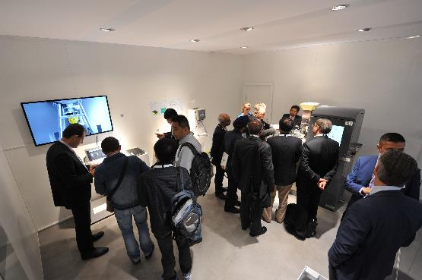

High resolution image available from nikki@thewordsworkshop.co.uk

Further editorial information from:
Steve Jordan
The Words Workshop Ltd
Tel: +44 (0)1908 695500
E-mail: steve@thewordsworkshop.co.uk

Business enquiries to:
GEA Pharma Systems
E-mail: pharma@gea.com
www.gea.com

About GEA Group
GEA Group is one of the largest suppliers of single-source solutions for the processing and packaging industries, including the food, dairy, beverage, pharmaceutical and chemical. As an international technology group, the company focuses on process technology and components for sophisticated production processes. In 2014, GEA generated consolidated sales of approximately EUR 4.5 billion, more than 70% of which came from the food sector, which is a long-term growth industry. The group employed about 18,000 people worldwide as of December 31, 2014. GEA Group is a market and technology leader in its business areas. It is listed in Germany’s MDAX stock index (G1A, WKN 660 200). In addition, GEA is a constituent of one of the MSCI Global Sustainability Indices. Further information is available at gea.com

