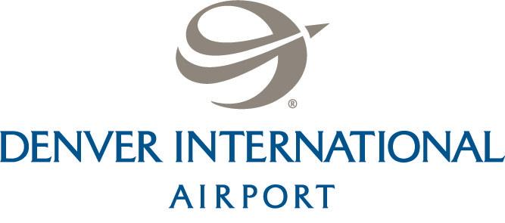

June 1, 2015

For Immediate Release
CONTACT: Mindy Crane, DIA – 303-342-2227
Meghan Dougherty/Laurie Meza
Communication Infrastructure Group
Cell: 720-560-0177 / 303-881-4507
O: 303-670-2537
Meghan@cig-pr.com/Laurie@cig-pr.com

Denver International Airport and the Westin Announces November 19 Opening Date for the new Westin Denver International Airport

Westin Guest Room Unveiled with Opening Day Countdown Clock in
Denver International Airport’s Main Terminal

Denver, CO –Today, Denver International Airport (DIA) and the Westin announced that it will officially open the Westin Denver International Airport, Denver’s newest world-class hotel and conference center, at 3 p.m. on November 19, 2015. The 433,000 square foot, 14-story hotel, with 519 guest rooms, will serve as a modern day oasis for both business and leisure travelers at the fifth busiest airport in the United States.

“Adding a state-of-the-art hotel and conference center to our international airport places our region front and center as a leader in travel, transportation and tourism,” said Denver Mayor Michael B. Hancock. “We now look to the completed vision of a commuter rail that will soon connect DIA to downtown Denver, creating additional economic opportunities along the Peña Boulevard corridor stretching to our city core.”

The architecturally inventive hotel, designed entirely with walls of towering, shimmering glass, overlooks both the mountains and DIA flight paths, and is part of Denver’s new Hotel and Transit Center program. Building upon imagery of flight and aviation, the sleek form resembles a bird with its wings extended as it hovers above the public plaza, framing and accenting the acclaimed tents of the Jeppesen Terminal. The floor-to-ceiling windows, which make up the entire wall of every one of the 519 guest rooms and 35 suites, offer expansive views of Denver’s signature Rocky Mountains and Colorado’s High Plains.

“We are thrilled to be delivering our brand promise For A Better You to Denver International Airport before the busy holiday travel season begins,” said Tom Curley, general manager of The Westin Denver International Airport. “As one of the fastest growing cities in the country, Denver is primed to soon have a hotel with refreshing ambience that allows the traveler to feel well while on the road, as well as a conference and transit center that will connect more people with everything the Rocky Mountains have to offer.”

Offering revitalizing comfort and innovative technology, each room has one of Westin’s signature Heavenly® Beds and Heavenly® Bath amenities, including the Heavenly® Shower. The 37,000 square-foot conference center is one of the few above-ground conference centers located at an airport, and will feature a Grand ballroom, junior ballroom, and 15 additional meeting/board rooms, bringing it to a total of 19 meeting rooms. The meeting space also boasts a 10,000 square foot pre-function area that showcases a panoramic three-story floor to ceiling glass wall that is approximately 100 ft. wide, providing a light and airy unique meeting space. The views are equally impressive from the top-story pool and WestinWORKOUT® Fitness Studio, located in the “saddle” of the building.

In addition to the hotel and conference center, there will be an 82,000 square foot open air public plaza that will become Denver’s newest venue for entertainment and relaxation and will create a community connection between the airport and downtown Denver through special event programming. by Denver Arts and Venues.

“Denver International Airport’s new Westin hotel, transit center, commuter rail connection and open air plaza will bring new amenities to our passengers that will enhance their experience and help us remain competitive,” said airport CEO Kim Day. “We look forward to November when we can share this new experience with passengers and show them why sleeping at the airport just become ‘heavenly’.”

ABOUT DENVER INTERNATIONAL AIRPORT:
Denver International Airport is the 15th-busiest airport in the world and the fifth-busiest airport in the United States. With more than 53 million passengers traveling through the airport each year, DIA is one of the busiest airline hubs in the world’s largest aviation market. DIA is the primary economic engine for the state of Colorado, generating more than $26 billion for the region annually. For more information visit, check us out on YouTube, Pinterest, and Instagram, like us on Facebook and follow us on Twitter.

ABOUT WESTIN HOTELS & RESORTS:
Westin Hotels & Resorts has been a leader in wellness and hospitality for more than a decade. Today, Westin has more than 200 hotels and resorts in nearly 40 countries and territories, and is owned by Starwood Hotels & Resorts Worldwide, Inc., one of the leading hotel and leisure companies in the world with more than 1,200 properties in 100 countries and over 180,000 employees at its owned and managed properties. Starwood is a fully integrated owner, operator and franchisor of hotels, resorts and residences with the following internationally renowned brands: St. Regis®, The Luxury Collection®, W®, Westin®, Le Méridien®, Sheraton®, Four Points® by Sheraton, Aloft®, element® and the recently introduced Tribute Portfolio™. The Company boasts one of the industry’s leading loyalty programs, Starwood Preferred Guest (SPG®), allowing members to earn and redeem points for room stays, room upgrades and flights, with no blackout dates. Starwood recently announced plans to spin off its Starwood Vacation Ownership, Inc. business, a premier provider of world-class vacation experiences through villa-style resorts and privileged access to Starwood brands, into a standalone public company by the end of 2015. For more information, please visit http://www.starwoodhotels.com.

###

