the nation’s top young historians compete in the Kenneth E. Behring National History Day Contest

WASHINGTON, D.C. – On June 14 through18 nearly 3,000 middle and high school students from around the world will compete at the University of Maryland in College Park in the 2015 Kenneth E. Behring National History Day Contest. National History Day invites the press and public to view the top projects of the more than 600,000 students that compete in the National History Day Contest. The top entries from state and national affiliate competitions take part in the weeklong program held each June. Contestants represent all 50 states, the District of Columbia, American Samoa, Guam, Puerto Rico and international schools in Central America, China, Korea, and South Asia. Students independently research a topic based upon an annual theme and present their findings in a documentary, exhibit, paper, performance or website. The 2015 theme is “Leadership and Legacy in History.” To view a video about the contest, click here.

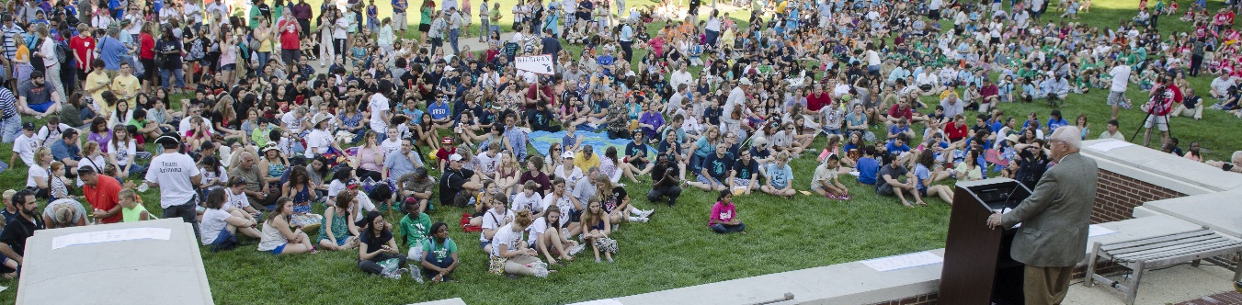
NHD participants at the opening ceremony at the University of Maryland in 2014
“This event is much more than just reciting history facts,” said National History Day (NHD) Executive Director Cathy Gorn. “These young historians spend an entire year researching their projects and scouring primary and secondary sources. Students compile all of these findings into projects that emphasize their individual talents and skills. The result is astonishing! I never cease to be amazed by the breadth and quality of projects.”

Founded in 1974, National History Day (NHD) has grown from a contest of a few hundred students to a multi-national initiative that influences more than half a million students, who are guided by more than 30,000 teachers.

Numerous awards are granted to both students and teachers including the following:
- First-place entries in the junior documentary, exhibit, paper, performance and website categories earn the designation, National Endowment for the Humanities (NEH) Scholar and receive an award sponsored by the NEH.
- First-place entries in the senior documentary categories receive a $5,000 award from HISTORY®. An outstanding senior entry connected to a historic site and a senior project with an international theme will also receive these awards.
- Two history teachers will be recognized as Patricia Behring Teachers of the Year. One teacher each is chosen from the junior and senior divisions and receives an award of $10,000. The nominees for this award are selected from the affiliate winners who each received a $500 award.
- Two entries from each NHD affiliate receive an “Outstanding Affiliate Entry” award sponsored by the National Park Service.
- More than 20 special awards are presented for topics ranging from African-American History to World War II. These prizes are sponsored by organizations from around the country and are presented to exceptional entries.
- Three senior participants will receive full or partial scholarships from Case Western Reserve University, Chaminade University, and the University of Maryland, College Park. These awards are chosen by representatives of the universities.

The contest this year includes the following three events.
Night at the Museum: Each NHD affiliate and state chooses one exhibit entry for display at the Smithsonian’s National Museum of American History Kenneth E. Behring Center on Wednesday, June 17 from 10 a.m.-7:30 p.m. This event allows the public to view a selection of the projects in the exhibit category. From 5-7 p.m., NHD hosts “Night at the Museum,” an open house for participants, teachers, and families to discuss their exhibits. The evening features a presentation by one student from the performance category.

Breakfast on the Hill: Selected history students from around the country join legislative staff and representatives for “Breakfast on the Hill,” Wednesday, June 17, 2015 at the Congressional Visitors Center. NHD is working with the National Endowment for the Humanities (NEH) to bring together the lawmakers creating history today and the young historians of tomorrow. More than 70 students from 48 of the NHD affiliates will meet with their senators and representatives in both a group setting and small group office meetings following the meal.

National History Day Contest Awards Ceremony: The final awards ceremony is on Thursday, June 18 from 8:30 a.m.-12:00 p.m. at the Xfinity Center at the University of Maryland. The ceremony begins with a colorful parade of all affiliates and is live-streamed on NHD.org by HISTORY®. Following the ceremony, awards will be announced via NHD social media outlets and posted on the NHD website.

NHD is a non-profit education organization in College Park, MD. Established in 1974, NHD offers year-long academic programs that engage over half a million middle- and high-school students around the world annually in conducting original research on historical topics of interest. These research-based projects are entered into contests at the local and affiliate levels, where the top student projects have the opportunity to advance to the National Contest at the University of Maryland at College Park. NHD also seeks to improve the quality of history education by providing professional development opportunities and curriculum materials for educators. NHD is sponsored in part by Kenneth E. Behring, Patricia Behring, HISTORY®, Jostens, the National Endowment for the Humanities, the National Park Service, Southwest Airlines, the Joe Weider Foundation, and the WEM 2000 Foundation of the Dorsey & Whitney Foundation. For more information, visit nhd.org.

###

