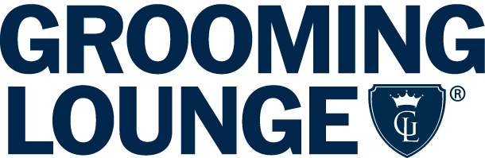

Survey Results Reveal The Gifts Dads Really Want for Father’s Day

This Father’s Day season, GroomingLounge.com, the nation’s premier resource for men’s grooming, set out to help dads get what they really want -- be it classic sneakers, a fancy safety razor or just a nap. GroomingLounge.com just released the results from their comprehensive survey and here’s what many different types of Fathers are hoping for…

The Jon Stewart type, who happily spends his down time playing with his kids, would like:
- Gear Gift: Bowers & Wilkins P7 Mobile Hi-Fi headphones
- Clothing Gift: Warby Parker Sunglasses
- Experience Gift: To be left alone to take a nap
- Grooming Gift: Grooming Lounge Greatest ShaveEver Kit

The Matthew McConaughey type, who finds his zen while exploring some new off-the-grid place, could really use the following:
- Gear Gift: Baladeo Locker Multi-Tool
- Clothing Gift: Saturday Surf NYC Esquina Cotton Jacquard Shirt
- Experience Gift: Landmark Festival Tickets
- Grooming Gift: Grooming Lounge Double-Edged Safety Razor

The Patrick Dempsey type, who likely spends his free time working on a new running/biking/kayaking personal best, would appreciate:
- Gear Gift: Ampstrip Heart Rate Monitor
- Clothing Gift: Shinola Runwell Watch
- Experience Gift: Tickets to a game
- Grooming Gift: Grooming Lounge Deodorant of the Month Club

The Kanye West type, who appreciates the finer things in life and can be especially hard to shop for, may want:
- Gear Gift: The Irish Man Whiskey
- Clothing Gift: Apple Watch
- Experience Gift: Spa Day
- Grooming Gift: Grooming Lounge Badger Hair Brush

The Jay-Z type, who knows his way around an airport and is on first name basis with the front-desk staff at their favorite hotels, would appreciate:
- Gear Gift: McGraw Earth & Sky Collection wallet
- Clothing /Accessories Gift: Filson Small Duffle Bag
- Experience Gift: Chef’s Table at the hottest new restaurant
- Grooming Gift: Aqua Di Parma Intensa Oud Cologne

The Ben Affleck type, who can often be found in his lucky mustard-stained tee throughout playoff season, tells us he would like:
- Gear Gift: High-Tech Underwear
- Clothing Gift: Adidas Stan Smith Classic Sneakers
- Experience: Tickets to a game
- Grooming Gift: Grooming Lounge Whole Shebang Kit

The most popular gifts overall were the The Irish Man Whiskey, Aqua Di Parma Intensa Oud Cologne, tickets to a game and the Grooming Lounge Greatest Shave Ever kit. The most popular write-in (especially among guys that work with computers) was the Apple watch.

Click here for the survey.
Follow: @groominglounge
#FathersDayGiftsThatDontSuck

###
About Grooming Lounge
Grooming Lounge is the country’s premiere destination for upscale men’s grooming products, services and advice. Open 24/7 worldwide at www.groominglounge.com, the company also has iconic Barbershop & Spa locations exclusively for men in Washington, DC and Northern, VA, with franchise opportunities open nationwide and its own line of custom-formulated Men’s Grooming Solutions.

