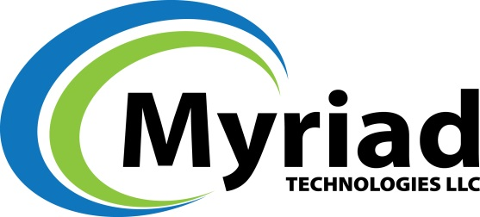

MYRIAD TECHNOLOGIES, LLC., ACQUIRES INTEREST IN NO RUSH CHARGE REPROGRAPHICS INC. (NRC).
Los Angeles, CA — June 22, 2015 — Myriad Technologies, LLC., a premier provider of ESI Consulting, Data Processing and Online Review Platforms with sophisticated analytics, as well as in-house Computer Forensic Services, announced today that it has acquired an interest in No Rush Charge Reprographics (NRC), Inc. –a traditional Litigation Support and Document Management company with offices in Los Angeles (CA), Long Beach (CA), Irvine (CA) and Las Vegas (NV).
Clients of Myriad Technologies will now have immediate access to expansive Litigation Support and Document Management Solutions that bring added value to the litigation case management process.
“The minority acquisition in NRC builds upon our strategic growth initiatives to provide single source case management solutions to our clients. With the addition of NRC services, we now have the ability to convert hard-copy discovery documents and process this information in our eDiscovery technology solutions. Further, with our recent acquisition of Summit Co-Locate, we can host and store all case data in our secure facility”
- William Sampson, COO of Myriad Technologies.
“We are pleased and excited to have Myriad Technologies LLC be our eDiscovery partner of choice. With Myriad’s extensive understanding of the eDiscovery process, solutions and commitment to client satisfaction, NRC believes this to be a tremendous value to our long standing and future clients”
- Frank Rodriguez CEO of NRC Inc.
Details of the transaction were not available.

About Myriad Technologies
Based in Los Angeles, CA., Myriad Technologies, LLC. is a comprehensive document and eDiscovery solutions provider serving law firms, corporations and government agencies. Myriad Technologies consultative approach leverages proven technology, professional resources, and optimized workflows to provide our customers a competitive advantage with maximum value.

About No Rush Charge Reprographics (NRC)
NRC specializes in fast, accurate reproduction of large and complex document productions both on-and off-site. With the highest level of integrity, providing exceptional capabilities and tremendous capacity while always monitoring and ensuring remarkable quality.

For Information Contact:

Anthony R. Bentancourt
Myriad Technologies LLC.
700 Wilshire Blvd.
Suite: 510
Los Angeles, CA. 90017
(213) 634-1500
www.gomyriad.com

Or Follow Us At:

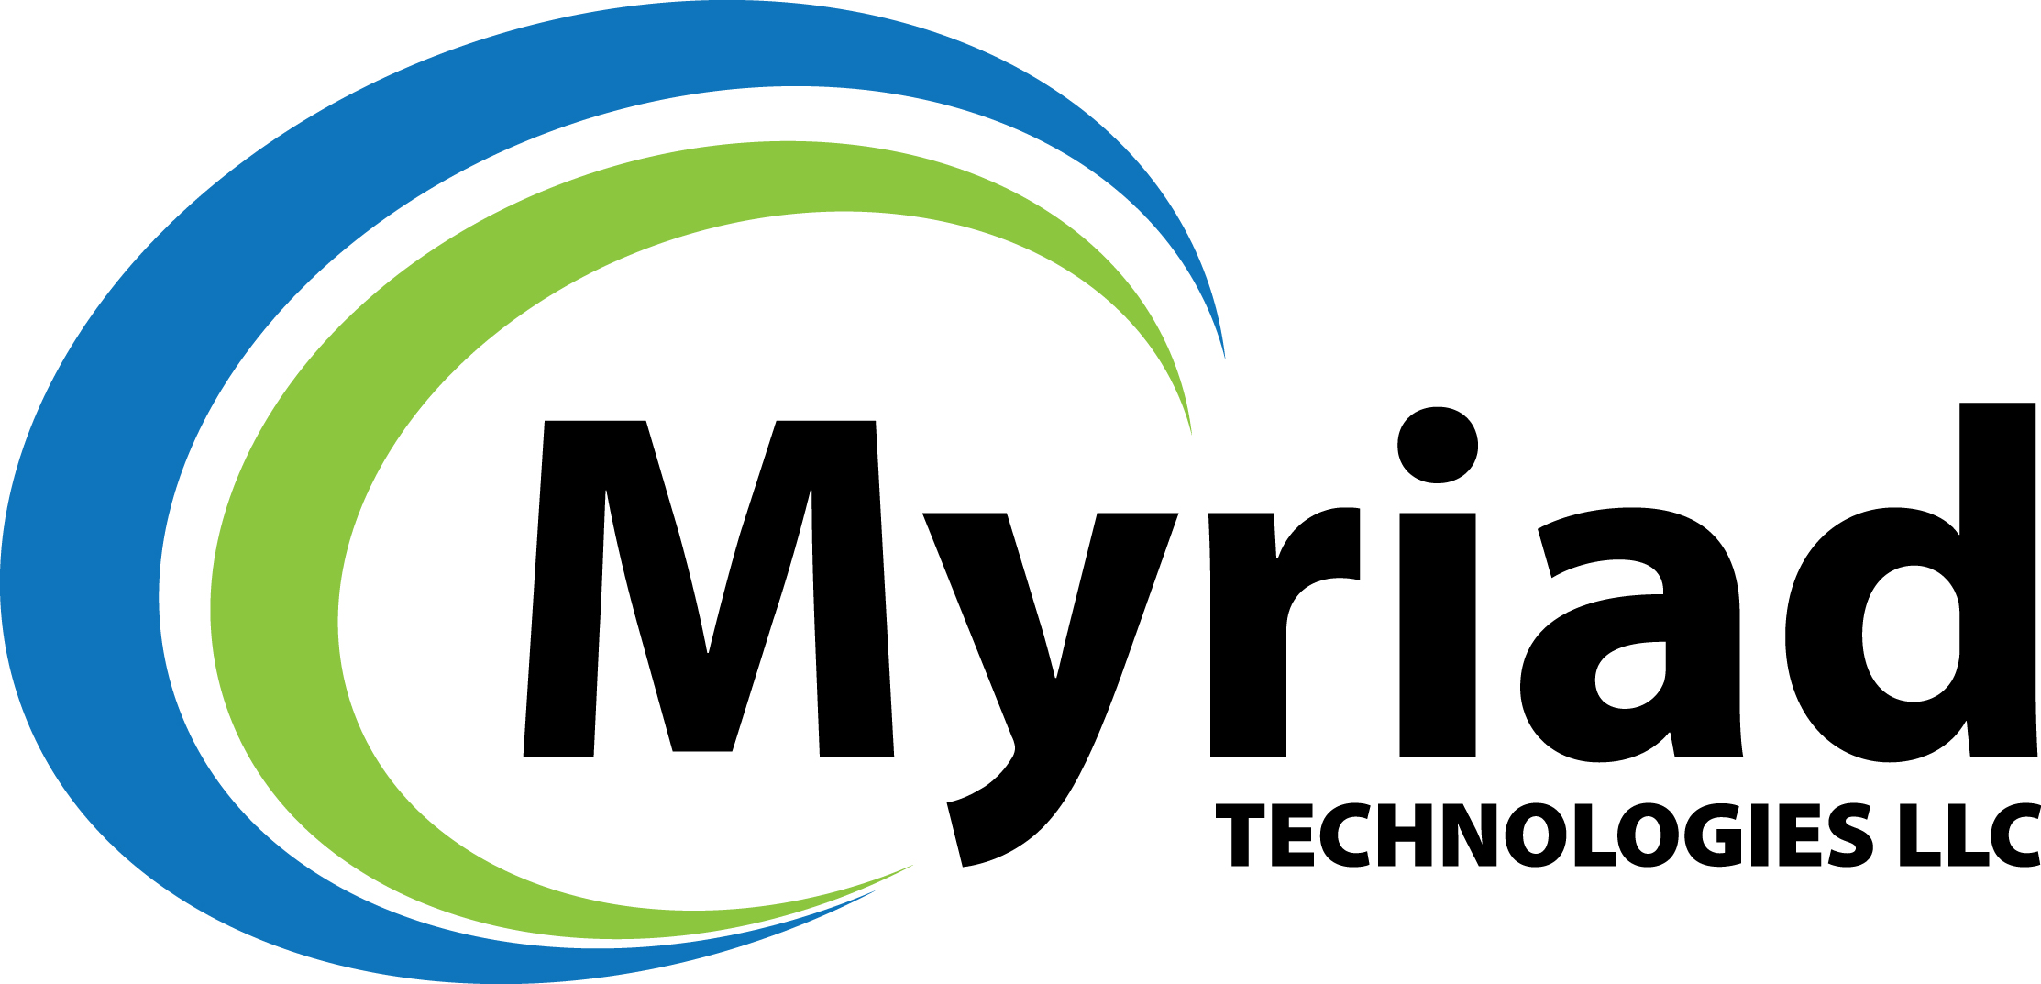

For Information Contact:

Frank Rodriguez
No Rush Charge Reprographics LLC.
510 West 6th Street
Suite: 430
Los Angeles, CA. 90014
(213) 258-2790
www.norushcharge.com

Or Follow Us At:

