
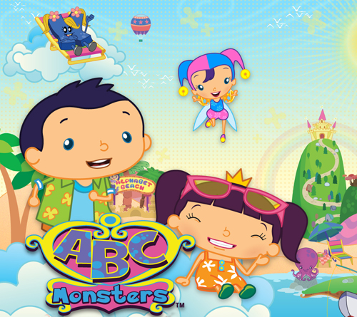


NCIRCLE ENTERTAINMENT ENRICHES ITS FAMILY DVD CATALOG
WITH THE ACQUISITION OF TWO TERRIFIC KIDS’ PROPERTIES

Animated Feature Film “Houdini” and Preschool Series “ABC Monsters”
Will Premiere on DVD and Other Platforms this Summer

DALLAS, TX, June 22, 2015 – NCircle Entertainment, the largest independent studio for children’s non-theatrical DVDs in the U.S., is proud to announce the acquisition of two new properties: ABC Monsters, an adventure-filled preschool series developed by Animasia Studio, and Houdini, a magical feature-length animated film for elementary-aged kids, produced by Dandelooo. ABC Monsters will launch on DVD on August 25 with the first title in the series, and Houdini will premiere in the U.S. on DVD on September 15. NCircle also plans to release these titles across digital platforms.

“We’re excited to be expanding our catalog of quality family programming with ABC Monsters and Houdini, which appeal to two of our core audiences,” said Mary Flynn, NCircle’s Vice President of Sales, Content and Acquisitions. “ABC Monsters is a terrific new series for little ones that presents early learning concepts in a fun and engaging way. Houdini is a beautiful animated feature about the life of the great magician that will mesmerize the grade-school set. Parents and kids have some great entertainment coming their way this summer with these two releases!”

ABC Monsters introduces preschoolers to the alphabet with colorful characters and stories that make learning fun. According to Edmund Chan, Managing Director of Animasia Studio, "We are very glad to be able to team up with NCircle Entertainment to bring ABC Monsters content into the North American market. It's definitely a big push for the ABC Monsters brand, and the beginning of a great venture together."

Houdini is an animated feature film that follows the story of a 12-year boy who follows his dream to become a world-class magician. “Our team in Paris is thrilled at our new partnership with NCircle Entertainment,” said Emmanuèle Pétry Sirvin of Dandelooo. “The launch of Houdini in America has special significance, knowing that this amazingly talented boy was born in Europe, then sailed to the United States where he became the greatest magician of all time.”

About NCircle Entertainment:

NCircle specializes in the sales, marketing, and distribution of children and family entertainment, and is a trusted brand for high-quality, age-appropriate content. As the largest independent studio for children’s non-theatrical DVDs, NCircle’s portfolio includes many of the most loved and best-selling children’s brands. Key brands currently in NCircle’s vast library include Octonauts, The Cat in the Hat Knows a Lot About That!, Mike the Knight, Pocoyo, Dino Dan, Sid the Science Kid, Doozers, and Gumby, as well as the Academy Award-nominated short films, The Gruffalo and Room on the Broom. For more information, please visit: www.ncircleentertainment.com
NCircle is a subsidiary of Alliance Entertainment.

For more information, contact:
Krystle Bersch, kryber@ncircleentertainment.com

