***For immediate release: Slice of Americana pizza competition set for 4th of July; the winner will receive a free international trip to compete against world pizzaioli***

Oxford, MS — In the heart of the Americana Music Triangle lies Oxford, Mississippi. Oxford also serves as the heart of the pizza industry as home base for PMQ Pizza Magazine and the United States Pizza Team. To celebrate Independence Day, PMQ will bring together pizzaioli (pizza makers) from throughout the United States for the Slice of Americana pizza culinary competition. Hand-rafted pizza, children’s activities and more brings a festive atmosphere to the Powerhouse.

Learning from the tremendous success of last year, this event will be limited to 200 adults and more pizza will be provided along with light appetizers. Food will be served from 10:30 a.m.-12:30 p.m. with the competition from 12:30 p.m. to 3:30 p.m. Soda and water are part of the ticket price but beers will be available at a cash bar for $3. Bar proceeds go to support the Oxford Film Festival. Fans of pizza can watch the exhibition, enjoy live music or participate in the lively family activities.

To be held as part of the Lafayette-Oxford-University Fourth of July community celebrations in Oxford, the event is open to the public but attendees need a ticket. Tickets can be purchased at <http://sliceofamericana.bpt.me/> or are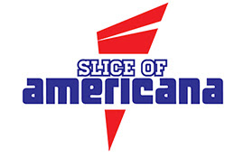 available at the door. Advanced ticket purchases are suggested in order to be able to provide enough pizza for everyone. Hand-crafted by our culinary experts from throughout the country, the pizzas will be fun creations to sample.

The cost is $12.50 online and at the door for adults. Tickets are $5 for kids 12 and under. Children, 3 and under, are free. For $30, you can purchase two adult tickets and a child entrance. For $40, you can purchase two adult tickets and up to 4 kids entrances (save $5!).

The winner of the Slice of Americana pizza culinary competition will win a place on the U.S. Pizza Team and a free trip to compete in the World Pizza Championships in 2015.

Events for the Fourth of July celebration continue in the Grove at The University of Mississippi at 4 p.m. with the L-O-U Community band and more acts to follow on the Grove stage. Fireworks begin over Oxford-University Stadium-Swayze Field at nightfall around 9 p.m.

For more information, please contact Melanie Addington via email at Melanie@pmq.com.

The U.S. Pizza Team consists of expert pizza makers and dough-spinning acrobatic performers from pizza restaurants across the United States. The squad won the Team Acrobatics World Championship in Salsomaggiore, Italy, in 2011. PMQ Pizza Magazine, the leading national trade 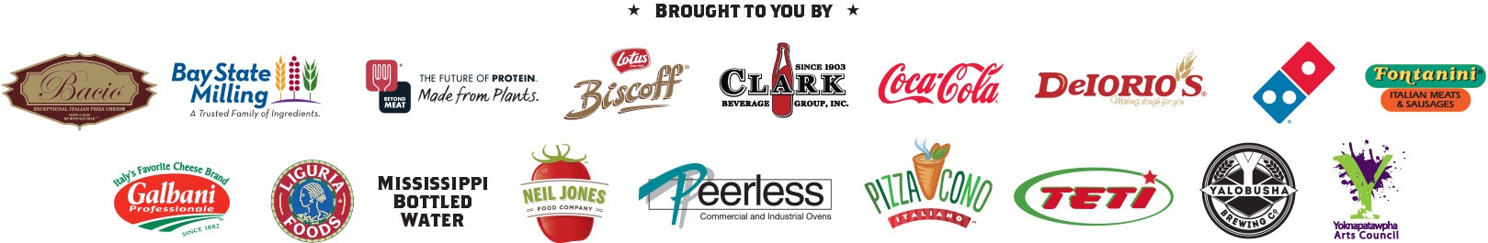publication for the pizza restaurant industry, created the U.S. Pizza Team in 2000.