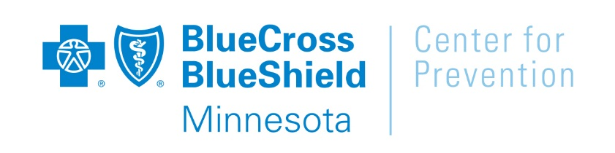

**Contact:**

Katy Schultz, Communications

Center for Prevention

651-662-8487 (office)

612-247-2873 (cell)

[katy.schultz@bluecrossmn.com](mailto:katy.schultz@bluecrossmn.com)

**FOR IMMEDIATE RELEASE**

**Blue Cross and Blue Shield of Minnesota Initiative**

**Aims to Reduce Barriers to Physical Activity**

*Ten organizations will explore ways to make their communities more inviting places*

*for physical activity, utilizing financial support from the Center for Prevention*

**EAGAN, MINN. (June 24, 2015)** – Whether it’s for recreation or transportation, Minnesota’s warmer months inspire many to be more physically active. Unfortunately, some Minnesota communities lack the amenities and infrastructure to support and encourage walking, biking and other healthy activities.

In an effort to make neighborhoods more amenable to walking, biking and other forms of physical activity, the Center for Prevention at Blue Cross and Blue Shield of Minnesota (Blue Cross) is awarding funding for 10 demonstration projects. These temporary, low-cost projects will help illustrate how small changes to our surroundings make it easier for people to be physically active. And, by giving people opportunities to experience their neighborhoods in a new way, these projects also aim to build support and momentum for more permanent, long-term changes within communities.

Active Places demonstration projects will be taking place throughout the state between June and October. The 10 organizations that have been awarded financial and technical assistance from the Center for Prevention include:

**Ventura Village Neighborhood** will provide Somali elders and youth places to play bocce ball, a sport that has cultural significance, encourages physical activity and creates intergenerational connections.

**Milaca Fine Arts Council** will create a temporary park where events and activities will be held in conjunction with the local farmers market. The park will serve as a place to connect with other community members while also encouraging residents to utilize established walking routes.

**Asian Economic Development Association** will transform an underutilized space into a green and welcoming public plaza. Temporary bike lanes and walkways will also be incorporated to encourage physical activity within the neighborhood.

**Corcoran Neighborhood Organization** will encourage community members to reimagine a public space by creating a temporary public plaza, adjacent to the local light rail transit station. A farmers market, fitness classes and other programming will inspire physical activity and community connections.

**Lake Street Council** will transform Minneapolis’ 29th Street into a community gathering space and pedestrian connection between the neighborhood, the Midtown greenway and the Lake Street transit and business corridor.

**Minneapolis Heart Institute Foundation** will implement a weeklong demonstration at elementary and high schools in New Ulm. The project aims to show how improvements to the school’s arrival and departure areas can be used to encourage walking and biking to and from school.

**The City of Hopkins** will engage community members in testing designs for The Artery, a connection between Hopkins’ planned light rail transit station and its historic downtown. Elements of the temporary installation include a farmers market and cycle track, along with bikes that will be available to test out the planned “living street.”

**Healthy Duluth** will use temporary parklets to demonstrate how outdoor public spaces can create economic benefits while also promoting active lifestyles.

**Friendly Streets Initiative** will collaborate with local artists to transform eight bridges over I-94, making them more safe and attractive for walkers and bikers.

**City of Cloquet** will introduce temporary bike lanes and incorporate bump-outs in two separate areas of downtown Cloquet. The goal is for these temporary changes to inspire more permanent infrastructure improvements within the community.

“Our surroundings have a significant impact on our health and wellbeing, including our opportunities to be physically active,” said Janelle Waldock, director of the Center for Prevention. “Blue Cross is proud to support organizations throughout Minnesota that share our commitment to creating spaces where people feel safe and inspired to be active. We hope our funding enables them to gain the public support needed to drive more long-term, permanent community change.”

Active Places demonstration projects were selected through a competitive process. Preference was given to organizations that expressed a commitment to community engagement and that focused on creating opportunities for those who commonly face barriers to physical activity.

**About the Center for Prevention**

The Center for Prevention at Blue Cross and Blue Shield of Minnesota delivers on Blue Cross’ long-term commitment to improve the health of all Minnesotans by tackling the leading root causes of preventable disease: tobacco use, lack of physical activity and unhealthy eating. Funded through proceeds from Blue Cross’ historic lawsuit against the tobacco industry, we collaborate with organizations statewide to increase health equity, transform communities and create a healthier state. Visit CenterforPreventionMN.com for more information.

**About Blue Cross and Blue Shield of Minnesota**

Blue Cross and Blue Shield of Minnesota (bluecrossmn.com), with headquarters in the St. Paul suburb of Eagan, was chartered in 1933 as Minnesota’s first health plan and continues to carry out its charter mission today as a health company: to promote a wider, more economical and timely availability of health services for the people of Minnesota. Blue Cross is a not-for-profit, taxable organization. Blue Cross and Blue Shield of Minnesota is an independent licensee of the Blue Cross and Blue Shield Association, headquartered in Chicago.

###