**Press Release Contacts:**

**For Immediate Release** Vinitaly International

International Media Dept.

+39 045 8101447

[media@vinitalytour.com](mailto:media@vinitalytour.com)

[www.vinitalytour.com](http://www.vinitalytour.com)

Twitter: @VinitalyTour

Join Vinitaly International Network on LinkedIn

**Vinitaly together with Sopexa and other wine associations sets out to win over Chinese consumers in Shanghai**

Seven months after announcing its return to Shanghai, on the first of July Vinitaly International took part in the official press conference for the presentation of the first edition of the Shanghai Wine & Dine Festival. All the key players of this new venture are now ready to step on board to organize what is going to be the largest b2c event of the food and wine sector that China has ever seen. During this consumer-orientated event, to be held from the 18th to the 20th of September, Vinitaly will be the sole organizer of the Italian national pavilion presenting a combination of Italy’s best food and wine.

The three-day event is organized by Shanghai’s most influential daily newspaper, the Shanghai Morning Post, by the largest ticketing service in China, and by the most widespread credit card in the Country, Unionpay, together with Bank of Communications.

Sopexa China, Conseil Interpofessionel du Vin de Bordeaux (CIVB), Wine Australia, Wines of Chile, Rioja, Wines of Argentina and the US foreign trade office will take the field together with Vinitaly.

The press conference was opened by Yang Wei Zhong, editor in chief of the Shanghai Morning Post, who explained the reason behind the launch of the new Festival: why this year and why in Shanghai.

The city has always shown a strong inclination towards looking beyond China’s borders and embracing Western lifestyle without giving up its individual Chinese character and traditions.

A metropolis that in the last two years has seen its wine consumers increasingly grow despite the fact that numbers are not all that promising in other parts of China.

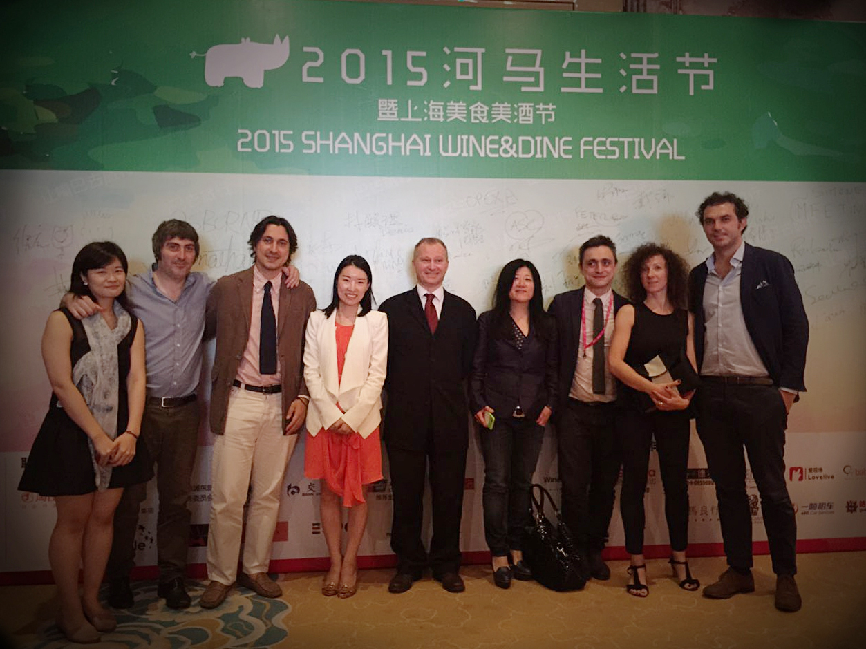

Shanghai remains nonetheless a point of reference for the entire country and the crossroad for all new Chinese consumer trends.

Weng Tao then passed the floor to Stevie Kim, Managing Director of Vinialy International, who spoke in the name of all national pavilions that will be present at the Festival.

“It is a very important year for Vinitaly and Italian wine” Stevie Kim reminded attending journalists. “For the first time in the history of Universal Exhibitions there is a pavilion entirely dedicated to wine and Chinese is the second language that has been used in its interior. Lets not forget that next year it will be Vinitaly’s fiftieth anniversary in Verona and, with our experience, we are ready to tackle a new kind of event in Shanghai, entirely consumer-orientated, where also food will play an important role. Since it is more approachable by final consumers it will act as driving force for wine”.

(<http://tinyurl.com/paavzr8>; <http://tinyurl.com/p7v8nhz>)

As during Expo Roadshow and the Off-site Showcase in Chengdu, Vinitaly will collaborate with local Italian wine importers, who are the first to have a natural interest in “selling more bottles of wine than in the past”.

One of the key moments of the event in Shanghai will be the recruitment of some of the city’s top Italian cooks and key players of the local food & beverage made in Italy. The Italian general consul in Shanghai, Stefano Beltrame, was also present at the press conference and took to the stage to launch the beginning of ticket sales. Once again Mr Beltrame highlighted the importance of achieving a coordinated action that may transform itself into tangible business for Italian wineries in one of the most difficult and promising markets in the world.

**About:**

Veronafiere is the leading organizer of trade shows in Italy including Vinitaly (www.vinitaly.com), the largest wine and spirits fair in the world. During its 49th edition Vinitaly counted some 4.000 exhibitors on a 100.000 square meter area and 150.000 visitors including more than 2.600 journalists from 46 different countries. The next edition of the fair will take place on 10 - 13 April 2016.

The premier event to Vinitaly, OperaWine (www.vinitalyinternational.com) “Finest Italian Wines: 100 Great Producers,” will unite international wine professionals on April 9th in the heart of Verona, offering them the unique opportunity to discover and taste the wines of the 100 Best Italian Producers, as selected by Wine Spectator. Since 1998 Vinitaly International travels to several countries such as Russia, China, USA and Hong Kong thanks to its strategic arm abroad, Vinitaly International. In February 2014 Vinitaly International launched an educational project, the Vinitaly International Academy (VIA) with the aim of divulging and broadcasting the excellence and diversity of Italian wine around the globe. VIA has now also created its very first Certification Course with the aim of creating new Ambassadors of Italian Wine in the World.

###