**My Plates releases 7-letter personalized plates for good!**

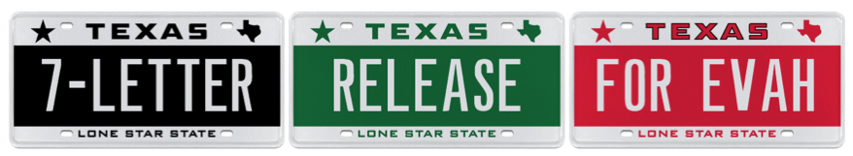

July 7, 2015 (Austin, TX) When My Plates first released 7-letter plates for a limited time back in 2011, Texans got to tell stories on their personalized plates in a way they’d not been able to before. Now the state’s official vendor for specialty license plates has decided to move away from their 7-day limited events and make 7-letter plates available on a daily basis, to allow Texans that extra level of 7-letter personalized freedom, forever!

Since My Plates first released 7 letter plates over four years ago, they have sold more than 13,900 in Texas. Considering that there are literally millions of combinations you can create when using up to 7 alphanumeric characters on a plate, from full words to multiple shorter words, as well as using plate speak and numerals, the personalized message possibilities are seemingly endless.

Whether you’re an ALL STAR, a TOP COOK, or even a TRUCKER, My Plates is confident they have an available MESSAGE for you. Whether YOU LIKE to go BOATING or prefer RUNNING, or maybe a plate for GOLFERS and HUNTERS, the good news is that 7-letters will become available on an everyday basis from July 7, 2015 until well, FOREVER!

So, if you’re the BIGGEST or the BADDEST, or maybe you’re the COOLEST or you think you’re THE BEST? One thing FOR SURE is that you’d better be the FASTEST to get the plate YOU WANT, as that would just be AWESOME.



To create a 7-letter personalized plate, simply visit the My Plates home page [www.myplates.com](http://www.myplates.com) seven days a week.

____________________________________________________________

Contact Steve Farrar at (512) 633-7978 or [steve@myplates.com](mailto:kristy@myplates.com)

**My Plates** designs and markets new specialty license plates as a vendor for the Texas Department of Motor Vehicles. Texans have bought more than 237,000 My Plates since November 2009, putting more than $30M in the state general revenue fund. My Plates’ goal is to create a long-term, mutually beneficial relationship designed to maximize revenues for the state through the sale of My Plates specialty plates. [www.myplates.com](http://www.myplates.com).

**The Texas Department of Motor Vehicles (TxDMV)** is charged with overseeing the state’s motor vehicle services that provide consumer protection, assist motor vehicle-related businesses and raise revenue for the state. For every $1 it spends, the TxDMV returns $10 to build and maintain highways, roads and bridges and provide needed services to Texans. The agency registers more than 23.8 million vehicles; regulates vehicle dealers; credentials buses and big trucks for intrastate and interstate commerce; issues oversize and overweight permits; and awards grants to law enforcement agencies to reduce vehicle burglaries and thefts. Learn more at [www.TxDMV.gov](http://www.TxDMV.gov).

TERMINOLOGY

-“Specialty” plate refers to any official license plate other than the state’s general issue plate.

-Specialty plates can be “personalized” plates, but they don’t have to be.

Image Download Links:

7-LETTER RELEASE FOR EVAH

<https://ce9a9387e1bc258c3cfa-af7906f4e771b24864bbfa3048e4a635.ssl.cf2.rackcdn.com/7%20Letter%20release%20for%20evah.png>

Multiple 7-Letter plates

<https://ce9a9387e1bc258c3cfa-af7906f4e771b24864bbfa3048e4a635.ssl.cf2.rackcdn.com/7%20Letter%20biggest,%20the%20best,%20baddest,%20etc..png>

7-Letter Black Plate

<https://ce9a9387e1bc258c3cfa-af7906f4e771b24864bbfa3048e4a635.ssl.cf2.rackcdn.com/7-Letter%20Black%20plate.png>

**Fun 7-LETTER Trivia:**

There is a seven-letter word in the English language that contains ten additional words without rearranging any of its letters. Do you know the word?

Answer:

THEREIN: THE, THERE, HE, HER, HERE, HEREIN, ERE, RE, REIN, IN.