  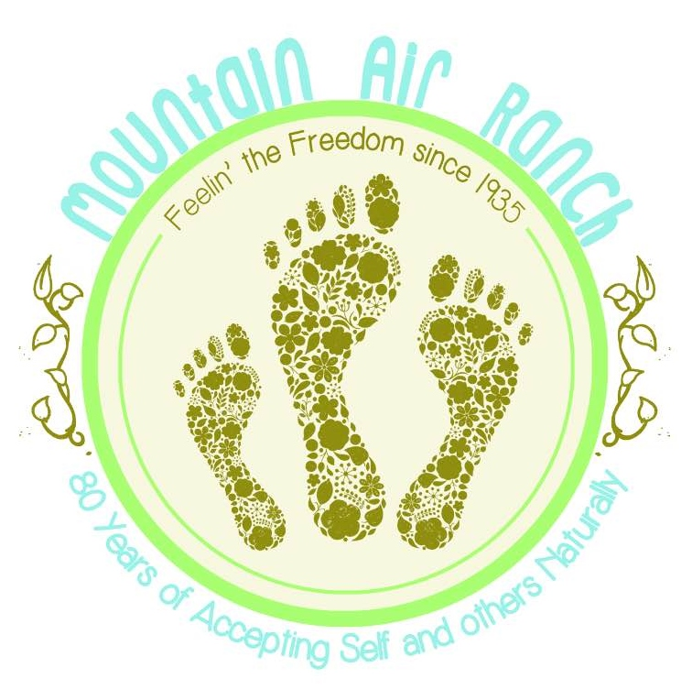
    - july 10, 11, 12 2015
    - Mountain air ranch
    - 80th anniversary celebration
  The oldest Family Nudist Resort in Colorado is celebrating 80 years of accepting self and others naturally. We are conveniently located in the foothills just 26 miles southwest from the center of Denver. MAR offers 10 miles of scenic hiking trails, heated pool, hot tub, sauna, massage, clubhouse, private dining, RV/tent camping and lodging.
  Friday Night BBQ and Open Mic
  Saturday Artisan Booths, Poolside Bands Luau & Pig Roast
  Game Night
  National Nude Recreation Week Annual Skinny Dip Saturday at 1:00 FREE TO THE PUBLIC Help us break the last record!
  Sunday Start your day with Champagne Brunch. Professional Body Painting all day, with parade and prizes
  Mountain Air Ranch
  Call for more information
  303-697-4083
  Find us on line
  www.trynude.com look for us on Facebook

