Media Contact:
Meaghan Morin
973-655-4333
morinm@mail.montclair.edu
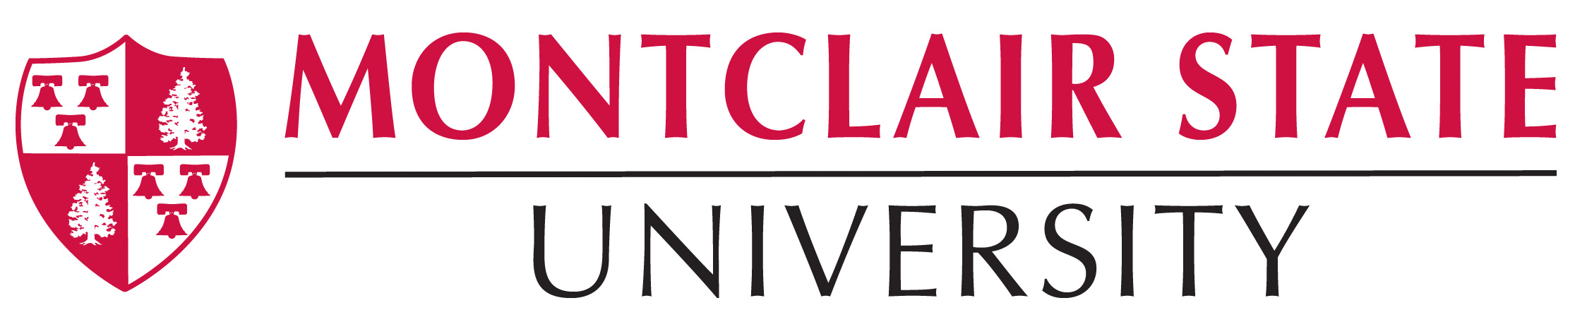
FOR IMMEDIATE RELEASE

Montclair State University Receives $20 Million Gift
Anonymous gift is largest in the University’s 107-year history
__________________________________________________________________________
Montclair, NJ, July 8, 2015 – Montclair State University today announced that it has received a $20 million anonymous gift, which is the single largest donation that the University has received in its 107-year history.
Funds from the gift will be dedicated to support the University’s School of Business and to advance its mission of transforming today’s students into tomorrow’s business leaders, successful entrepreneurs and industry innovators.
“Montclair State is both grateful and honored to receive this extraordinary gift and the recognition that comes with it of the quality of education that this University has made available to the people of New Jersey,” said Montclair State University President Susan A. Cole in announcing the gift. “At a time when governmental funding for public higher education institutions continues to decline, we are especially grateful for the substantial support of donors who believe in our commitment to meeting the expanding educational needs of the State.”
The gift comes at a period of unprecedented growth, expansion and opportunity at Montclair State. Today, the University’s more than 20,000 graduate and undergraduate students are enrolled in over 300 doctoral, master’s and baccalaureate degree programs. Enriched scholarship and research activities from a top-tier faculty have enhanced the University’s reputation both within New Jersey and beyond. This fall, another record-setting number of qualified applicants will result in continued growth in enrollments.
In September, the University will open a new state-of-the-art facility for its School of Business, under the leadership of a new dean, Dr. Greg Cant. The 143,000 square-foot School of Business building will provide the School’s 2,500 students with a $66 million high-tech learning environment, featuring a 150-seat lecture hall, classrooms and computer labs, a hub for the Feliciano Center for Entrepreneurship as well as market research/analysis labs and a financial trading floor.
”This historic gift provides us with an extra level of support to continue developing and expanding our high demand programs in Entrepreneurship, Accounting, and Sports Events and Tourism Marketing, and our innovative new programs in Business Analytics, Forensic Accounting and Real Estate,” said Cant. “We can also sharpen our focus on dynamic partnerships with leading national companies, such as KPMG and Enterprise, which provide hands-on learning and career opportunities for our students.”
This fall, the University will also open a new Center for Environmental and Life Sciences, a 100,000 square-foot, $55 million facility, providing an array of laboratories for research in the environmental and pharmaceutical sciences, as well as advanced instructional spaces. The University will also be breaking ground in the next few weeks on a $53 million facility for its growing programs in Communications and Media.

# # #
______________________________________________________________________
Montclair State University
Building on a distinguished 107-year history, Montclair State University is proud to be a leading institution of higher education in New Jersey. The University’s six colleges and schools serve over 20,000 undergraduate and graduate students in more than 300 doctoral, master's and baccalaureate level programs. Situated on a beautiful, 250-acre suburban campus just 14 miles from New York City, Montclair State delivers the instructional and research resources of a large public university in a supportive, sophisticated and diverse academic environment.
montclair.edu

