Introducing WTR Racing
Get ready for some fast and furious racing, with the impeding launch of the world’s first Apple iOS racing game that combines both high speed street racing action, with tire screeching drift events.
WTR Racing is a fresh new launch from established mobile app and game developer Orb Vision that will set new standards in mobile racing gameplay for some time to come.
WTR is scheduled for release via the Apple Store for compatible iOS devices on July 10th, 2015. This is a free to play game, with optional in-game micro transaction purchases.
Game Features
Single Player Mode – Players follow the game storyline and compete against 6 separate racing crews. The goal of single player mode is to eliminate all 6 crews, and win the title of King of the Streets.
Multiplayer Mode – Players compete in head to head street and drift racing events. Success is recorded using a global leaderboard, where players in the online game compete for rankings.
Available Vehicles – The player has over 50 different cars to choose from, each of which can be customized in a number of ways.
Customization – Each of the 50 vehicles included in WTR Racing can be customized in two ways. Firstly the styling can be customized, color etc. Secondly, performance can be customized in various ways, to improve speed, handling, weight and acceleration.
Player Rewards – By connecting WTR Racing to the Game Center, a player gains access to a performance based reward system. They can win in-game cash and other bonuses by beating challenges, completing achievements, and also for moving up the multiplayer leaderboard.
Game Information
WTR Racing requires a device running Apple iOS 6 and an active internet connection.
The WTR Racing website can be found at:
http://www.wtrracing.com
The WTR Racing teaser trailer can be found at:
https://www.youtube.com/watch?v=u-QbMLKJeSw
Players who sigh to connect with the developers, and network with other players, can do so via Facebook and Twitter.
The WTR Racing Facebook page can be found at:
https://www.facebook.com/wtrracingpage
Follow @WTRRacing on Twitter or visit the Twitter URL for WTR Racing:
http://twitter.com/WTRRacing
Initial Gameplay Comments
WTR Racing has been pre-released to a number of testers, and the response has been overwhelmingly positive. Here are just a few of the things that the players testing WTR Racing have had to say so far:
“Fun and addictive, can’t put my phone down!”
“Love this game, brilliant graphics and action scenes, very challenging.”
“One of the best fames I’ve ever played.”

Screenshots
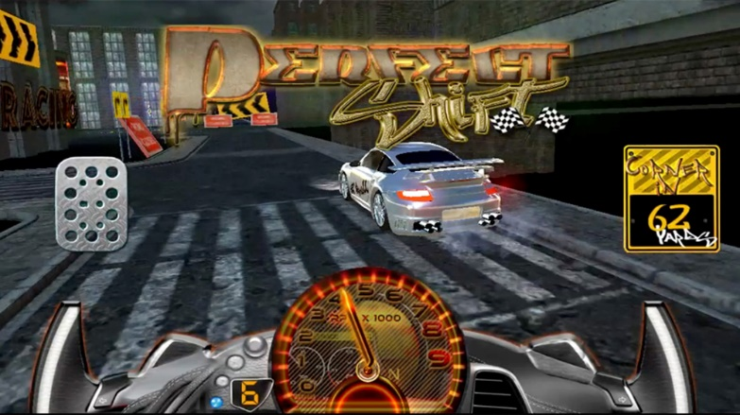 | 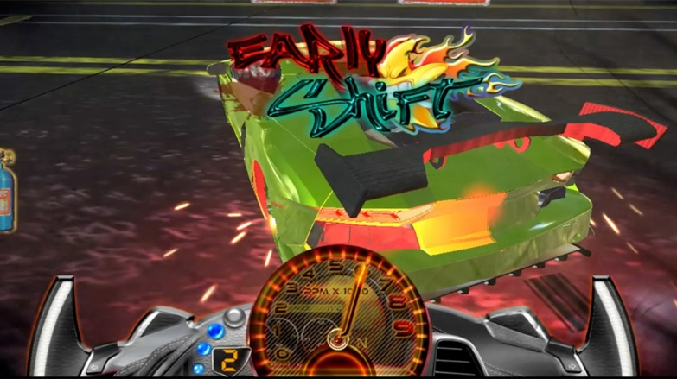
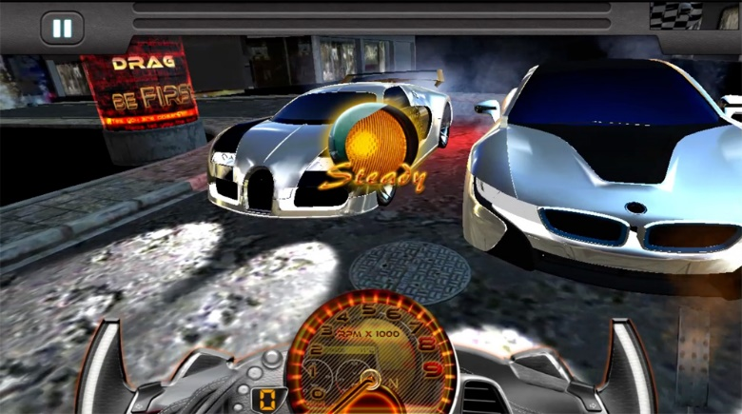 | 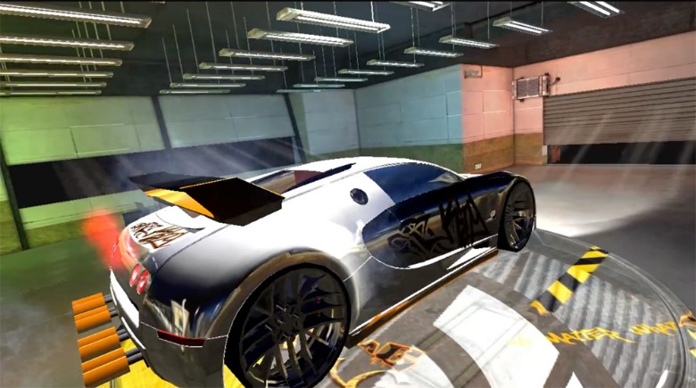

About Orb Vision
Orb Vision is a successful Apple iOS and Google Android mobile app developer, with a focus on developing interactive games that are engaging, rewarding and fun to play.
Since its inception in 2006, London based Orb Vision is noted for several high profile mobile games. This includes Real Time Racing, which has been downloaded over 1 million times. Other notable Orb Vision titles include Brain Bumble and WTR Racing.
Contacting Orb Vision
Orbvision Ltd
Email: abc@xzy.com
Telephone: +44 79 5021 0074
Address: 6 Edith Road, West Kensington, London. W14 9BA

