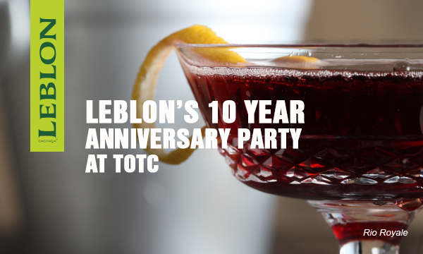

Media Contacts:
Whitney Peak, +1 212.741.2675 x1625, whitney@leblon.com

FOR IMMEDIATE RELEASE

LEBLON® Cachaça Celebrates Ten-Year Anniversary at Tales of the Cocktail with Unique Pairing Dinner

At the Event, Top Mixologists from Brazil and the U.S. create cocktails to pair with innovative southern cuisine from Coquette.

NEW YORK, July 17, 2015—LEBLON®, a premium artisanal spirit from Brazil and the most award-winning cachaça on the market, celebrated its Ten-Year Anniversary with a five course Cachaça dinner at New Orleans’s innovative Coquette restaurant on July 16th as part of the Tales of the Cocktail Spirited Dinner series. Leblon’s founder Steve Luttmann hosted the event. Felipe Jannuzzi, founder of Mapa da Cachaça (a reference about cachaça recognized as one of the best cultural projects in Brazil by the Federal Ministry of Culture) lead a special tasting of the Leblon portfolio, including the newest limited-release LEBLON cachaça expression Seleção Verde.

The menu for the dinner was created by chef/owner of Coquette, Michael Stoltzfus, and cocktail pairings were made by some of the top mixoligsits in Brazil and from around the U.S.:

Course 1
Southern Ceviches
Shrimp, Duck, Summer Squash

Paired with
Sunset in Leblon by Cari Hah of Los Angeles
Maison Leblon Reserva Especial, fresh pineapple, fresh lime juice and simple syrup. Topped with Champagne and Cedilla Liqueur de Açai. Served in a champagne flute, and garnished with a mint leaf.

Course 2
Chilled Corn Soup
Stuffed Pepper

Paired with
Leblon Brise by Alex Mesquita of Bar Paris, Rio de Janeiro
Leblon Cachaça, Yellow Chartreuse, fresh lime juice and basil syrup. Served up, in a coupe glass.

Course 3
Smoked Gulf fish
Plantains, Buttermilk

Paired with
Rabo de Burro by Talita Simões of Side Bar, São Paulo
Yerba mate-infused Leblon Cachaça, pineapple juice, fresh grapefruit juice and simple syrup. Served a lowball glass, and garnished with cardamom and cinnamon.

Course 4
Pork
Rice, Beans, Okra, Steamed Bread

Paired with
Leblon Celebration by Tony Harion of Belo Horizonte, Brazil
Leblon Cachaça, fresh pressed sugarcane juice, fresh lime juice, demerara syrup and Brazilian bitters. Served over ice in a wine glass, with a grapefruit twist.

Course 5
Baba Cachaça
Lime, Mint, Vanilla

Paired with
Garoto Old Fashioned by Daniel de Oliveira of Chicago
Peanut butter cup-infused Maison Leblon Reserva Especial, Giffard Banana Liqueur, Demerara syrup, Angostura and Bitter Truth chocolate bitters. Served in an old fashioned glass, and garnished with a lemon peel.

More information is available at http://talesofthecocktail.com/dining-events/leblon-10th-anniversary-dinner/.

About Leblon Cachaça
Leblon is a handcrafted premium artisanal Cachaça (pronounced ka-SHA-sa) produced at Maison Leblon in Minas Gerais, Brazil’s fertile agricultural heartland. Leblon is already a favorite alambique cachaça in top culinary venues in Brazil, where cachaça is the national spirit. It is also the key ingredient to the caipirinha (pronounced kai-pur-EEN-ya), the wildly popular, muddled lime cocktail and national treasure of Brazil.
Overseen by Gilles Merlet, one of the world’s preeminent Master Distillers, Leblon’s special quality is achieved with painstaking attention to every detail in the production process, from the cutting of the fresh sugar cane, fermentation, and distillation, to the filtering, blending, and resting in XO Cognac casks for up to six months. The result is a lively, fruity nose with complex layers of flavor and an ultra-smooth finish that is perfect alone, mixed with fruit juice, in a traditional Caipirinha, or as a Brazilian twist to any cocktail. Winner of “Best Cachaça” a record six times, as well as an unprecedented nine consecutive gold medals from 2006 to 2014 at the San Francisco World Spirits Competition, Leblon is available in all 50 U.S. States. Leblon is also widely sold in Europe, as well as Asia and Australia.
Leblon recently introduced Maison Leblon Reserva Especial, which is aged for two years in the highest grade, new Limousin French oak and expertly blended by Mr. Merlet. It earned “Best Cachaça - Double Gold” in the 2012 San Francisco World Spirits Competition; “Gold” in the 2013 San Francisco World Spirits Competition; and, “Gold Outstanding” in the 2013 International Wine & Spirits Competition.

The company also produces Cedilla Açai Liqueur, which is made by macerating Amazonian Sambazon Açai berries with the highest quality alambique Cachaça from Maison Leblon. Cedilla earned a “Best Fruit Liqueur - Double Gold” in the 2013 San Francisco World Spirits Competition.
The newest Leblon expression is the limited-release Maison Leblon Seleção Verde. Made from the most select sugar cane during the heart of the 2014 harvest, Seleção Verde is a still-strength unfiltered alambique cachaça from the Maison Leblon in Patos de Minas, Minas Gerais. With notes of lemongrass, lychee, and fresh citrus.

For more information, please visit www.leblon.com.
LEBLON is part of the portfolio of Bacardi Limited, headquartered in Hamilton, Bermuda. Bacardi Limited refers to the Bacardi group of companies, including Bacardi International Limited.

# # #

©2015 LEBLON Cachaça. Product of Brazil. Imported by Leblon USA Manhasset, NY. Alcohol 40% by volume.

