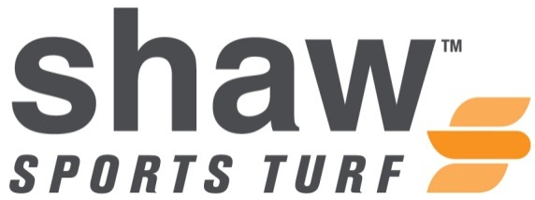

**FOR IMMEDIATE RELEASE CONTACT:** Todd Britton

Wednesday, July 28, 2015 [todd.britton@shawinc.com](mailto:todd.britton@shawinc.com)

(706) 217-9690

**HALL OF FAMER JOHN SMOLTZ DISCUSSES THE IMPACT OF SHAW SPORTS TURF ON BASEBALL**

**(CALHOUN, Georgia) -** Baseball’s newest Hall of Famer, John Smoltz, has worked with Shaw Sports Turf to develop the TruHop synthetic turf system for baseball.

Smoltz worked with the Shaw Sports Turf R&D department to develop the system, which can custom designed to meet the performance specifications of the customer.

Smoltz cites the consistency and availability of the system for hosting games. The system can be designed to feature turf on all parts of the field, including the mound, batter’s box, and base paths. Infill levels can be adjusted to different locations on the field to adjust the levels of firmness and speed.

“I’m telling you, it’s going to revolutionize the sport,” said Smoltz.

Smoltz has spent time at LakePoint Sporting Community in Georgia to help continue to develop the best baseball system available. LakePoint is the world’s largest tournament sports destination.

“My experience with Shaw Sports Turf has been incredible, said Smoltz. “I’ve been on all kinds of surfaces and played baseball my whole life. Their development of TruHop has been incredible. They’ve taken not only their R&D, but everything they have to create the most natural playing surface.”

The TruHop system has been installed throughout the country and is gaining momentum as the premier synthetic turf system for baseball.

“John Smoltz brings an extreme level of focus to everything he does,” said Dr. Phil Stricklen, Director of research and Development for Shaw Sports Turf. “His input has been invaluable and we are proud that he has helped us develop the best system available for baseball.”

**About Shaw Sports Turf**

A wholly-owned subsidiary of Berkshire Hathaway Inc., Shaw Industries is a full flooring provider to the residential and commercial markets. Shaw supplies carpet, hardwood, laminate, resilient, and tile/ stone flooring products, as well as synthetic turf.  Shaw Sports Turf is one of the leading synthetic turf companies in North America and has represented quality and innovation for more than two decades with over 1,500 successful installations, including an impressive list of high-profile field installations. For more information please visit [www.shawsportsturf.com](http://www.shawsportsturf.com), call 866-703-4004 or find us on [Facebook](http://www.facebook.com/ShawSportsTurf).

**###**