Shawcity’s New Website Promises Users a Better Experience

We’ve recently launched our new website so now it’s even easier for our customers to buy or hire instruments and access clearer product information. New and improved features on our mobile responsive site include:
*New* online checkout
Allowing customers to take control, you can now purchase from our entire product range via the web site. If you need a monitoring solution for VOCs, gas, sound, noise, vibration, air quality, dust, confined space, heat stress or accessories you can now search, buy and arrange delivery without picking up the phone. For any help or product advice you can still contact us.
*Improved* searching
For instant results we have simplified and improved the search functionality for the site and online product catalogue to help you find what you want quickly and easily. Detailed technical product data will help you in your decision-making and of course you can always contact us to discuss your requirements.

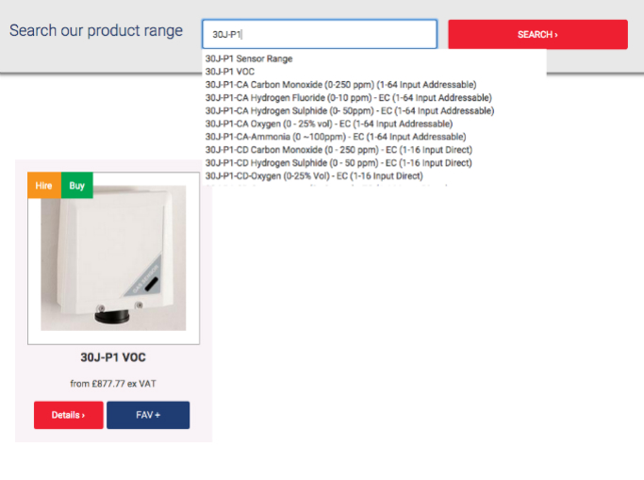

*Now available* online hire requests
Need to hire instruments? You can now request a quote online for any of our products available to hire. Just fill in the quick online form and we’ll be in touch with a bespoke price for your individual requirements.

Reflecting on the performance of the new site, Shawcity’s Managing Director Neil O’Regan said:
“We are already seeing the impact. Visitors are staying for considerably longer and viewing more pages, indicating the quality of the content has improved and the new site is offering a better service.
“Feedback tells us that customers like being able to purchase online, because it's at their convenience. A lot of our customers regularly work out in the field, so they have a real need for flexibility.
“Our aim is to keep adding industry updates, product and technical data to the site, as well as innovative new products, to continue to evolve a valuable information resource for anyone working in health and safety, occupational hygiene and environmental monitoring applications.”
To visit the new Shawcity site, go to: http://www.shawcity.co.uk/

