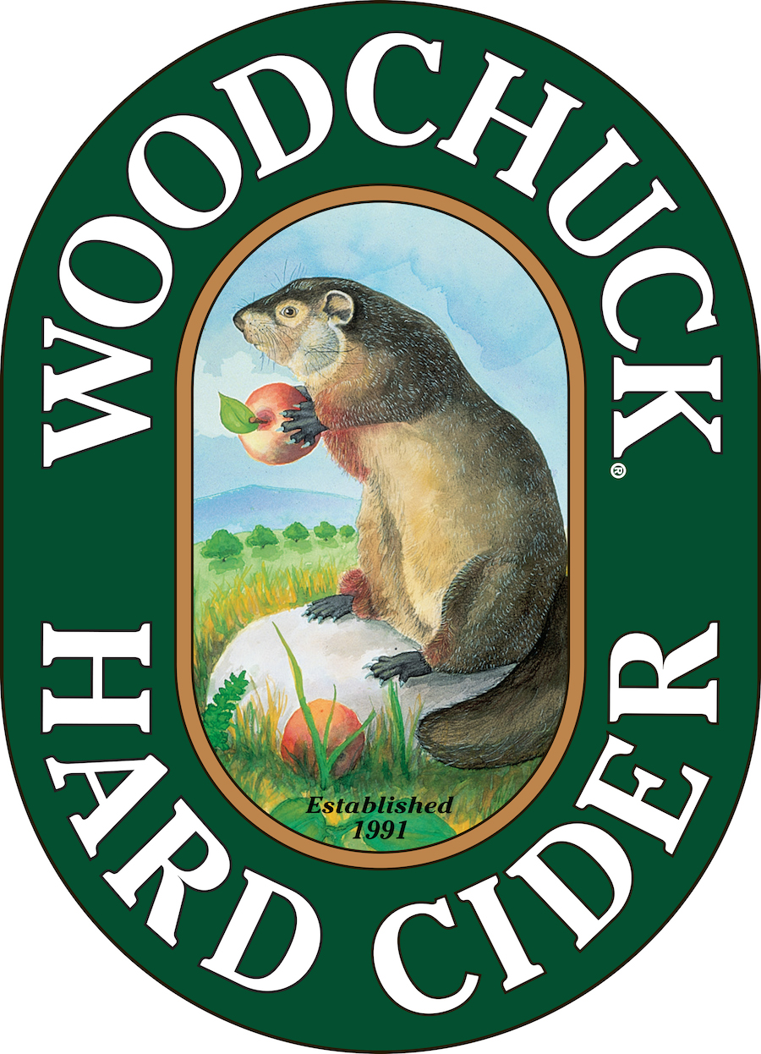

FOR IMMEDIATE RELEASE

Contact: Caitlin Stroupe
(802) 398-6958
cstroupe@vthardcider.com

Woodchuck® Presents Ciderstock™ Music Festival
- Second annual “Ciderbration” brings Cage the Elephant, New Politics and hard cider to Middlebury, VT—

AUGUST 5, 2015 MIDDLEBURY, Vt. —Ciderstock™ 2015 is coming to Middlebury Vermont on August 22, 2015. Presented by Woodchuck Hard Cider, Ciderstock is a daylong event featuring live music, great food trucks, and of course, Woodchuck cider held at the Cidery in Middlebury. Tickets ($25) are available via Ticketfly, and will be $30 day of.
This year’s musical line-up includes: Cage the Elephant, with special guests New Politic, Vermont’s own Kat Wright & The Indomitable Soul Band and Madaila.

The details:
What: Ciderstock 2015
When: August 22, 2015, 2pm – 10pm
Where: The Woodchuck Cidery, 1321 Exchange St, Middlebury, VT 05753
For tickets: http://www.woodchuck.com/ciderstock/index.php

“After the overwhelming response to our inaugural celebration, it was clear that Ciderstock is a tradition we need to continue,” said Woodchuck Marketing Director Bridget Blacklock. “Ciderstock allows us to share some of our favorite things with the Vermont community – and what’s better than a backyard party with great music and several thousand of your closest friends?”

Ciderstock guests will also have opportunity to meet the Cider Makers, take tours of the facility, sample new styles of cider, and kick back and enjoy lawn games with friends. Local food vendors, including Crescent Catering, Island Ice Cream, Ahli Baba’s, Smokin’ Pete’s BBQ, A&W, Thelma’s Bread Dough, and One Hearth Pizza will be on hand to sell their wares.

For press credentials, please contact Caitlin Stroupe at cstroupe@vthardcider.com, or (802) 398-6958.
###
About Woodchuck® Hard Cider
Woodchuck Hard Cider introduced the U.S. to the craft cider category 24 years ago after it was first handcrafted in a 2-car garage in Proctorsville, Vermont. Staying true to its roots, Woodchuck is dedicated exclusively to cider making. In other words, we “Give a ‘Chuck” about authenticity and handcrafting the best cider possible. Innovation is at the core of everything Woodchuck’s cider makers do, which is why they continuously strive to create unique new ciders using the finest ingredients. That attention to detail has paid off and Woodchuck Hard Cider has recently received awards at the World Expo of Beer, The Great Lakes International Cider and Perry Competition and the New York International Beer Competition. For more information about Woodchuck Hard Cider visit www.woodchuck.com, or download the new mobile app, available for iOS and Android users.

