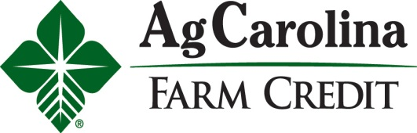
Contact: Linda Strickland
Email: lstrickland@agcarolina.com
(919) 250-9500 ext 214
www.agcarolina.com
August 4, 2015
Rural Visionaries to be Honored During Farm Credit Centennial
Nominations accepted at www.FarmCredit100.com
RALEIGH, NC – As part of the Farm Credit centennial celebration, AgCarolina Farm Credit is participating in the national Farm Credit 100 Fresh Perspectives Program. This nationwide search will identify and honor 100 leaders in the agricultural industry, who are changing the future of rural America.
“Farmers, as well as individuals who represent other agribusinesses, cooperatives, academic institutions, government agencies, community, and non-government organizations, are encouraged to apply,” said Dave Corum, AgCarolina President and CEO. “For a century, Farm Credit has worked side by side with the farmers, innovators, and entrepreneurs in the agricultural industry. We believe the future will be defined by individuals with fresh perspectives and insights within rural communities and agriculture,” he added.
Nomination information and additional details about the Farm Credit 100 Fresh Perspectives are available at www.FarmCredit100.com. Nominations will be accepted until December 18, 2015.
A panel of experts will evaluate the entrants and select the top 100 honorees to be announced during National Ag Week, March 14-18, 2016. These 100 individuals will be celebrated and supported at the national and local level in an effort to build awareness of and appreciation for rural American contributions to everyday life.
Of the Farm Credit 100 Fresh Perspectives honorees, 10 exceptional leaders will each receive a $10,000 award to help further their contributions to their community and to the ag industry. These 10 honorees and a guest will be invited to Washington, DC to participate in a special recognition event in 2016.
AgCarolina Farm Credit is a farmer owned financial cooperative with headquarters in Raleigh. They are the leading provider of credit to farmers in central and eastern North Carolina. AgCarolina Farm Credit has over $1.4 billion in loans and commitments outstanding to nearly 3,000 North Carolina farmers. Loans are made to finance land, homes, farm buildings, operating expenses, livestock and equipment, as well as other purposes. Credit life insurance, crop insurance, appraisal services, and leasing are also available through AgCarolina Farm Credit.

