PRESS RELEASE

For immediate release: 06 August 2015

imageHOLDERS Launches its Most Secure iPad and Tablet Enclosure Kiosk Range

imageHOLDERS today announced the launch of the Shell+ range of iPad and tablet kiosks, the most secure iPad and tablet enclosure kiosk available on the market.

The Shell+ is incredibly robust making it ideal for situations when staff can’t monitor public interaction all the time. The Shell+ range has been designed to seamlessly incorporate device integration without compromising on style and can securely house many devices alongside the tablet including; mobile payment, contactless readers, ID scanners, swipe card reader, EMV readers, barcode scanners and fingerprint scanners.

The Shell+ range is available in different size variations including the Shell+ 10, Shell+ 12 and Shell+ 14 to cover a multitude of different tablets available in today's market including but not limited to Apple iPads, Microsoft Surface, Samsung Galaxy Tabs and Google Nexus.

The Shell+ range is unique as it also includes an enclosure specifically designed for the Microsoft Surface 3 and Pro 3 with keyboard accessory. imageHOLDERS has also secured the official ‘Designed for Surface’ approval, cementing our position as trusted partners of Microsoft and assuring the enclosures are produced to the very highest standards.

Adrian Thompson, CEO, imageHOLDERS said: “the Shell+ range is our most secure tablet enclosure kiosk and we believe you won't find a tougher, more secure option on the market. Its ability to incorporate devices seamlessly into the enclosure whilst not compromising in its elegant design really sets it apart from all other tablet enclosures available.”

The Shell+ Range includes:
- Shell+ 10
- Shell+ 10 KEY: Designed specifically for the Microsoft Surface 3 with keyboard accessory
- Shell+ 12
- Shell+ 12 KEY: Designed specifically for the Microsoft Surface Pro 3 with keyboard accessory
- Shell+ 14

The Shell+ range is extremely flexible and can be counter mounted, wall mounted or freestanding to meet customer requirements.

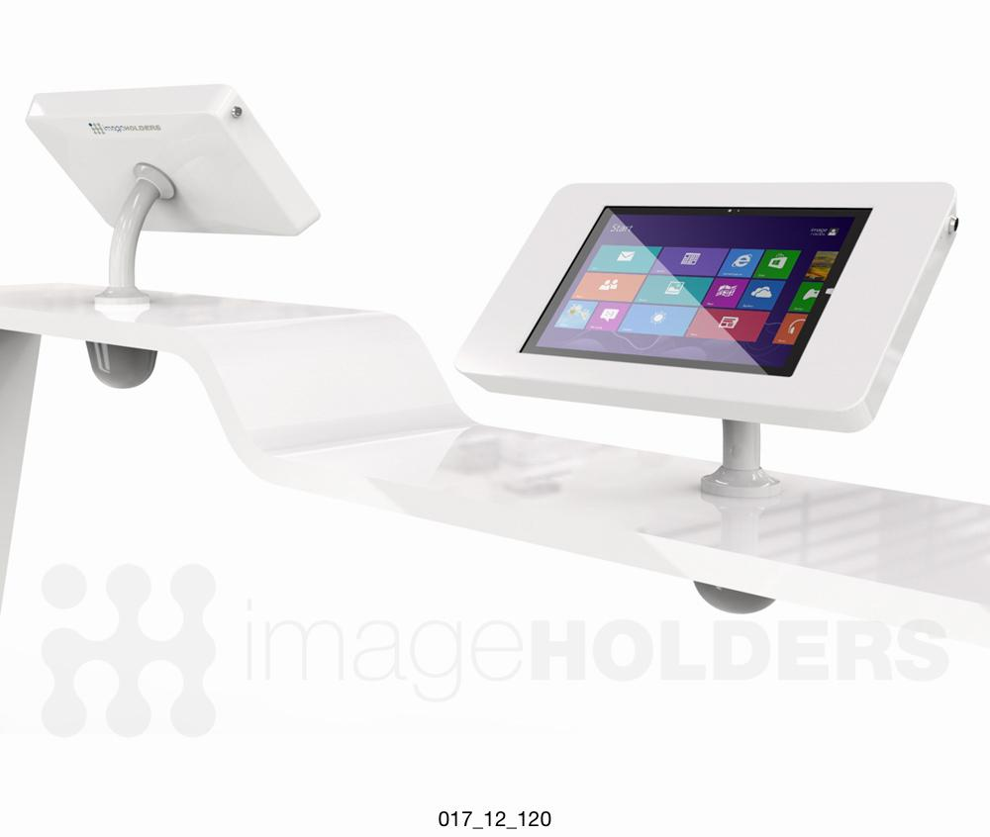

Image of imageHOLDERS Shell+ 12 counter mounted iPad and tablet enclosure kiosk.

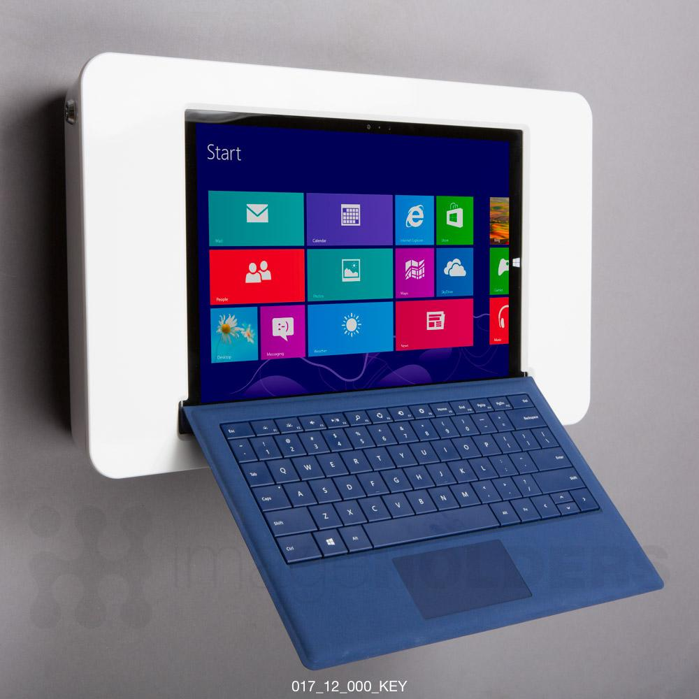
Image of imageHOLDERS Shell+12 wall mounted Microsoft Surface Pro 3 with keyboard enclosure kiosk.

- End -

Note to editors
imageHOLDERS was established in 1996 and is based in Poole, Dorset. Our dedicated team are experts in the design, development and manufacture of ipad and tablet enclosure kiosks.

Our stylish and secure range of iPad and tablet enclosure kiosks and M.POS solutions have helped some of the world's largest enterprises implement tablet technology in a number of environments. We support clients from a variety of industry sectors including hospitality, retail, leisure, automotive, casino, corporate and healthcare - all of which have seen the benefits of tablet enclosure kiosks first hand. We have a range of different products to suit all consumers needs from counter mounted and freestanding to wall mounted enclosures.

Contact
Keely Marsango
Digital Copywriter
keely@imageholders.co.uk

