**Protocol Insight™ Announces MIPI® UniPro (Unified Protocol)   
Protocol Conformance, Debug and Analysis Beta Release**

**UNI16COMP UniPro Test Executive™ offers CTS conformance testing, intelligent Trace Validation, Stimulus mode, Test Case Builder and stress testing**

Colorado Springs, Colorado, August 14, 2015 - Protocol Insight today announced the beta release of [UniPro](http://mipi.org/specifications/unipro-specifications) Test Executive. [UNI16COMP UniPro Test Executive](http://www.protocolinsight.com/unified-protocol-unipro/) extends the capabilities of their current UFS Test Executive to UniPro conformance testing and debugging. New capabilities of UniPro Test Executive include three distinct analysis modes and a new Statistics window.

Trace Validation mode

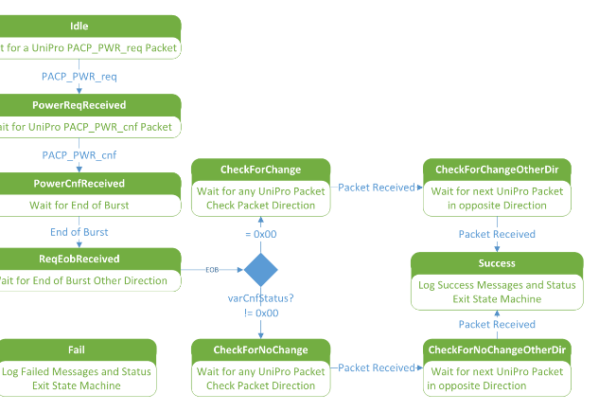 Intelligent Trace Validation mode identifies transactions on the UniPro bus by analyzing millions of packets in a trace capture, then evaluates the protocol sequences and individual packets for conformance to the UniPro 1.6 specification. With Trace Validation, complex transactions such as power mode changes, Link Startup Sequence and NAC/Replay events can be automatically analyzed and easily debugged.

CTS mode

In CTS mode Test Executive initiates conformance test cases, then uses the Trace Validation engine to verify that the resulting protocol sequences and packets conform to the UniPro v1.0 CTS.

Extensive reporting and analysis tools include reports by test parameters – status, test category, individual tests, or test rules, and by packet characteristics – packet number, byte, speed, link, etc. Summary and full reports and pass/fail reports are also provided.

Stimulus mode

Stimulus mode allows Test Executive to control the Keysight Technologies U4431A to create specific traffic on the bus, and also has the ability to do error insertion.

Statistics

The new Statistics window provides an overview of trace characteristics in Trace Validation mode, enabling sum, filter and sort by Tests, Variables, Attributes, or Values such as TRG_UPR, Start-of-burst and End-of-burst, NAC, and PACP_CAP.

**Pricing, configuration and availability:**

UNI16COMP UniPro Test Executive beta is shipping now, and operates in conjunction with the [Keysight Technologies U4431A MIPI M-PHY Protocol Analyzer](http://www.keysight.com/en/pd-2302494-pn-U4431A/mipi-m-phy-protocol-analyzer?cc=US&lc=eng). Contact sales@protocolinsight.com for pricing information or to request a demo or trail license.

[**About Protocol Insight:**](http://www.protocolinsight.com/about-protocol-insight/)

Protocol Insight ([www.protocolinsight.com](http://www.protocolinsight.com)) offers test and measurement (T&M) software tools to customers who are developing products for the mobile computing and cloud computing market, and consulting and design services to engineers designing serial protocol interfaces.

Protocol Insight staff have extensive experience developing T&M protocol tools, having been involved in the industry’s first Bluetooth, PCI Express, MIPI D-PHY and MIPI M-PHY protocol analyzer, exerciser, and compliance products.

Protocol Insight is a MIPI expert, with a background developing both D-PHY and M-PHY protocol exercisers and analyzers. Protocol Insight staff have contributed to the development of the UniPro standard thru the UniPro Working Group, and have had direct interaction and collaborated with strategic MIPI customers and industry leaders worldwide, in marketing, business development and co-development roles.

**About the MIPI Alliance**

The [MIPI Alliance](http://mipi.org/) is a global, collaborative organization comprised of companies that span the mobile ecosystem and are committed to defining and promoting interface specifications for mobile devices.

The MIPI® Alliance is a non-profit corporation that operates as an open membership organization. All companies in the mobile device industry are encouraged to join, including semiconductor companies, software vendors, IP providers, peripheral manufacturers, test labs and end product OEMs. Today, more than 250 member companies actively participate in the Alliance, developing interface specifications which drive consistency in processor and peripheral interfaces, promoting reuse and compatibility in mobile devices.

**Contact:**

Ross Nelson

+1 (503) 367-5656

rossn@protocolinsight.com

MIPI and the MIPI logo are a licensed trademark of the MIPI Alliance.

JEDEC® and the JEDEC logo are registered trademarks of JEDEC Solid State Technology Association.

PCI-SIG®, PCI™, PCI Express®, and PCIe® are registered or unregistered marks of PCI-SIG.

The Bluetooth figure mark, word mark and combined mark are the property of the Bluetooth SIG.