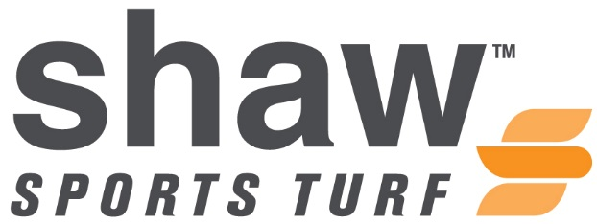
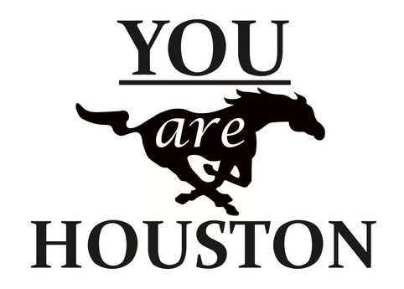

FOR IMMEDIATE RELEASE CONTACT: Cassie Cochran
Thursday, August 13, 2015 cassie.cochran@shawinc.com
(706)-618-0515

HOUSTON HIGH TO CONTINUE WINNING LEGACY WITH SHAW SPORTS TURF

(GERMANTOWN, Tennessee) – Houston High and Shaw Sports Turf are proud to announce that the first-ever synthetic turf field for the Houston High Mustangs is complete and ready for the school year.
Houston High School was established in 1989 and is located in the Shelby County suburban community of Germantown. It is the only high school in the Germantown Municipal School District. The district consists of 43,000 residents, and 1,890 of those residents attend Houston High.
Newsweek Magazine listed Houston High School as one of the "Best High Schools in America" in 2010, 2011, 2012, and 2013.
Houston won The Commercial Appeal's Best of the Preps award in 1996, a prestigious award for given to the most successful high school athletic department in Memphis and west Tennessee. Then in 1998, they began their current streak of 17 consecutive years (1998-2015) as the recipient of that award.

They have won 31 State Championships since opening in 1989, and last year 15 of the school’s 17 varsity sports went to the State Championship Tournament. That was more than any public school in the state.

Being the only high school in the Germantown Municipal School District, the natural grass field could no longer withstand or provide any benefit to the school and community.
“The new Shaw Sports Turf field solves a lot of problems for Houston High and takes pressure off of the outdoor facilities,” said the Athletic Surfaces Plus Project Consultant, Tim Cowan.
The Mustangs needed a field that could withstand heavy and multi-use, while providing maximum safety and performance.
According to the Chad Becker, District Director of Athletics, Shaw Sports Turf met all of Houston High School’s needs.
“After looking at all of the possible solutions, Shaw Sports Turf was the most aesthetic, highest quality, and financially the best option,” said Becker.
Several age groups and sports teams will be using the Shaw Sports Turf field including; football, marching band, track and field, boys and girls soccer, as well as an upcoming 5K and various other community events.
The Shaw Sports Turf field signals to the students and community that Houston High is interested in providing the absolute best, whom of which have been very enthusiastic throughout the field installation process.
“Everything with Shaw Sports Turf from the bid process, to design work, to the installation, has been exceptional. We look forward to the future and the possibilities of continuing to achieve more with them,” said the District Director of Athletics, said Becker.
The field is named after Principle Toyota, who was the field naming sponsor.
“From all of us at Principle Toyota, we consider it a true blessing to be in a position to support the Houston High School Athletics and Arts Foundation by sponsoring this beautiful new Shaw Sports Turf field,” said Principle Toyota General Manager, Todd Lochner. “We hope that every athlete that steps foot on this field remains safe and that they play the game with honesty, integrity, and a commitment to excellence.”
The first football game to be played on the Shaw Sports Turf field will be on August 21, against Ridgeway High School from Memphis, Tennessee.
“It has been a great honor to work with Houston High and Athletic Surfaces Plus,” said Shaw Sports Turf Territory Manager, Jimmy Marshall. “I look forward to the future together and wish Houston High the best of luck this school year. Go Mustangs!”
About Shaw Sports Turf:
A wholly-owned subsidiary of Berkshire Hathaway Inc., Shaw Industries is a full flooring provider to the residential and commercial markets. Shaw supplies carpet, hardwood, laminate, resilient, and tile/ stone flooring products, as well as synthetic turf. Shaw Sports Turf is one of the leading synthetic turf companies in North America and has represented quality and innovation for more than two decades with over 1,500 successful installations, including an impressive list of high-profile field installations. For more information please visit http://www.shawsportsturf.com, call 866-703-4004 or find us on Facebook.
###

