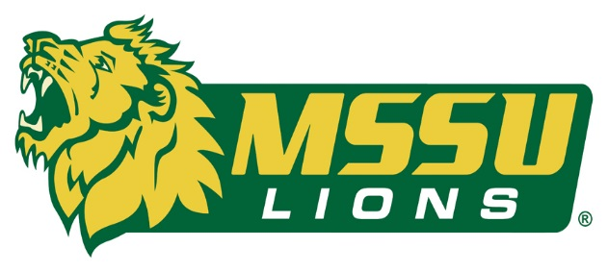
FOR IMMEDIATE RELEASE CONTACT: Cassie Cochran
Tuesday, August 18, 2015 cassie.cochran@shawinc.com
(706)-618-0515

MSSU IS READY FOR KICK-OFF ON THEIR BRAND NEW SHAW SPORTS TURF FIELD

(JOPLIN, Missouri)- Missouri Southern State University has completed installation of its brand new synthetic turf field. Shaw Sports Turf was the chosen turf manufacturer and provider.

The Lions are currently practicing on and counting down the days to kick-off on the Shaw Sports Turf field.

MSSU was founded in 1937 and has a current average enrollment of 5,600 students and more than 350 student-athletes

The university is within minutes of the Oklahoma, Kansas, and Arkansas borders. Historic Route 66 runs through the city, with the major metropolitan areas of Kansas City, Springfield, St. Louis and Tulsa just a few hours from the city limits.

The athletic teams at MSSU participate in NCAA Division II and compete in the Mid-America Intercollegiate Athletic Association (MIAA).

Synthetic turf fields are nothing new to the Lions. Fred G. Hughes Stadium was the first collegiate stadium in the state of Missouri to install an artificial playing surface when it opened in 1975.

Shaw Sports Turf was selected as the synthetic turf manufacturer and provider for MSSU this time for many reasons.

"We are very excited above having Shaw Turf on the football field,” said Jared Bruggeman, Director of Athletics at Missouri Southern. "With extensive research regarding quality, ease of maintenance, safety and affordability the committee was excited about the Momentum product. We look forward to a long and productive relationship with Shaw Sports Turf."

The Momentum synthetic turf system features Strenexe slit film fiber, a proven technology known for its durability and overall performance. The slit film fiber construction results in an “umbrella” effect that helps hold infill in and reduce overall fly-out.

The Baltimore Ravens play and practice on the Momentum system.

The football program is the only collegiate sport that will play games on the Shaw Sports Turf field. Soccer will occasionally play on the field if their grass facility isn’t playable. There are also local high school football programs that will use the field, as well.

The Shaw Sports Turf field is a quality addition to a facility that is in the process of a major overhaul. Southern recently constructed a $9.4 million end-zone facility, and the plan is to completely renovate the stadium in coming years.

Shaw Sports Turf will help Missouri Southern achieve its goals because the quality of the surface and safety of the players will be dramatically improved right away.

“It has been a great pleasure working with Missouri Southern State University,” says Shaw Sports Turf Territory Manager Nathan Henderson. “The facility looks incredible and I wish them the best of luck this school year!”

Mercy Hospital in Joplin helped with funding the Shaw Sports Turf field project.

The first game to be played on the field will be the MSSU Lions football team vs. Emporia State on September 3 at 7 p.m.

About Shaw Sports Turf:
A wholly-owned subsidiary of Berkshire Hathaway Inc., Shaw Industries is a full flooring provider to the residential and commercial markets. Shaw supplies carpet, hardwood, laminate, resilient, and tile/ stone flooring products, as well as synthetic turf. Shaw Sports Turf is one of the leading synthetic turf companies in North America and has represented quality and innovation for more than two decades with over 1,500 successful installations, including an impressive list of high-profile field installations. For more information please visit http://www.shawsportsturf.com, call 866-703-4004 or find us on Facebook.
###

