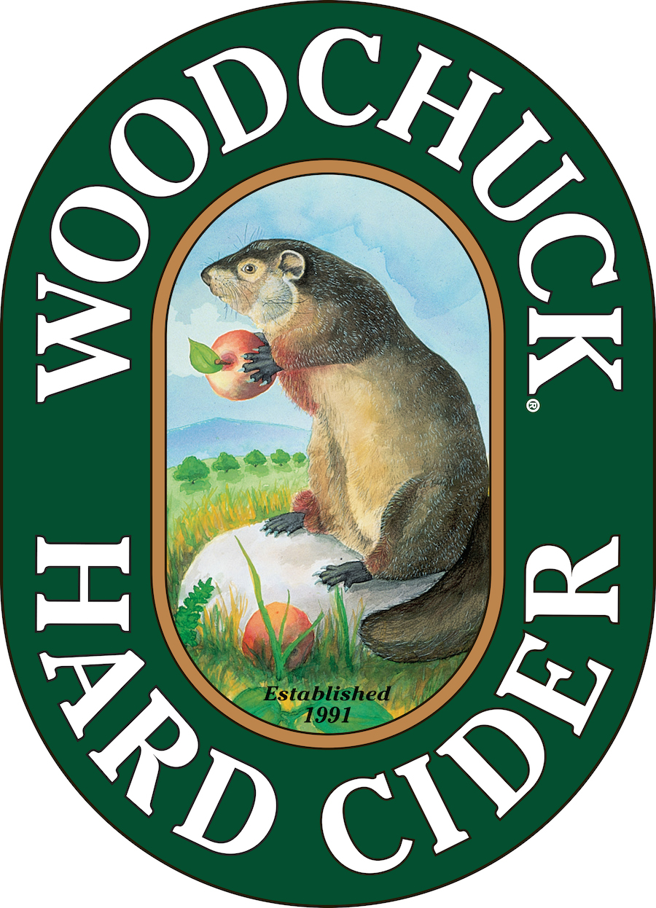

## FOR IMMEDIATE RELEASE

**Attention Assignment/Photo Editors**

**—**  **Woodchuck® presents Ciderstock™ Music Festival —**

What: *Ciderstock* Music Festival 2015 - Daylong celebration featuring live music, great food, and Woodchuck Hard Cider.

When: August 22, 2015, 2pm – 10pm

Where: The *Woodchuck* Cidery, 1321 Exchange St, Middlebury, VT 05753

Website: <http://www.woodchuck.com/ciderstock>

*Featured bands and schedule:*

3:00pm – 4:00pm: [Madaila](http://www.musicofmadaila.com/)

4:30pm – 5:30pm: [Kat Wright & The Indomitable Soul Band](http://www.katwrightsoulband.com/)

6:15pm – 7:30pm: [New Politics](http://newpoliticsrock.com/)

8:00pm – 9:30pm: [Cage the Elephant](http://www.cagetheelephant.com/)

Participating Food Vendors: [Crescent Catering](http://www.crescentfoodscatering.com/), [Island Ice Cream](http://www.islandhomemadeicecream.com/), [Ahli Baba’s Kabob Shop](https://plus.google.com/100400182419168121685/about?gl=us&hl=en), [Smokin Pete’s Barbecue](http://www.smokinpetes.com/), [A&W](http://www.awrestaurants.com/), [Thelma’s Bread Dough](https://www.facebook.com/ThelmasBreadDough), [One Hearth Pizza](http://www.onehearthvt.com/)

Coverage opportunities: cidery tours, backstage access, Cider Maker interviews and exclusive cider tasting at the Firkin Frenzy event.

B-roll and photos will be available on request.

**Contact:** Caitlin Stroupe

Office: (802) 398-6958

On Site: (802) 318-1504

cstroupe@vthardcider.com

**###**

# About Woodchuck® Hard Cider

Woodchuck Hard Cider introduced the U.S. to the craft cider category 24 years ago after it was first handcrafted in a 2-car garage in Proctorsville, Vermont. Staying true to its roots, Woodchuck is dedicated exclusively to cider making. In other words, we “Give a ‘Chuck” about authenticity and handcrafting the best cider possible. Innovation is at the core of everything Woodchuck’s cider makers do, which is why they continuously strive to create unique new ciders using the finest ingredients. That attention to detail has paid off and Woodchuck Hard Cider has recently received awards at the World Expo of Beer, The Great Lakes International Cider and Perry Competition and the New York International Beer Competition. For more information about Woodchuck Hard Cider visitwww.woodchuck.com, or download the new [mobile app](http://www.woodchuck.com/blog/introducing-the-woodchuck-mobile-app/), available for iOS and Android users.