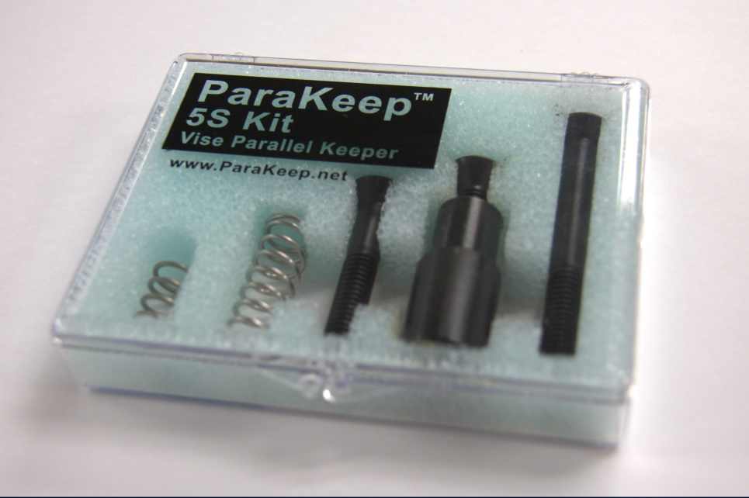

ParaKeep Time Study
 | Without ParaKeep | With ParaKeep
Vise set-ups per week | 2 | 2
Time per set-up | 5 Minutes | .5 Minutes
Machine shop rate | $60.00/Hour | $60.00/Hour
Cost per minute | $1.00 | $1.00
Cost per week | $10.00 | $1.00
Cost per year | $520.00 | $52.00
Savings per week | N/A | $9.00
Savings per year | N/A | $468.00

5S Kit will pay for itself in 4 weeks and then lead to $468.00 per year per vise.  A shop with 10 vises will have $4680.00 in bottom line savings per year. |  | With ParaKeep
 |  | 2

