News Release
For Immediate Release
Sept. 4, 2015

Contact:
Michael Sullivan
GOED Communications Director
801-538-8811
mgsullivan@utah.gov

Utah Aerospace Pathways Program Takes Flight
Major aerospace industry partners come together to hire students right out of high school

SALT LAKE CITY, UT— Governor Gary R. Herbert, along with Utah Aerospace industry partners and the Governor’s Office of Economic Development (GOED), held a press conference for a special announcement today at the FedEx sort facility in Salt Lake City.

Gov. Herbert announced the Utah Aerospace Pathways program, which will provide Utah students the opportunity to graduate high school with a certificate in aerospace manufacturing and begin an aerospace manufacturing career. This unique program has brought aerospace industry representatives, education leaders and government together in an unprecedented collaboration.

“The creation of the Utah Aerospace Pathways program will benefit Utah students for generations to come. This is among the first time industry partners and K-12 educators are working closely together to directly address their workforce needs in the state,” Gov. Herbert said. “We look forward to unlocking more opportunities with industry leaders to improve education and to ensure lasting economic growth in Utah.”

The collaboration started in March of this year with the goal of developing a pilot program for the 2015 school year. The first semester of the program will take place in high schools in Granite and Davis School Districts, while the second semester will take place at Davis Applied Technology College and Salt Lake Community College. Students will also participate in a paid internship during their senior year of high school.

“Improving our education system is the most important thing we can do to build a strong economy for the future,” said Larry Coughlin, general manager of Boeing Salt Lake. “This program provides students who have a passion for technology and innovation the opportunity to become familiar with aerospace manufacturing and get hands-on experiential learning."

Upon completing the UAP program, along with passing pre-employment requirements, students will be certified to begin work with one of the aerospace partners in Utah. Not only will the students begin work at a family-sustaining wage— many of the industry partners have agreed to provide tuition reimbursements after a minimum of one year working for the company. If the student prefers, they can pursue training within their company and work their way up there.

“We are thrilled for this opportunity to partner with K-12 to train students in aerospace manufacturing,” said Deneece Huftalin, president of Salt Lake Community College. “With this pathway, students will be able to enter the aerospace field with a recognized credential and, when ready, return to the college for additional advanced certificates or degrees.”

The program’s launch has been made possible through the dedication and commitment of several organizations throughout Utah. Davis and Granite School Districts, as well as the State Office of Education (USOE) have worked through the educational requirements, putting the curriculum together and providing the teachers and school counselors with the essentials. SLCC and DATC have also come together to support the second semester of the program, allowing students to take courses at their locations to complete additional certification.

The six aerospace industry partners in Utah are Boeing, Harris, Hexcel, Hill Air Force Base, Janicki, and Orbital ATK. The industry partners have worked closely together with the Utah Manufacturers Association to provide paid internships during the certification process and define the requirements to hire these students out of high school. Lastly, the Utah Aerospace Pathways program is a grant recipient of the Utah Cluster Acceleration Partnership (UCAP), a program that provides funding to public educational institutions to develop, implement, or enhance educational programs that are responsive to regional and statewide industry needs. UCAP is a partnership between the Department of Workforce Services, GOED and the Utah System of Higher Education.

###
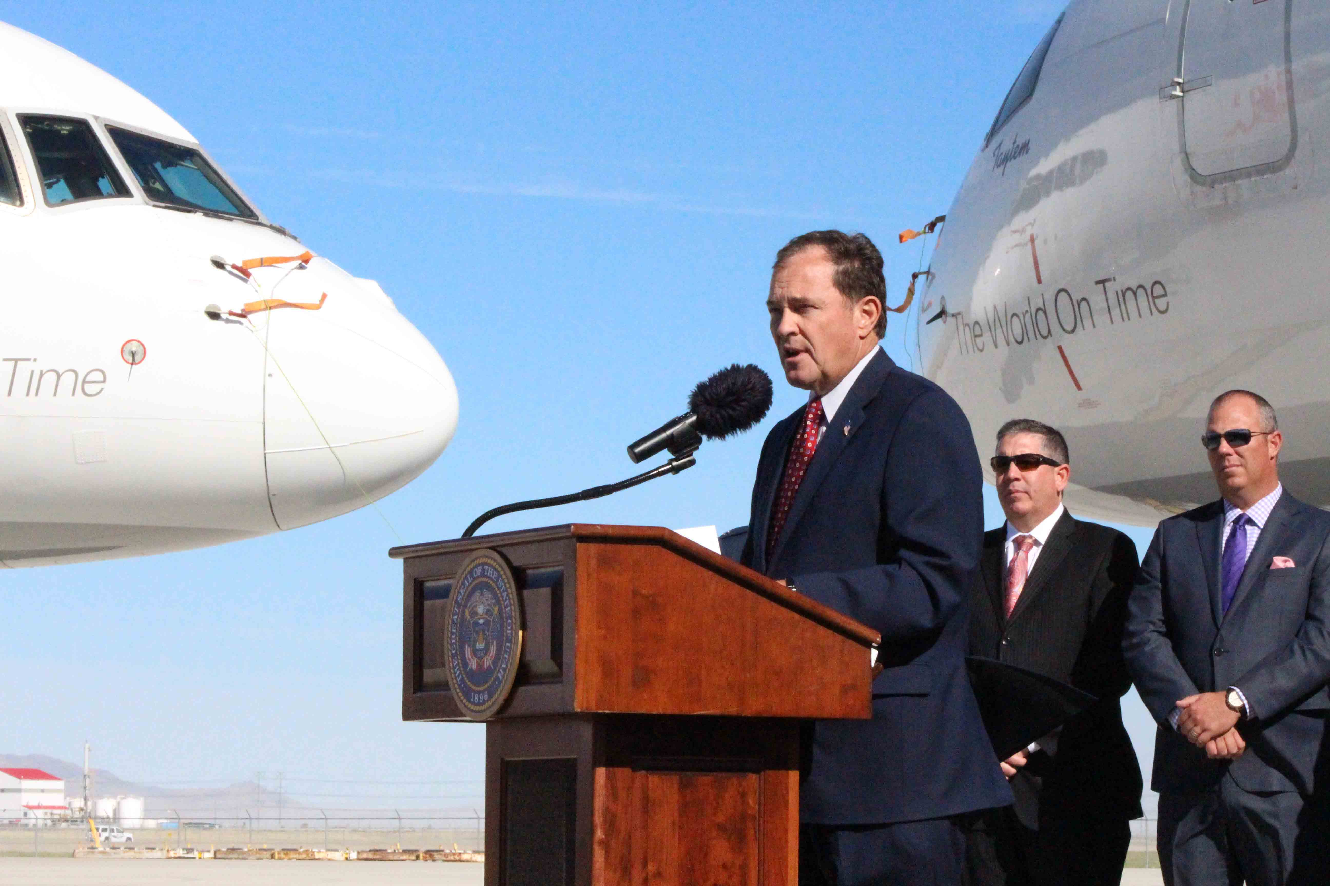
Utah Governor Gary R. Herbert announces the Utah Aerospace Pathways program at the FedEx sort facility in Salt Lake City.
About the Utah Governor’s Office of Economic Development (GOED)
Web: business.utah.gov

The Governor’s Office of Economic Development (GOED) charter is based on Governor Gary Herbert’s commitment to economic development statewide. Utah’s economic development vision is that Utah will lead the nation as the best performing economy and be recognized as a premier global business environment and tourist destination. The mandate for this office is to provide rich business resources for the creation, growth and recruitment of companies to Utah and to increase tourism and film production in the state. GOED accomplishes this mission through the administration of programs that are based around targeted industries or “economic clusters” that demonstrate the best potential for development. GOED utilizes state resources and private sector contracts to fulfill its mission. For more information please contact: Michael Sullivan, 801-538-8811 or mgsullivan@utah.gov

About UCAP
Web: https://jobs.utah.gov/department/ucap.html
The UCAP program is designed to strengthen collaboration between education, industry, and economic development in order to better respond to the needs of regional and statewide-designated clusters.

