**Press Release Contacts:**

**For Immediate Release** Vinitaly International

International Media Dept.

+39 045 8101447

[media@vinitalytour.com](mailto:media@vinitalytour.com)

[www.vinitalytour.com](http://www.vinitalytour.com)

Twitter: @VinitalyTour

Join Vinitaly International Network on LinkedIn

**Italian food and wine star in first b2c event in Shanghai**

Less than two weeks to go to the Shanghai Wine & Dine Festival, the first edition an event that aims at becoming the most important b2c showcase in China. During the Festival, organized by the Shanghai Morning Post, Gewara and the Bank of Communication with Unionpay, Vinitaly International will be organizing an Italian pavilion starring both Italian food and wine.

It has been an intense year for Vinitaly China, starting from the Expo Roadshow (in eight cities and in tight collaboration with the most important Italian wine producers), followed by the second edition of the Offsite showcase in Chengdu. Now here in Shanghai, Vinitaly is getting ready to represent Italy’s food and wine scene on the occasion of the first attempt to be made to organize a b2c event in Shanghai, the city that best symbolizes China’s constant growth.

Italian food will represent will be taking centre stage at the Italian Pavilion where two symbols of the Italian food scene in Shanghai, Da Marco and Jacky Group, together with Chef in The City, will represent Italy’s top gastronomic delights.

There is great excitement in the air about the two top chefs, Marco Barbieri and Jacky Xue, who will be cooking at the Italian Pavilion throughout the entire Festival in Shanghai (18-20 September). Jacky Xue will even be closing one of his restaurants for all three days in order to be able to give his best at the event with a staff of 15 cooks.

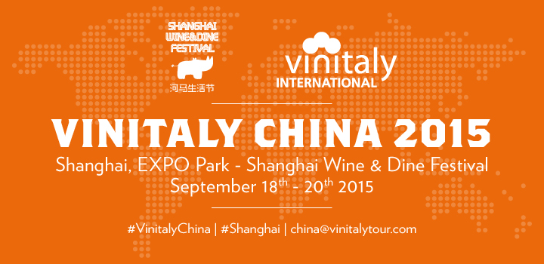

Jacky Xue, a thirty-three year old from Shanghai, became famous in the city about three years ago and his first restaurant, Top Chef, in a short time has become a fashionable meeting place for Chinese wine lovers. Jacky Xue will become the owner, together with Marco Barbieri, of the most famous Italian restaurant in Shanghai, Da Marco, reference point for the Italian community and for all those passionate about Italian food. The two cooks may also organize a cooking show together with other famous Italian cooks in Shanghai.

“Italian food and food and wine matching will represent the winning strategy to approach Chinese consumer-attendees”, says Stevie Kim, Managing Director of Vinitaly International. “We are really very happy that Da Marco and Jacky Group believe in this important b2c endeavour. Together with them there will be two of our most important partners here in China: Fabbri and Illy, that will serve respectively ice-cream and coffee during the entire duration of the Festival”. Exhibitors at the Italian Pavilion will also include Inalca and Farchioni, Enoteca Italiana with its new local management and top Italian wine importers in Shanghai such as ChuXiao (number one of Italian wine online), Sinodrink (organizer of Gambero Rosso), one of the first wine bars in China, Enoterra and the inventor of the Lady Asti, Insider China. Pre-sale has now reached 10 thousand tickets and VIP entrances are already all sold out. A good omen for the first edition of the Shanghai Wine & Dine Festival.

**About:**

Veronafiere is the leading organizer of trade shows in Italy including Vinitaly (www.vinitaly.com), the largest wine and spirits fair in the world. During its 49th edition Vinitaly counted some 4.000 exhibitors on a 100.000 square meter area and 150.000 visitors including more than 2.600 journalists from 46 different countries. The next edition of the fair will take place on 10 - 13 April 2016.

The premier event to Vinitaly, OperaWine (www.vinitalyinternational.com) “Finest Italian Wines: 100 Great Producers,” will unite international wine professionals on April 9th in the heart of Verona, offering them the unique opportunity to discover and taste the wines of the 100 Best Italian Producers, as selected by Wine Spectator. Since 1998 Vinitaly International travels to several countries such as Russia, China, USA and Hong Kong thanks to its strategic arm abroad, Vinitaly International. In February 2014 Vinitaly International launched an educational project, the Vinitaly International Academy (VIA) with the aim of divulging and broadcasting the excellence and diversity of Italian wine around the globe. VIA has now also created its very first Certification Course with the aim of creating new Ambassadors of Italian Wine in the World.

###