**Ready to “Swap It Out?” Here are our top picks for planting RIGHT NOW:**

**(NOTE: HI RES IMAGES ARE AVAILABLE UPON REQUEST FOR ALL LISTED PLANTS)**

**Trees:**

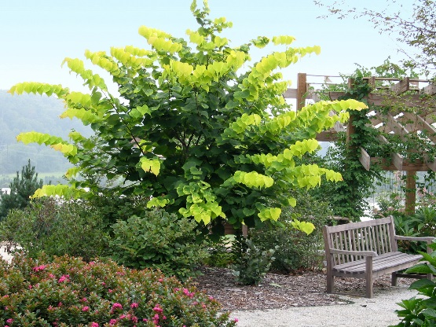

[Hearts of Gold redbud](http://www.monrovia.com/plant-catalog/plants/1325/hearts-of-gold-redbud/)

[Timeless Beauty desert willow](http://www.monrovia.com/plant-catalog/plants/753/timeless-beauty-desert-willow/)

[Emerald Wave® Sweet Bay](http://www.monrovia.com/plant-catalog/plants/3224/emerald-wave-sweet-bay/)

[Majestic Beauty® Fruitless Olive](http://www.monrovia.com/plant-catalog/plants/1890/majestic-beauty-fruitless-olive/)

[Deodar cedar](http://www.monrovia.com/plant-catalog/plants/716/deodar-cedar/)

**Shrubs:**

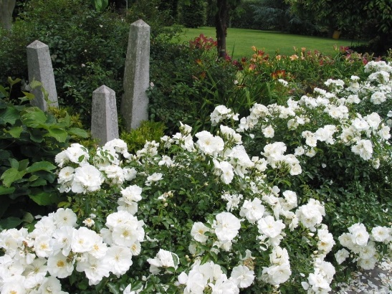

[Flower Carpet® White Groundcover Rose](http://www.monrovia.com/plant-catalog/plants/2066/flower-carpet-white-groundcover-rose/)

[Arabian Lilac](http://www.monrovia.com/plant-catalog/plants/2458/arabian-lilac/)

[Dwarf bottlebrush](http://www.monrovia.com/plant-catalog/plants/418/dwarf-bottlebrush/)

[Golf Ball Kohuhu](http://www.monrovia.com/plant-catalog/plants/453/golf-ball-kohuhu/)

[Southern Moon® Yedda Hawthorn](http://www.monrovia.com/plant-catalog/plants/1594/southern-moon-yedda-hawthorn/)

[Icee Blue® Juniper](http://www.monrovia.com/plant-catalog/plants/1662/icee-blue-juniper/)

[Bonsai Blue Jacaranda](http://www.monrovia.com/plant-catalog/plants/5091/bonsai-blue-jacaranda/)

[Tiny Tower® Italian Cypress](http://www.monrovia.com/plant-catalog/plants/1028/tiny-tower-italian-cypress/)

**Perennials:**

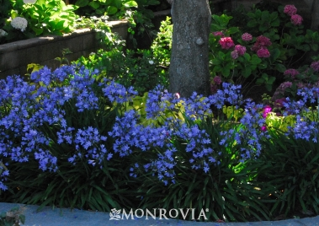

[Baby Pete™ Lily Of The Nile](http://www.monrovia.com/plant-catalog/plants/2349/baby-pete-lily-of-the-nile/)

[KATRINA® African Iris](http://www.monrovia.com/plant-catalog/plants/1593/katrina-african-iris/)

[Brakelights® Red Yucca](http://www.monrovia.com/plant-catalog/plants/3198/brakelights-red-yucca/)

[Lemon Popsicle Hot Poker](http://www.monrovia.com/plant-catalog/plants/5336/lemon-popsicle-hot-poker/)

[Blonde Ambition Blue Grama Grass](http://www.monrovia.com/plant-catalog/plants/3129/blonde-ambition-blue-grama-grass/)

[Riverina Thomas French Lavender](http://www.monrovia.com/plant-catalog/plants/5043/riverina-thomas-french-lavender/)

[Heatwave™ Sparkle Sage](http://www.monrovia.com/plant-catalog/plants/2335/heatwave-sparkle-sage/)

**Groundcovers:**

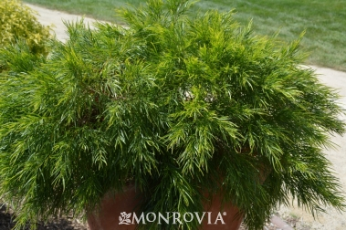

[Cousin Itt river wattle](http://www.monrovia.com/plant-catalog/plants/5191/cousin-itt-little-river-wattle/)

[Centennial hybrid wild lilac](http://www.monrovia.com/plant-catalog/plants/3260/centennial-hybrid-wild-lilac/)

[Jewel of the Desert Garnet ice plant](http://www.monrovia.com/plant-catalog/plants/4953/jewel-of-desert-garnet-ice-plant/)

[Creeping Mahonia](http://www.monrovia.com/plant-catalog/plants/2479/creeping-mahonia/)

[Raspberry Ice Bougainvillea](http://www.monrovia.com/plant-catalog/plants/381/raspberry-ice-bougainvillea/)

[Ice Chip Summer Lilac](http://www.monrovia.com/plant-catalog/plants/3475/ice-chip-summer-lilac/)

**Kitchen Garden:**

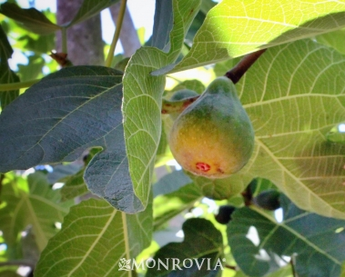

[Corky's Honey Delight™ Fig](http://www.monrovia.com/plant-catalog/plants/3459/corkys-honey-delight-fig/)

[Pineapple guava](http://www.monrovia.com/plant-catalog/plants/1197/pineapple-guava/)

[Little Ragu™ Sweet Bay](http://www.monrovia.com/plant-catalog/plants/3697/little-ragu-sweet-bay/)

[Angel Red® Pomegranate](http://www.monrovia.com/plant-catalog/plants/2844/angel-red-pomegranate/)

[Roman Beauty Rosemary](http://www.monrovia.com/plant-catalog/plants/1429/roman-beauty-rosemary/)

[Flame seedless grape](http://www.monrovia.com/plant-catalog/plants/2221/flame-seedless-grape/)

**Containers:**

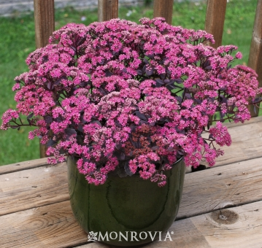

[Sunsparkler® Dazzleberry Sedum](http://www.monrovia.com/plant-catalog/plants/3628/sunsparkler-dazzleberry-sedum/)

[Lavender Swirl® Trailing Lantana](http://www.monrovia.com/plant-catalog/plants/1770/lavender-swirl-trailing-lantana/)

[Festival™ Raspberry Cordyline](http://www.monrovia.com/plant-catalog/plants/3286/festival-raspberry-cordyline/)

[Endurascape™ Purple Verbena](http://www.monrovia.com/plant-catalog/plants/5359/endurascape-purple-verbena/)

[Green Columnar Juniper](http://www.monrovia.com/plant-catalog/plants/1613/green-columnar-juniper/) (topiary)

[Dwarf Fountain Grass](http://www.monrovia.com/plant-catalog/plants/2484/dwarf-fountain-grass/)

**Vines:**

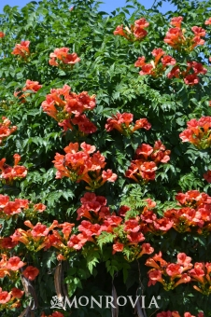

[Balboa Sunset® Trumpet Creeper](http://www.monrovia.com/plant-catalog/plants/693/balboa-sunset-trumpet-creeper/)

[White stripe bougainvillea](http://www.monrovia.com/plant-catalog/plants/3114/white-stripe-bougainvillea/)