Press Release Contacts:
For Immediate Release Vinitaly International
International Media Dept.
+39 045 8101447
media@vinitalytour.com
www.vinitalytour.com
Twitter: @VinitalyTour
Join Vinitaly International Network on LinkedIn

Louis Roederer Award goes to an Italian for the first time in history

Italian wine expert and Scientific Director of Vinitaly International Academy Ian D’Agata was awarded on Wednesday the 2015 Louis Roederer International Wine Writers' Award for his book Native Wine Grapes of Italy, an authoritative guide to Italy’s 300 plus native grapes and their wines.
Doctor D’Agata is the first Italian to have been nominated and to have won the prestigious award that was founded back in 2004 by Louis Roederer to celebrate all those who have put in words or images the magic of the wine world with the aim to educate and entertain.
Divided into 7 different categories the competition attracts candidates from all over the world ranging from established trade communicators alongside new aspiring talent, all of whom are judged by some of the greatest names in the wine sector today including, Charles Metcalfe, Jancis Robinson, and Neil Beckett. Historical facts also concurred to making this award so prestigious: founded in 1776, Champagne Louis Roederer is one of the very rare Champagne houses to have remained firmly in the hands of the family. Louis Roederer inherited the company from his German uncle in 1833, renamed it eponymously and in 1876 created Cristal, the first Cuvée de Prestige of Champagne, to satisfy the demanding tastes of Tsar Alexander II. Mr Roderer’s great passion for books and drawings, that he also collects, has equally contributed to the significance of this award that throughout the years has counted among its winner top names of the world of wine.
The four books shortlisted for this year’s The Domaine Faiveley Wine Book Of The Year category were:

- Barolo & Barbaresco – Kerin O’Keefe
- Native Grapes of Italy – Ian D’Agata
- Natural Wine – Isabelle Legeron MW
- The Essence of Wine: Celebrating the Delights of the Palate – Alder Yarrow

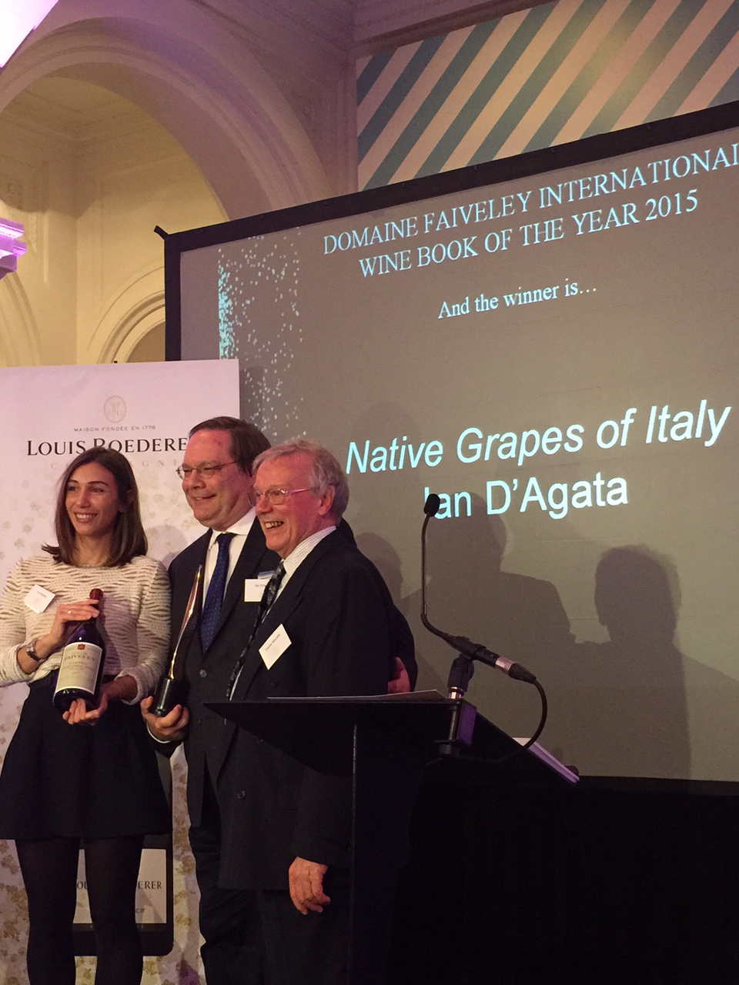

Praise for Dr. D’Agata’s book has been swift and copious amidst the world of Italian wine: “It’s an unbelievable honour, truly one of the high points of my career. “said Ian D’Agata following the award ceremony. “I am glad for Italy, and share the award in spirit with all those passionate wine producers who have dedicated their lives to saving Italy’s native grapes and were such help in my research for the book”
Ian D’Agata has been writing and lecturing about food and wine for more than 25 years and is one of the world’s best known wine writers: he covers Alsace, Bordeaux, Italy and Canada for Stephen Tanzer’s International Wine Cellar and contributes regularly to Britain’s Decanter magazine, of which he is also the Regional Co-Chairman for Italy at the Decanter World Wine Awards. He has also won a number of prizes for his many works which now also include his latest book devoted to Italy’s native grapes and wines. The Native Wine Grapes of Italy, University of California Press, is a mesmerizing trip through Italy’s more than 540 different Italian grape varieties from Aglianico to Zibibbo.
The award winning guide is also the essential study companion for the new prestigious Certification Course of the Vinitaly International Academy of which Doctor D’Agata is Scientific Director: aim of the educational project and of the course is to explain and broadcast, with scientific rigor, the great diversity of Italian wines around the globe.

About:
Veronafiere is the leading organizer of trade shows in Italy including Vinitaly (www.vinitaly.com), the largest wine and spirits fair in the world. During its 49th edition Vinitaly counted some 4.000 exhibitors on a 100.000 square meter area and 150.000 visitors including 2.600 journalists from 46 different countries. The next edition of the fair will take place on 10 - 13 April 2016. The premier event to Vinitaly, OperaWine (www.vinitalyinternational.com) “Finest Italian Wines: 100 Great Producers,” will unite international wine professionals on April 9th in the heart of Verona, offering them the unique opportunity to discover and taste the wines of the 100 Best Italian Producers, as selected by Wine Spectator. Since 1998 Vinitaly International travels to several countries such as Russia, China, USA and Hong Kong thanks to its strategic arm abroad, Vinitaly International. In February 2014 Vinitaly International launched an educational project, the Vinitaly International Academy (VIA) with the aim of divulging and broadcasting the excellence and diversity of Italian wine around the globe. VIA has now also organized its very first Certification Course with the aim of creating new Ambassadors of Italian Wine in the World.

###

