Press Release Contacts:
For Immediate Release Vinitaly International
International Media Dept.
+39 045 8101447
media@vinitalytour.com
www.vinitalytour.com
Twitter: @VinitalyTour
Join Vinitaly International Network on LinkedIn

Four days after the end of the first edition of Shanghai’s Wine & Dine Festival, in which Vinitaly International organised the Italian National Pavilion, the first reports of the festival confirm two facts: food and wine Made in Italy are in good health and the Festival can represent a point of reference in China.
According to the organisers, the three-day Festival hosted 70 thousand visitors at Expo Park. The masterclasses – two of which on Italian wines – were sold out and the Italian National Area, together with the Japanese area, was the most visited with crowds of Chinese visitors rushing to its booths. A calendar packed with appointments and events at the Vinitaly Lounge, over 150 wines, Fabbri’s ice-cream and Illy’s coffee, 15 chefs on stage featuring fine cuisine with Italian wine pairing, and the happy-hour organized in collaboration with Vinitaly International’s media partners made the difference allowing Italy to be the visitors’ first choice.
Predictably, food achieved resounding success and acted as a draw for wine. “The Festival has been fantastic for us”, exclaimed Lu Yongchuan, Fabbri’s General Manager in China. “During the entire festival we had long queues of visitors at our stand. To us, this means that the concept is well accepted by consumers.” The managers of two big Italian companies at the event, Inalca F&B and Bonacchi showed the same enthusiam. The former has just entered the Chinese market with an ambitious expansion program, while the latter has a long-lasting experience and achieved excellent results in southern China as well as in second and third-tier cities. “Positive and pleasant experience to be repeated” said Livio Rotini, head of Farchioni in Cina, “I liked the format of Shanghai’s Wine & Dine Festival very much and it should be repeated again for sure.”
“The Festival represented for us a great occasion to test our products, especially the new ones, directly with final consumer” explained Jiang Zhiping, founder of Chuxiao, the biggest Italian wine online distributor in China, at its the first participation to a b2c event. “I am sure that Shanghai’s Wine & Dine Festival can represent from now on an excellent platform for Italian wine promotion in China.”

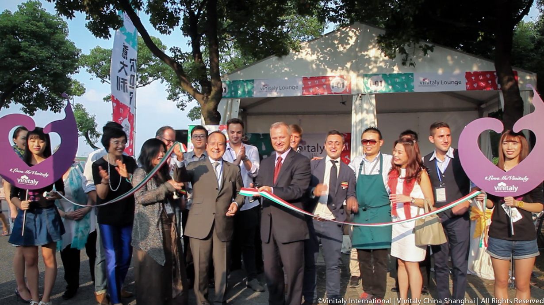

Even Mattia Morelli, who arrived from Italy with Omina Romana, was positively surprised by the large inflow of visitors at Expo Park. “An occasion for me to see with my own eyes what Chinese wine -lovers are like”.
The General Director of Veronafiere Giovanni Mantovani and the Consul General of Italy in Shanghai, Stefano Beltrame, were both present during the opening ceremony of the Italian Pavilion: “This experience at the Wine & Dine Festival was truly interesting. We wanted to create exactly an event of this nature in Shanghai, a marketplace in which food and wine pairing has been the right key to approach such a large population and attract the attention of interested consumers. It was a great idea to create a sort of Italian street food oriented towards Chinese taste”.
“Italy has the moral authority to put together all importers, creating a minimum of critical mass to impact a huge country like China with a billion and a half people and a big market” added Mr Beltrame. “Vinitaly International has the catalyst function to face an educational effort, so we can increase our sales in China. I’d like to thank Vinitaly for being here today. To be competitive in Shanghai where there is a big competition means to be competitive in the rest of China. If you are successful here, then in the rest of China they will copy. HK, Chongqing, Chengdu are also important cities, but Shanghai represents for us a big market”.
The image of Italy drawn from the festival, as hoped during the meeting organised by the Italian Consul General in Shanghai on the eve of the festival, is that of Country united by the strength of its excellent food and wine. All this gives us great hope for the next big appointment of Vinitaly in Asia, with Vinitaly China - Hong Kong from the 5th to the 8th of November.

About:

Veronafiere is the leading organizer of trade shows in Italy including Vinitaly (www.vinitaly.com), the largest wine and spirits fair in the world. During its 49th edition Vinitaly counted some 4.000 exhibitors on a 100.000 square meter area and 150.000 visitors including more than 2.600 journalists from 46 different countries. The next edition of the fair will take place on 10 - 13 April 2016.
The premier event to Vinitaly, OperaWine (www.vinitalyinternational.com) “Finest Italian Wines: 100 Great Producers,” will unite international wine professionals on April 9th in the heart of Verona, offering them the unique opportunity to discover and taste the wines of the 100 Best Italian Producers, as selected by Wine Spectator. Since 1998 Vinitaly International travels to several countries such as Russia, China, USA and Hong Kong thanks to its strategic arm abroad, Vinitaly International. In February 2014 Vinitaly International launched an educational project, the Vinitaly International Academy (VIA) with the aim of divulging and broadcasting the excellence and diversity of Italian wine around the globe. VIA has now also created its very first Certification Course with the aim of creating new Ambassadors of Italian Wine in the World.

###

