Join Us
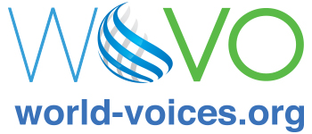
THIS IS WORLD-VOICES ORGANIZATION,
THE VOICE OVER INDUSTRY ASSOCIATION.

"Our mission is to strengthen, improve and promote the artistic, professional and economic success of freelance professional voice actors world wide."
We are committed to integrity, creativity, and the pursuit of excellence and we advocate for the highest ideals and practices within all aspects of the voice over marketplace.

World-Voices Organization (“WoVO”) is a non-profit, member-driven international association of voice actors that seeks to educate members in the essentials of voice over performance skills and operating a private studio. World-Voices Organization provides mentoring to voice talent across a spectrum of techniques and recording skills, engaging membership in a meaningful community, and promoting proficient and uniform standards for the practicing voice acting professional.

Through chapters and national programs, WoVO works to:
- Inform and educate about best practices, standards for ethical conduct and professional expertise. Communicate voice acting’s importance to the public and business leaders and affirm the power of professional quality voicing and recording.
- Inspire through articles, portfolios and recognition of achievement and excellence.
- Represent the profession through a network of chapters and independent professionals.
- Stimulate discussion of the industry through events, social media and websites.
WoVO offers member benefits via discount programs, annual membership meetings, the WoVOCon conference, virtual small-group meetings and mentorship programs.

If you are interested in voice acting or are an established professional, please help us make your voice over industry better and stronger.
Join World-Voices Organization at
www.WorldVO.org.

