Press Release For Immediate Release

Contacts:
Vinitaly International
International Media Dept.
+39 045 8101447
media@vinitalytour.com
www.vinitalytour.com
Twitter: @VinitalyTour
Join Vinitaly International Network on LinkedIn

Vinitaly International Academy opens its doors to the second edition of the VIA Certification Course

One year and a half later and Vinitaly International Academy is once again on the lookout for 50 new Candidates for the second edition of the Certification Course, to be held in April 2016 in Verona, just before the 50th edition of Vinitaly (https://www.youtube.com/watch?v=qtJSPXfW5Og).
Registrations are now open online (http://www.vinitalyinternational.com/certification-course-application-form) with a large number of potential candidates already applying, including one Master of Wine and three Master of Wine Students who’s profiles have now been made public.

The VIA Certification Course represents a unique opportunity for wine professionals from all over the world to gain comprehensive knowledge on the specific subject of Italian wine grapes and wines from the world's best known Italian wine expert Ian D'Agata. According to Dr. D’Agata, “the course offers not just hours of in-depth classroom teaching but also the opportunity to taste hundreds of wines that are not easily found in many countries outside of Italy. In this manner, our students have an opportunity to really understand and learn the differences between each variety and wine, and even more important, learn what each wine should really smell and taste like.”

In a complex matter like Italian wine, with its more than 500 native grapes, only in-depth knowledge can facilitate the ability to understand the nuances and distinctions of different types of wine. And this is exactly what VIA offers, as explained by Fongyee Walker from Mainland China: one of VIA’s new candidates and Head of Dragon Phoenix Wine Consulting, Fongyee has already passed the MW exam and is now preparing the research project: “I applied because I wish to study a greater variety of Italian wines in a more systematic and profound manner.”

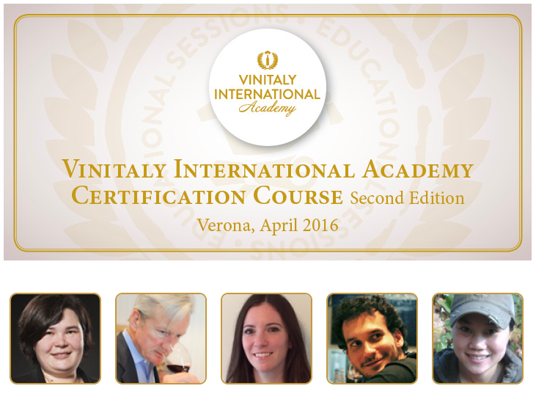

Her future classmate Lin Liu, a Chinese based in France working both as a wine writer for Bettane et Desseauve and Conde Nast Traveller amongst others and export manager for Chateau de Chambert, shares the same opinion: “I would like to better grasp the complexity of Italian wine through the guidance of great masters with profound field experience” she commented when applying for the course.
But what is it that makes the VIA Certification Course so unique amongst the large number of new educational programs proliferating both in Italy and abroad? American candidate, Jay Youmans, owner of Capital Wine School and the first MW to join the ranks of VIA’s growing community, shines some light on one of the possible reasons: “Who better than the organization that hosts the most important trade event for Italian wine could be the leading entity for Italian wine education around the world? I am keen to learn about Italian wine from the Italian perspective.”

The strategic back-up of Vinitaly, the gold standard for Italian wine culture and business, proves once again to be a strong draw for people eager to learn about Italian wine. This year, the second edition of the Certification Course will be held the week before Vinitaly’s 50th anniversary (10 – 13 April 2016).

The other two Candidates selected by the Scientific Commettee are the Canadian Brie Dema, a Sommelier certified by the Court of Master Sommeliers, who works for Langdon Hall Relais and Chateau, and the Brazilian Bernardo Silveira Moreira Pinto, Technical Director of Zahil Vinhos, another MW student. If the first “would love to be an Italian Wine Expert, and share knowledge on the diverse and unique native grapes of Italy, the special wines that come from them, and the passion of Italian wine producers”, the second expressed his wish “to learn even more about Italian wines and contribute to their diffusion in the Brazilian market.”

“We are impressed by the number and, even more, by the quality of the applications that we have received up until now. I am positive that the first five Candidates represent only a small percentage of the high quality students that will come to Verona in April next year. This means more probability of having outstanding Italian Wine Ambassadors and Italian Wine Experts around the world in the near future” says Stevie Kim, Managing Director of Vinitaly International.

About:

Veronafiere is the leading organizer of trade shows in Italy including Vinitaly (www.vinitaly.com), the largest wine and spirits fair in the world. During its 49th edition Vinitaly counted some 4.000 exhibitors on a 100.000 square meter area and 150.000 visitors including 2.600 journalists from 46 different countries. The next edition of the fair will take place on 10 - 13 April 2016. The premier event to Vinitaly, OperaWine (www.vinitalyinternational.com) “Finest Italian Wines: 100 Great Producers,” will unite international wine professionals on April 9th in the heart of Verona, offering them the unique opportunity to discover and taste the wines of the 100 Best Italian Producers, as selected by Wine Spectator. Since 1998 Vinitaly International travels to several countries such as Russia, China, USA and Hong Kong thanks to its strategic arm abroad, Vinitaly International. In February 2014 Vinitaly International launched an educational project, the Vinitaly International Academy (VIA) with the aim of divulging and broadcasting the excellence and diversity of Italian wine around the globe. VIA has now also organized its very first Certification Course with the aim of creating new Ambassadors of Italian Wine in the World.

###

