Press
Sunnyvale, CA, September 30, 2015
New Osram Ostar Stage Multichip LEDs offer twice the brightness from the same surface area for stage spotlights

New high-power LEDs with red, green, blue and white chips

Osram Opto Semiconductors’ new Osram Ostar Stage LED features four high-power chips with the latest thin-film and UX:3 technologies in red, green, blue and white. Providing higher brightness with no increase in package size, this LED is ideal for use in stage spotlights. The four chips of the new high-power LED can be operated at up to 2.5 amperes (DC), thanks to improved chip technologies. This leads to twice the output of 30 watts (electric) from the same chip and package area compared to the existing version, adding another output class to the Osram Ostar Stage product family.

These 1 mm² chips can be operated for the first time at up to 2.5 amperes (A), providing an output of 30 watts (W), which is twice as high as the existing version. The Osram Ostar Stage family now covers outputs between 15 and 60 watts, with the 60 watts coming from the previously released LE RTDUW S2WP version. “The higher current that is necessary for a higher output requires the thermal management of the Osram Ostar Stage to be adapted so that the heat generated in the chip can be removed as effectively as possible,” said Andrew Lin, Product Marketing Manager at Osram Opto Semiconductors.

More flexibility with a number of identical parameters
“At the same time,” continued Lin, “many features such as the package size and beam characteristics match those from previous versions. That way, customers can stick to their existing optics and the overall design of their lighting solutions.” The new Osram Ostar Stage LED gives customers more flexibility for their stage spotlight product portfolio. Spotlights with the same number of LEDs will be even more powerful, while spotlights with fewer light emitting diodes will have the same brightness.

The new LEDs are also ideal for use in mood and architectural lighting; in the latter case, they are the preferred light source for effect and accent lighting. These high-power LEDs will be available from Q1/2016 in high volumes.

Press Contact:
Kate Cleveland
Tel. 248-277-8018
Fax 248-596-0395
Email kate.cleveland@osram-os.com

Technical Information:
Tel. 866-993-5211
Email: support@osram-os.com
Sales contact: www.osram-os.com/sales-contacts

Technical data (LE RTDUW S2WN):
Dimensions | 4.68 mm x 5.75 mm x 1.26 mm
Chip size | 1 mm²
Thermal resistance R_{th} | 0.9 K/W
Output | 30 W
Beam angle | 120°

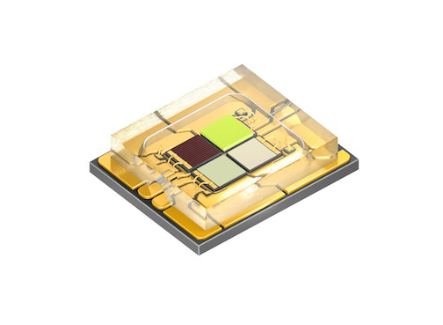
The thin-film and UX:3 chips of the new Osram Ostar Stage LED can be operated at up to 2.5 amperes, resulting in higher output.
Picture: Osram

More light on stage: the new Osram Ostar Stage LEDs generate greater brightness from the same chip surface area.
Picture: Osram

www.osram-os.com/pr-ostar-stage

ABOUT OSRAM
OSRAM of Munich, Germany is one of the two leading light manufacturers in the world. The company's portfolio covers the entire value chain from components – including lamps, electronic control gear and opto semiconductors such as light-emitting diodes (LED) – as well as luminaires, light management systems and lighting solutions. OSRAM has around 34,000 employees worldwide and generated revenue of more than €5.1 billion in fiscal 2014 (ended September 30). The company's business activities have been focusing on light – and hence on quality of life – for over 100 years. The company was listed on the stock exchanges in Frankfurt and Munich on July 8, 2013 (ISIN: DE000LED4000; WKN: LED 400; Trading symbol: OSR).
Additional information can be found at www.osram.com

