THE FIRST COMBINATION OF CHILDREN`S MOST POPULAR BIKES IN ONE
The only joy the kids will ever need

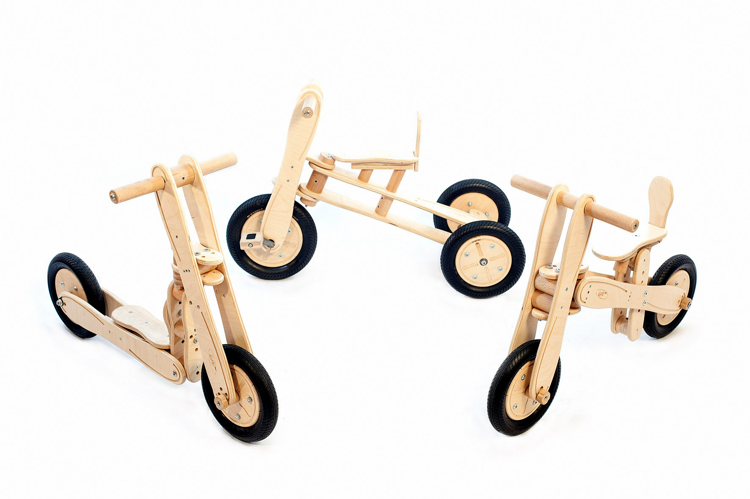

Kranj – Slovenia 4.10.2015 - Lucky^{3in1} is the first combination of wooden balance bike, trike and scooter in one bike. The product solves the problem of accumulation of individual toys, storage space, the price of the product and the long-term usefulness. The beautiful toy is, therefore, a flexible combination of the most popular children's bike, which accompany them throughout their childhood. While maintaining the balance and bikes handling, the kids learn with all versions the basic movements of motion, for the future successful riding a bike. The toy is wrapped in an amazing single package for children aged from 18 months to 4 years.
The benefits:
- 3 different bikes in 1
- unique design
- easy to combine parts
- for children of different ages and heights
- the combination of wooden rim and inflatable rubber wheel for better comfort
- seat with backrest for a correct posture and confidence
- made of wood with moisture protection

Launching on Kickstarter
The Lucky^{3in1} is a new Slovenian innovation and is launching on Kickstarter with a funding goal of $15,000.

About Lucky^{3in1}
The idea comes from experiences working with the children. »The mission is to give the children as many movements as possible through game and joy with just a single toy. Our company is very excited to offer this one of a kind product to the world,« says Matjaž Loc the inventor of Lucky^{3in1}. Behind the company stands a young team who passionately wants to show the world the unique products made from eco-friendly materials. »We believe it is the best widget available, and we believe our customers will agree,« says Anja Žmuc the CFO of the company.
Slovenia is one of the most forested countries in Europe and is known for its quality wood products. The Lucky^{3in1} also continues a rich tradition of wooden innovations, bringing the view of the usefulness, quality, design and safety to another level.
To view the campaign see the links below:
https://www.kickstarter.com/projects/1882878522/lucky-3in1-the-only-joy-the-kids-will-ever-need
Media contact information:
- Website: http://lucky3in1.com/
- Press-Kit
- E-mail: info@lucky3in1.com
- Facebook: https://www.facebook.com/luckythreeinone
- Phone: +386 40 825 777

